9
Ex Libro Lapidum Historia Mundi:
Reading History Written in Rocks

Walter Alvarez, Alessandro Montanari,
David Shimabukuro

Abstract
In the emerging conception of Big History, the largely contemporaneous regimes of Earth and life occupy the middle ground between the Cosmos and humanity. As part of the bridging of disciplinary boundaries, historians and astronomers will need to learn how geologists and paleontologists read history written in rocks. This was the goal of a workshop held at the Geological Observatory of Coldigioco, in the Marche Region of Italy in August 2010. The Ob-servatory is in a part of the Apennine Mountains with extensive exposures of deep-water, or ‘pelagic’, limestones, which carry absolutely the best record of Earth history we have, covering an interval of about 200 million years. Especially in the remarkable outcrops at Gubbio, geologists and paleontologists have recovered records of the evolution of microfossils, the reversals of the Earth's magnetic field, the giant impact that caused the mass extinction in which the dinosaurs perished, and have dated parts of this record with volcanic ash layers that give numerical ages. The integrative stratigraphy obtained from the Italian pelagic limestones has been very important for the development of the geologic time scale, and new developments in cyclostratigraphy hold the promise of dating these rocks back to about 100 million years ago with a resolution of about 1,000 years.
Introduction: The Emergence of Big History
Universal history, the attempt to make sense of all of the human past, fell into disrepute some decades ago, in part because the need to understand particular historical episodes in detail has led to extreme specialization, and in part because previous attempts sometimes led to deplorable results, like the glorification of ‘Aryans’ by the Nazis. At the present time, history is studied mostly in tiny chunks by specialists, but this does not seem like a healthy long-term situation. There is already a reaction to this situation with the rise of World History, looking at the entire human past.
An even more ambitious approach is Big History, developed in the 1990s by the Anglo-Australian historian David Christian. Big History seeks to unify the study of all of the past, both human and pre-human, thus bringing together the work of historians and other humanists, and of historical scientists, including cosmologists, astronomers, geologists, paleontologists, paleoanthropologists and archaeologists (Christian 1991, 2004). The Dutch sociologist Fred Spier proposed the usefully vague term ‘regime’ to refer to ‘a more or less regular but ultimately unstable pattern that has a certain temporal permanence’ (Spier 1996: 14). No standard set of regimes has been agreed upon, but one useful set would be (1) Cosmic history, (2) Earth history, (3) Life history and (4) Human history, while a more detailed subdivision would be (1) Big-Bang history, (2) Cosmic history, (3) Earth History, (4) Life history, (5) Human prehistory and (6) Human written history (Alvarez et al. 2009). It is only now becoming possible to construct a serious account of all of the past, because of
the discovery and invention of a wide variety of techniques for dating historical events in all of the regimes (Hedman 2007). Christian (2008a) has reviewed this chronometric revolution. Other recent book-length treatments of Big History have been published by Brown (2007), Christian (2008b), and Spier (2010).
The Role of Geology and Paleontology in Big History
In either of the sets of regimes mentioned above, Earth history and life history are fundamental parts of the unified understanding of the past that Big Historians wish to develop.
Earth history began with the origin of the Earth, 4.567 billion years ago, and runs to the present time. Life probably appeared not long after the origin of
the Earth, perhaps about 4 billion years ago, so the regimes of Earth history and life history are largely coextensive in time.
Earth history and life history fall largely in the domain of geology and paleontology, and in both of these fields of study, much of the historical record comes from sedimentary rocks. The study of sedimentary rocks is called ‘stratigraphy’, and although the procedures of stratigraphy are fairly straightforward, they are largely unfamiliar to most historians, although much has been learned about human history through the work of archaeologists, who use stratigraphic techniques in their excavations.
The August 2010 Coldigioco Workshop
In order to bridge the gap between the techniques used by historians and those used by geologists and paleontologists, a workshop was held in Italy, at
the Geological Observatory of Coldigioco, in August, 2010. The goal of
the workshop was to demonstrate – in the field, in the laboratory and using maps – how geologists and paleontologists extract historical information from sedimentary rocks.
The workshop was taught by the three authors of the present paper, all of them practicing geologists, and was attended by six Big Historians who come from humanistic and social science backgrounds – Craig Benjamin, Cynthia Brown, David Christian, Lowell Gustafson, Barry Rodrigue and Fred Spier – as well as Daron Green and Michael Dix of Microsoft, who are involved in developing tools for Big History teaching and research. The workshop was extremely successful in crossing the disciplinary barriers that separate historians and geologists, and in addition it provided the opportunity to plan what has since become the International Big History Association. The present paper summarizes the concepts and techniques of reading Earth and life history from rocks that were demonstrated at the workshop (Fig. 1).

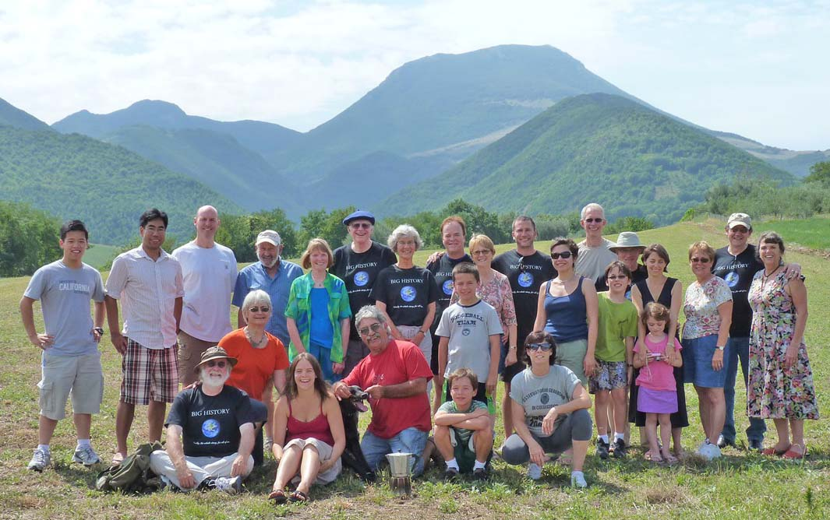

Fig. 1. Participants in the August 2010 Workshop on geology in Big History, at the Geological Observatory of Coldigioco in
the Apennine Mountains of Italy
Ex Libro Lapidum Historia Mundi
The central concept of stratigraphy – that history is written in rocks – is conveyed by the motto, Ex Libro Lapidum Historia Mundi, – ‘Out of the book of rocks comes the history of the world’. Of course, there are all kinds of rocks, and different kinds of rocks record different kinds of history. Metamorphic rocks, which have been subjected to high temperatures and high pressures, carry a record of events deep in the Earth's crust, and thus they are critical for understanding the origins of deformed mountain belts like the Alps, which resulted from collision between the continental crust of Europe and that of Italy. Igneous rocks, which are produced by the cooling of molten magmas generated under conditions of very high temperature, again tell us more about the conditions deep within the Earth than about the history of the Earth's surface, except in cases where volcanic ash has buried and preserved surface features like Pompeii and Herculaneum, or forests and river valleys (Alvarez 2009: part II).
Most of the information we have about the history of the surface of
the Earth and of life on that surface, comes from the stratigraphic study of sedimentary rocks. There are many kinds of sedimentary rock, and different kinds carry different types of historical information. Clastic, or fragmental, rocks like conglomerates, sandstones, and shales tell us about the erosion of ancient highlands, the transportation of the resulting debris by rivers, glaciers, winds and submarine gravity flows, and their deposition in low areas or oceans.
Evaporitic rocks like halite (rock salt) and gypsum tell us about the chemical conditions in shallow seas in hot dry regions, where so much water evaporates that the dissolved salts are left behind as sedimentary deposits. A spectacular example is the evaporite layer that lies beneath most of the floor of
the Mediterranean Sea – the result of the evaporation of that sea about 5 million years ago when the inlet at the Strait of Gibraltar was blocked by uplift, so that the entire floor of the Mediterranean became a desert, 2–3 km below sea level (Hsü 1983).
Limestones, composed primarily of the mineral calcite (CaCO₃) are made largely of the shells of what were once living organisms, and as a result, they tell us directly about the history of life. Most limestones formed in shallow ocean water where, sadly, their record of the history of life has been disturbed or even partly removed by waves, currents, and storms. Fortunately some limestones are deposited in deeper water, below the depths where those disturbances can reach. These are the pelagic (deep-water) limestones, and they carry absolutely the finest record we have of many aspects of the history of the Earth, and of life.
Pelagic Limestones
Pelagic limestones are deposited under rather unusual conditions. Their site of deposition must be deep enough to avoid scouring by currents, waves and storms, but shallow enough to avoid the dissolution of CaCO₃ that occurs in deep, very cold water. In addition, they must somehow be out of reach of clastic sediments, which can be deposited very rapidly, overwhelming the slow accumulation of limestone. That accumulation rate is very slow, because pelagic limestones are made of tiny shells and skeletons that were secreted by organisms that floated in the shallow surface waters, and which, after death, have drifted down very slowly onto the deep-sea floor beneath them.
There are quite a few places on the floor of the modern ocean where pelagic limestones can be sampled by deep-sea drilling ships, but very few places where they have been uplifted above sea level and are exposed on the surface of the land. Absolutely the best of these places in the entire world is in the Italian Apennine Mountains of the regions of Umbria and Marche. These splendid exposures of pelagic limestones have yielded a vast treasure trove of historical information about the Earth, and it was to study these limestones that the Geological Observatory of Coldigioco was founded in 1992.
The Geological Observatory of Coldigioco
Since the importance of the Apennine pelagic limestones was recognized in
the 1960s, geologists and paleontologists have come from all over the world
in increasing numbers to study the remarkable historical record in these rocks.
In 1992, the Geological Observatory of Coldigioco was founded by two of us (AM, WA), together with Paula Metallo and Milly Alvarez, as a center that can be used both for research and for teaching. In the nearly 20 years since its founding, Coldigioco has hosted a large number of researchers, geological field courses and international conferences.
The workshop of August, 2010, for the first time brought a component of Big History into the activities of the Observatory. It was here that the first steps were taken toward the now-completed organization of the International Big History Association. We anticipate that Coldigioco will continue to play a valuable role in the growth and development of the new field of Big History. Scholars and scientists from any discipline relevant to Big History are urged to contact Director, Dr. Alessandro Montanari, about possibilities for collaboration or conferences at the Observatory (sandro.ogc@fastnet.it).
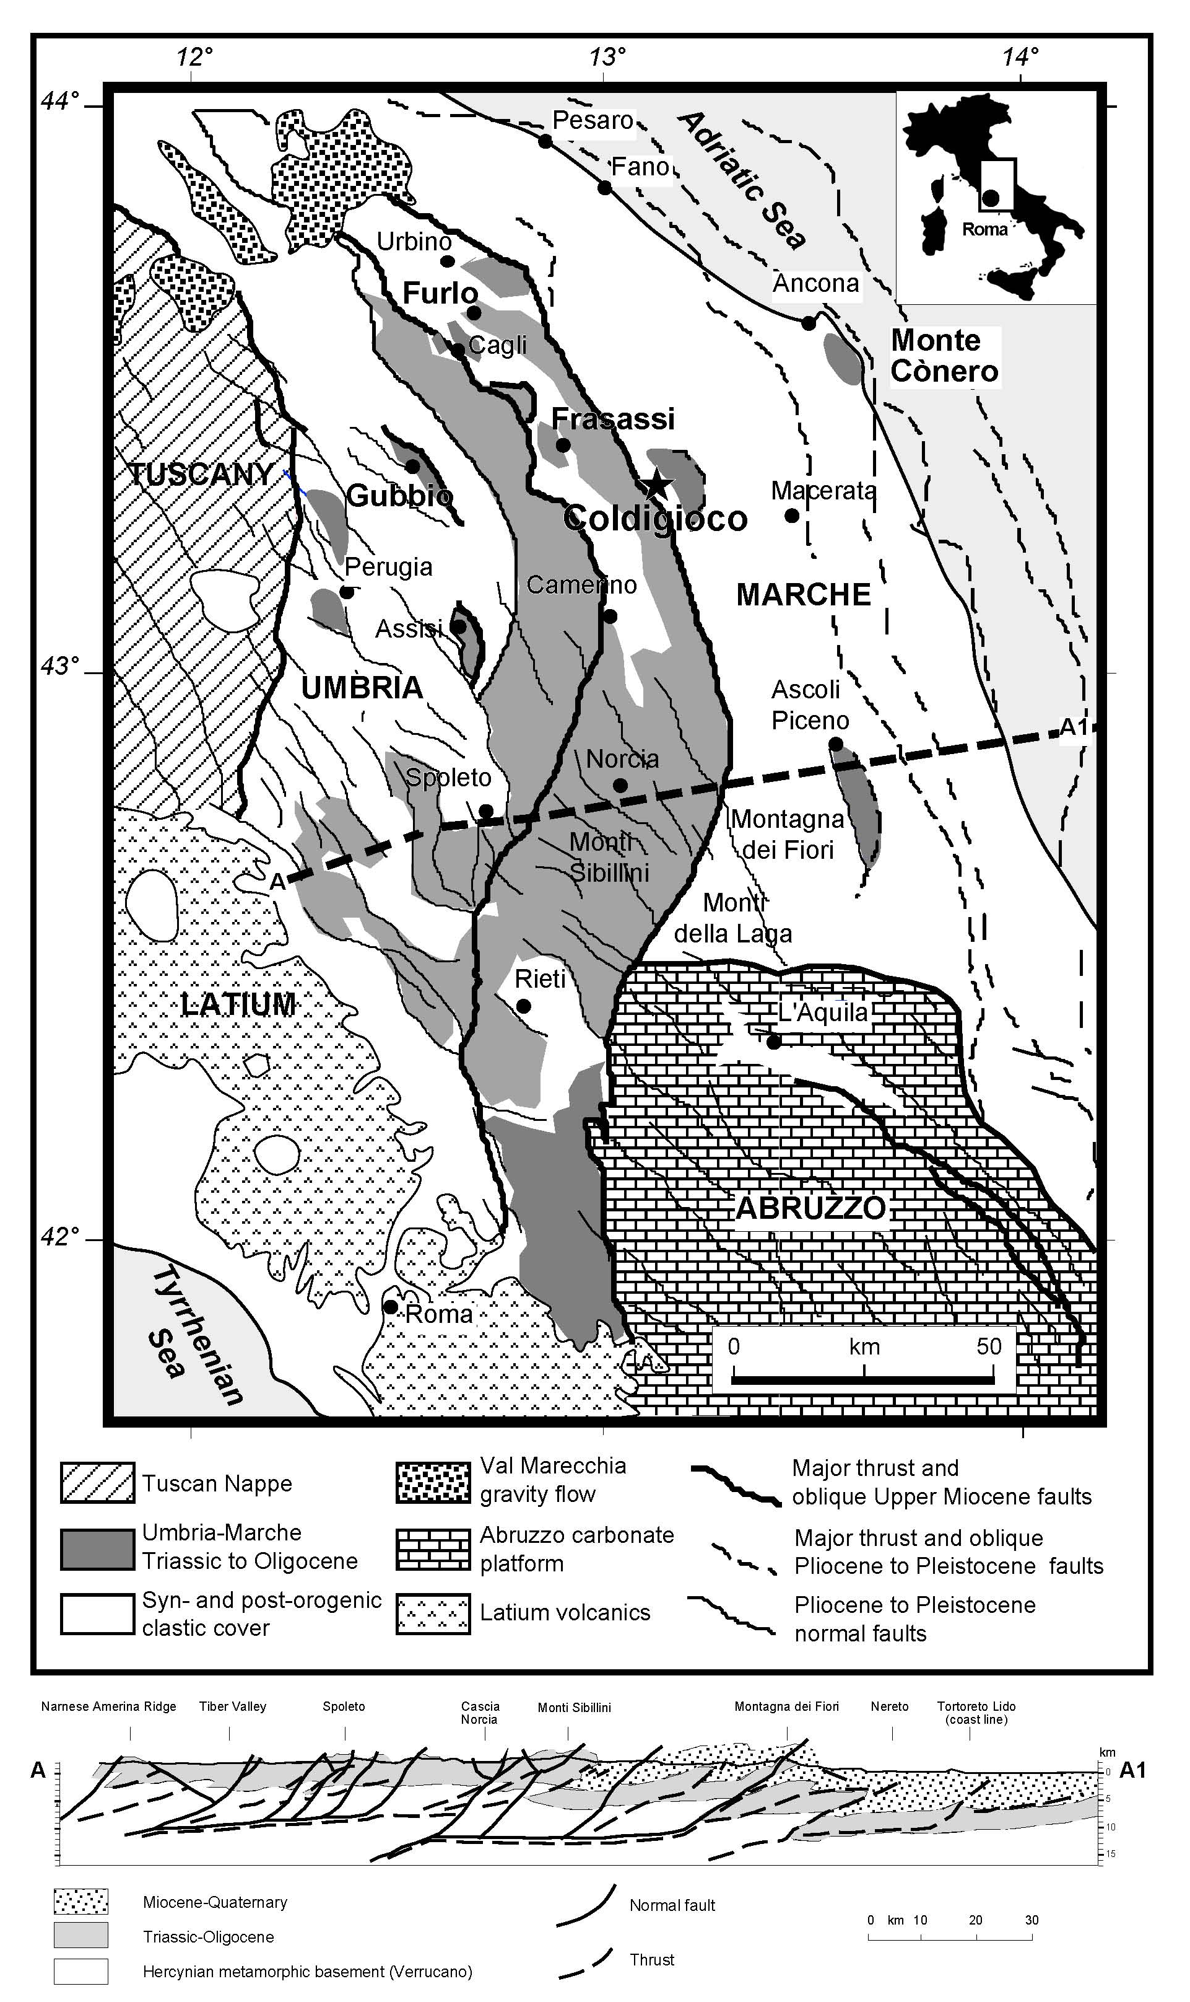
Fig. 2. Coldigioco and its setting in the Apennine Mountains of Italy
Nicolas Steno and the Origins of Stratigraphy
The Danish anatomist, Nicolas Steno (1638–1686), discovered the principles of stratigraphy in Tuscany in the 17th century (Cutler 2003; Alvarez 2009: ch. 5). The fundamental principle, which seems obvious today but was not obvious in the 17th century, is that what is on top is younger, unless there has been some still younger deformation or some other kind of complication. A second principle of Steno is that sedimentary rocks are laid down in roughly horizontal beds, so that if we now see inclined, vertical or even overturned beds, we can infer that there has been a deformational event after the deposition of the rocks that has tilted them. Thus, in order to understand the rock record in the pelagic limestones of the Apennines, we need to tilt the beds mentally back to their original horizontal orientation.
Paleontology and the Rock Record of Evolution
Writing in the 17th century and pioneering the study of history written in rocks, Steno had no way either to date or to interpret his rock history other than on
the basis of the account in Genesis. Thus, he recognized evidence for two periods of flooding in Tuscany, each of them marked by accumulations of sedimentary rock, and he attributed the first to the universal flood of creation and
the second to Noah's flood. It was not until the late 18th and early 19th century that geologists recognized that the fossils found in sedimentary rocks provide
a way of establishing the ages of those rocks, based on the changing shape
of the fossils, a record of evolution that Darwin later interpreted as the result of natural selection.
Early geologists worked out the sequence of changing, evolving fossils, put that sequence into a chronological time scale, and gave names to the different periods, which were characterized by different fossils. It was at this time that names for periods, like Jurassic and Cretaceous, were established. The fossils used by the early geologists were large enough to be studied with the naked eye, but unfortunately there was no way to determine the ages in years of
the fossils or of the rocks they were found in.
Jacopo Beccaria, Ambrogio Soldani
and the Beginnings of Micropaleontology
The large fossils studied by the early geologists, which are sometimes called macrofossils, can be identified with the naked eye but they are relatively uncommon and can be difficult to find. But it turns out that there are also tiny microfossils, produced by single-celled marine organisms, and they are extremely abundant in some sedimentary rocks, including pelagic limestones of Cretaceous and younger age. Microfossils were first studied by Jacopo Bartolomeo Beccaria in Bologna and Ambrogio Soldani in Siena in the 18th century (Alvarez 2009: ch. 5). After a century of careful study with microscopes, paleontologists now know a very great deal about the evolution of these tiny fossils, and in rocks where they are present, they are the dating tool of choice.
Gubbio and the Scaglia Limestones
Gubbio is a wonderful little medieval city in the Apennines of the Region of Umbria (Alvarez 2009: ch. 6). In the Bottaccione Gorge and the Contessa Valley, cutting through the mountains behind Gubbio, there are continuous exposures of pelagic limestones (Fig. 3). Several different rock units, or formations, can be studied in these two canyons, and the most intensely investigated is the formation known as the Scaglia Rossa. These rocks were first seriously studied by the Italian geologist Guido Bonarelli, at the turn of the 19th to the 20th century. At the time, these limestones were very strange and puzzling. They did not contain macrofossils and thus were difficult to date, and their whole character was completely foreign and unfamiliar to the geologists like Bonarelli. We now understand the reason: most pelagic limestones still lie inaccessible beneath the floor of the ocean and it is only in rare situations like
the Apennines that any pelagic limestones have been lifted up above sea level to where geologists can easily study them.
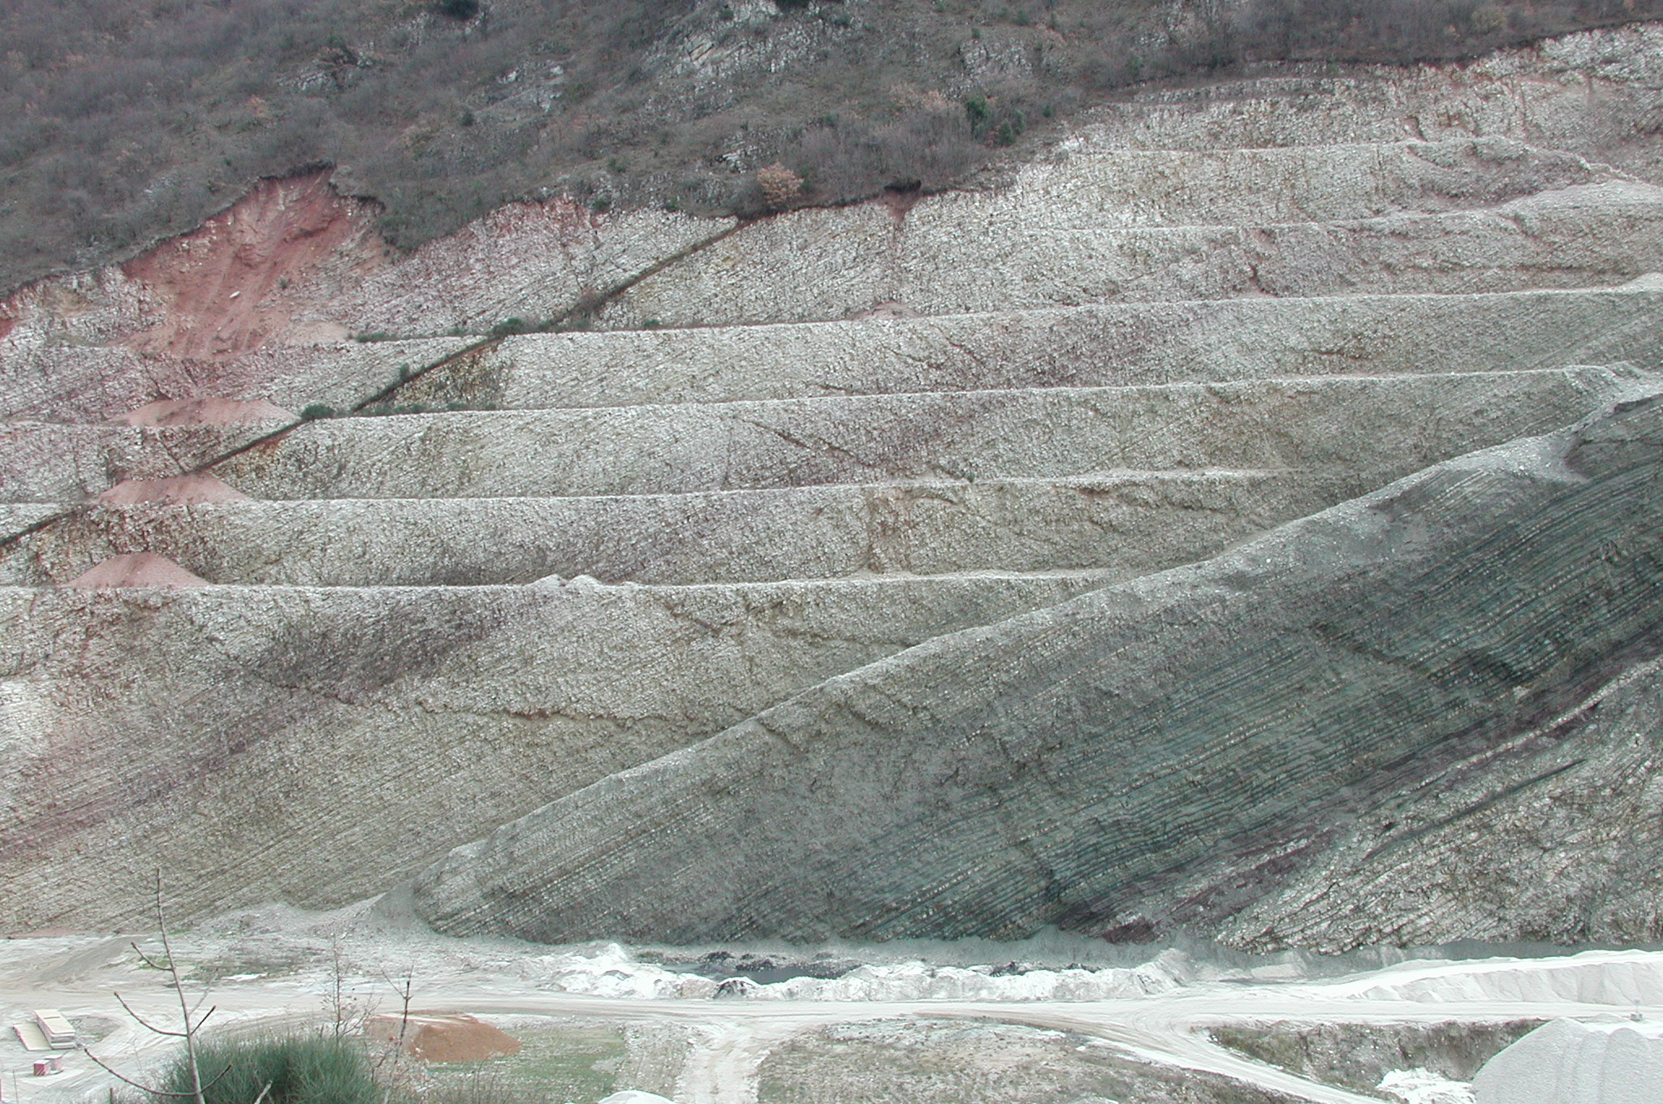

Fig. 3. The Vispi quarry in the Contessa Valley near Gubbio. The beds slant, or ‘dip’, gently to the left, whereas the horizontal lines are quarrying terraces. The thin black band in the upper left is the Bonarelli Level, representing an oceanic anoxic event 94 million years ago. The pelagic sediments in this photograph record about 40 million years of Earth history
However, since the 1930s, and especially since the 1960s, pelagic limestones have been better and better understood, through very careful studies by large numbers of geologists and paleontologists who have been drawn to the remarkable historical record preserved in these rocks. Although pelagic limestones are exposed all over the Apennines of Umbria and Marche, it is the splendid outcrops of Gubbio that have attracted the most attention and have yielded
the most abundant historical information (Fig. 4).
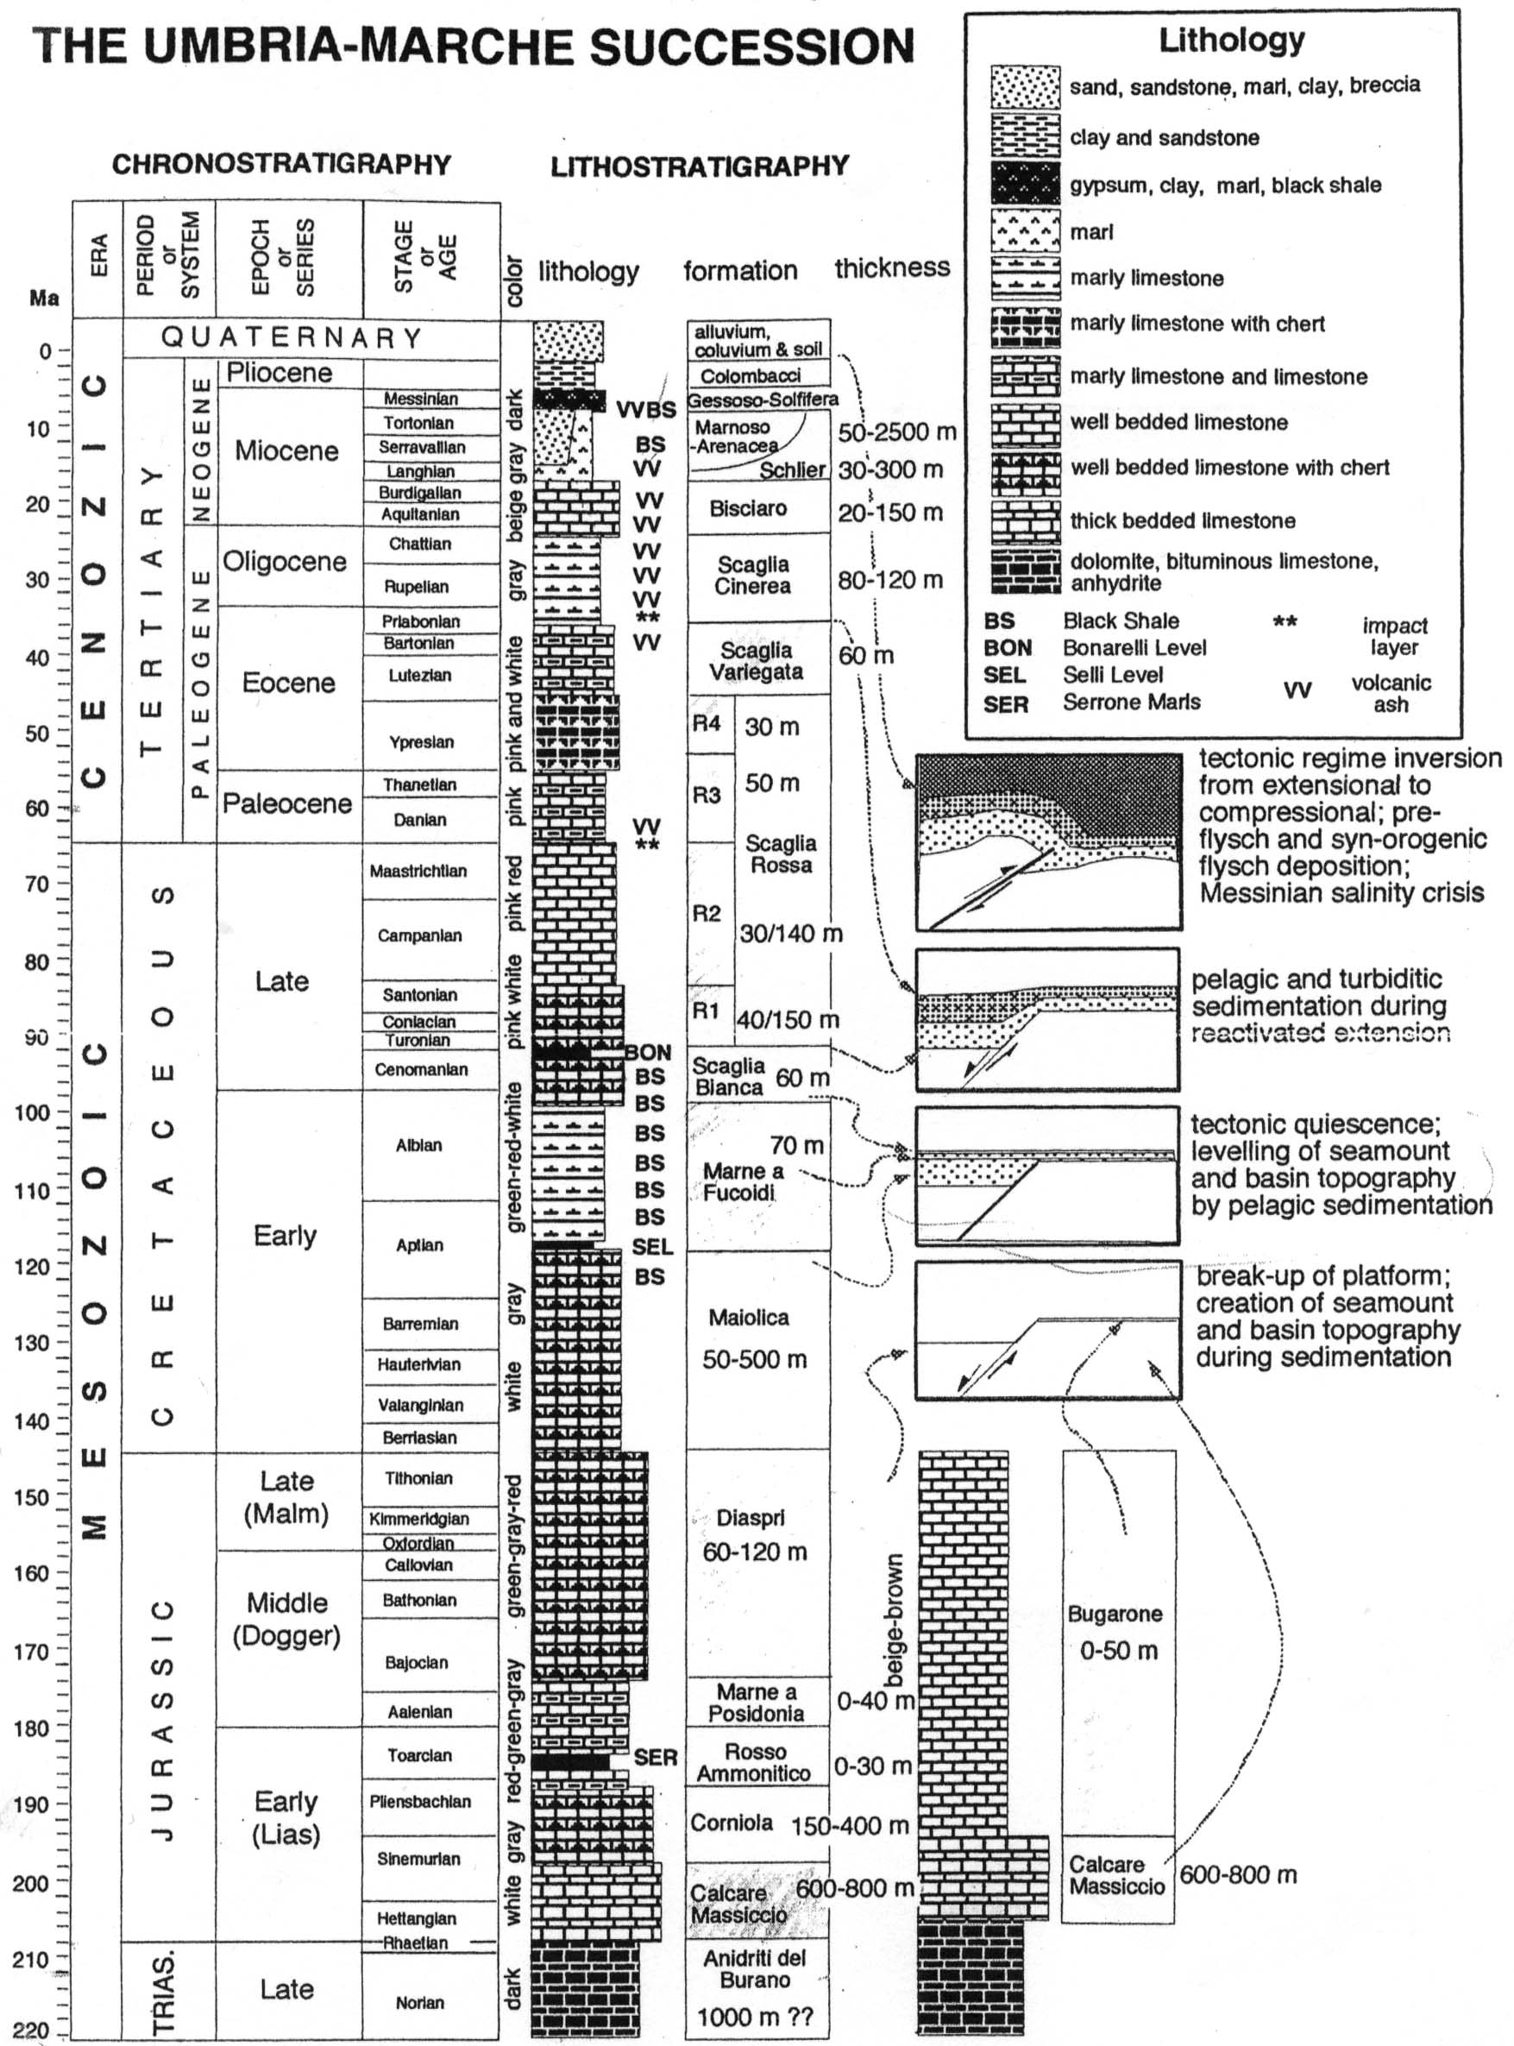

Fig. 4. A time-chart, or stratigraphic column, showing schematically the main features of the limestone sequence of the Umbria-Marche Apennines. Two important features to note are that (1) geologists and paleontologists draw their diagrams with younger rocks at the top, because that is the way they occur in nature, and (2) this diagram is scaled to time in millions of years ago (Ma); other widely-used diagrams are scaled to thickness in meters, which is what we observe in the field. From left to right the diagram shows ‘Chronostratigraphy’,
the standard names and dates into which geologic time has been divided by international agreement, ‘Lithostratigraphy’, the kind of rocks present and their local names and thicknesses, and sketches indicating the environment in which they were deposited
Isabella Premoli Silva and the Evolution of Foraminifera
Although macrofossils are vanishingly rare in the Scaglia limestone, it turns out that microfossils are extremely common. But at first they were very hard to use. Paleontologists are accustomed to working with whole fossils, or whole microfossils, that they can study in three dimensions, either with the naked eye or with the microscope. Unfortunately, the Scaglia pelagic limestones are very hard, and you cannot get the microfossils out whole or intact. In the 1930s, Otto Renz found that if he made a thin section, gluing a slab of limestone onto
a glass slide and polishing until it was very thin, he could study the microfossils in a two-dimensional slice (Fig. 5). It was not as satisfactory as studying loose microfossils in three dimensions, but Renz began to learn how to identify them, and in the 1960s, Isabella Premoli Silva and Hans-Peter Luterbacher perfected this way of identifying microfossils.
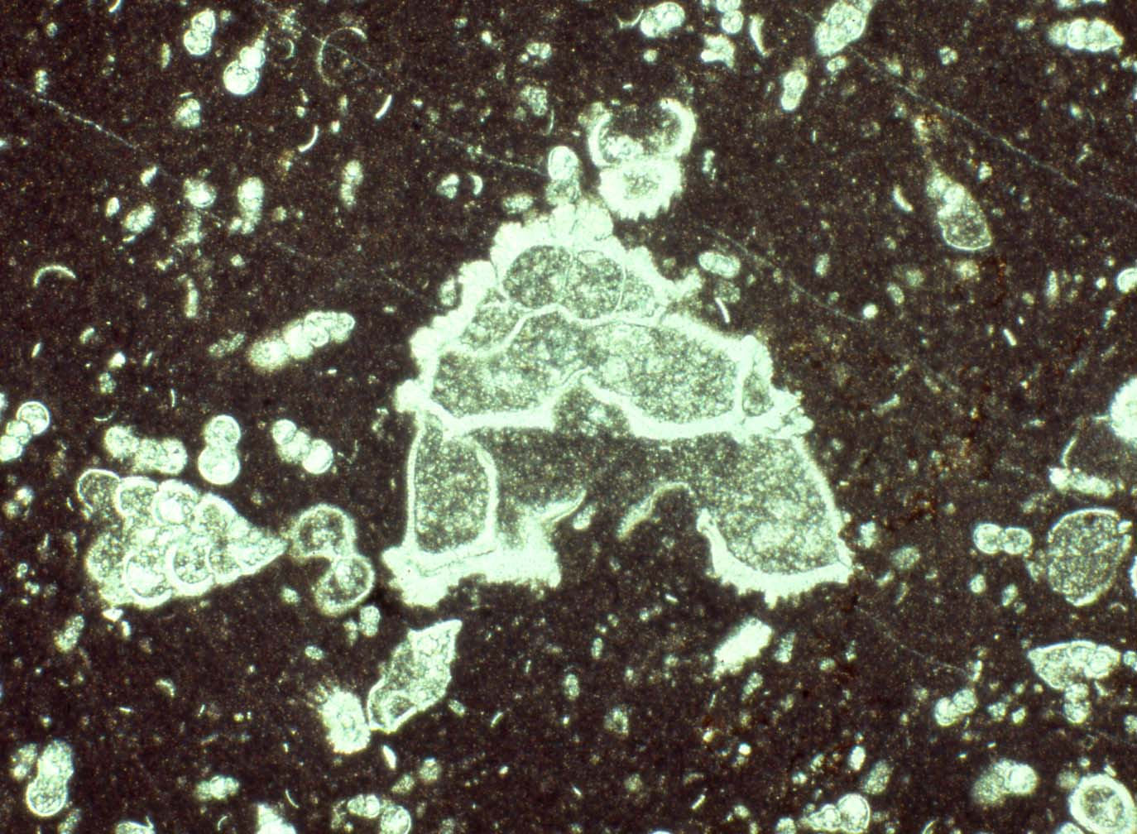

Fig. 5. Microfossil (the largest is the foraminifer Globotruncana contusa, 1 mm across) seen in a microscope view of a thin section from the Scaglia limestone at Gubbio
Meanwhile, other micropaleontologists had found that microfossils provide an extremely useful way of determining the ages of sedimentary rocks. So once Premoli Silva and Luterbacher had figured out how to identify the Scaglia microfossils, they were able to determine in detail the age of the pelagic limestones at Gubbio. Bonarelli's frustration at not being able to date these rocks was overcome at last, and it turned out that the Gubbio pelagic limestones were deposited over a time interval of almost 200 million years. This was a historical record of remarkable extent!
Gubbio and the Origin of Magnetostratigraphy
Geologists soon found out that the Gubbio limestones record more than just
the evolution of microfossils. In the 1970s, paleomagnetists discovered that these pelagic limestones also record the direction of the Earth's magnetic field at the time they were deposited. It is as if the limestones contained fossil magnetic compasses that can be read by sophisticated instruments in the laboratory. One of us (WA) was involved in this work, studying the magnetic record of the Gubbio limestones (Alvarez 2009: ch. 6). A few years earlier, geologists had discovered that the Earth's magnetic field reverses every now and then – every few tens of thousands of years to few millions of years – and that these magnetic reversals are recorded in the Earth's ocean crust because of seafloor spreading. The pattern of magnetic reversals in the ocean crust could be read by magnetometers towed behind ships or airplanes crossing the oceans, but there was no way to date those reversals.
However, at Gubbio, we realized that the limestones that record the magnetic reversals are full of the tiny microfossils that provide our best tool for dating sedimentary rocks! Through the 1970s and into the 1980s, the work of numerous geologists and paleontologists at Gubbio and nearby parts of the Apennines made it possible to determine the reversal history of the Earth's magnetic field over 150 million years. That was one of the first steps in developing the field now called magnetostratigraphy, in which the record of magnetic reversals has been used all over the world as a second major dating tool, to supplement the use of microfossils.
Iridium and the Rock Record of Mass Extinction
While collecting samples for the paleomagnetic research, we became ever more familiar with the stratigraphy of the Scaglia limestones. A prominent feature that attracted our attention was the boundary between the Cretaceous and Tertiary periods of geological time. Geologists have long known that this boundary at least approximately marked the extinction of the dinosaurs and of many other groups of animals and plants, but they did not know whether that extinction had been sudden or gradual. In the Gubbio sequence, the boundary was very abrupt, marking the near extinction of the microfossils known as the foraminifera.
In an attempt to understand what had happened at that abrupt extinction in the Gubbio strata, we collected samples across the boundary and measured them for iridium, a marker for extraterrestrial material. To our surprise, the amount of iridium was remarkably high, and after considering many possible explanations, we concluded that the anomalous iridium was the result of impact of a very large extraterrestrial object – a comet or an asteroid – on the Earth, causing the mass extinction of dinosaurs and the near extinction of foraminifera (Alvarez 1997). In 1991, the very large crater that resulted from that impact was discovered beneath the surface of the Yucatán Peninsula of Mexico. Although a few paleontologists have continued to dispute this interpretation, it has now been confirmed to the satisfaction of almost all the scientists who have studied the matter in detail (Schulte et al. 2010). And so another major piece of historical information was extracted from the Scaglia limestones.
Radiometric Dating and the Ages of Rocks in Years
The sequence at Gubbio provided yet another piece of historical information when, during the collection of samples for paleomagnetic studies, we discovered that at a few levels there were concentrations of mica grains and other minerals that could only have come from explosive volcanic eruptions and have been carried by the winds to the site of deposition of the Scaglia limestones. One of us (A.M.) led the research effort in which the volcanic mineral grains from these levels were dated on the basis of radioactive decay (Montanari and Koeberl 2000).
This was a remarkable opportunity, because none of the minerals in
the normal pelagic limestone can be dated radioactively. However, the volcanic mineral grains were indeed datable, and the dates obtained gave the age of
the volcanic eruption, and thus also of the level in the limestone where the mica grains were found, because the grains must have been carried by the wind to their site of deposition in a geologically instantaneous interval of time. Thus we were able to obtain ages in years for a number of levels within the sequence of microfossil zones and paleomagnetic reversals. It was the first time that all three of these methods of dating rocks – fossils, magnetic reversals and radioactive dates – had been tied together. It was a critical contribution to the development of the modern geological time scale.
The Geological Time Scale
Through stratigraphic studies like those at Gubbio, carried out by geologists and paleontologists all over the world, the geological time scale has been worked out in detail and formalized at an international level of agreement. Every few years, a new and updated version of the timescale is published.
The most recent was published in 2004 and edited by Gradstein et al. (2004). Additions and revisions since that time are available on the web at this address: https://engineering.purdue.edu/Stratigraphy/index.html
Although superficially the geological time scale units look like the kinds of periodizations that historians use to organize their narrative accounts of human history, the geological time scale is in fact quite different. In particular, the geological time scale units, like Jurassic and Cretaceous, have been agreed upon at an international level, and have been formally established at specific geological outcrops chosen after exhaustive consideration and debate. The difference between geological and human-history periodizations is considered by Alvarez
et al. (2009).
Cyclostratigraphy and the Future of
the Geological Time Scale
In the 2004 Geological Time Scale most numerical dates are given with a precision of 1 million years, 100,000 years, or 10,000 years, depending on the quality of information available for that particular time-unit boundary. As people working on the time scale move towards the next version, there is some hope that it may be possible to calibrate the history of the Earth with a precision
of 1000 years, back to about 100 million years ago. This extraordinary development comes from the relatively new field of cyclostratigraphy, in which stratigraphic rhythms are being tied to the calculated cyclicities of the Earth's rotation and its orbit around the Sun – rhythms that are known as Milankovitch cycles (Kuiper et al. 2008). In the fall of 2010, a conference of mainly European scientists, held at the Geological Observatory of Coldigioco, laid the groundwork for this next geological time scale, with the unprecedented chronological precision that may be achievable.
Because of the richness of the historical record of the pelagic limestones of the Apennines, it has been possible to tie together in great detail many aspects of the history of the Earth throughout the time interval in which these rocks were deposited. With cyclostratigraphy offering the prospect of dating with
a resolution on the order of a thousand years, an unprecedented clarity of understanding of Earth history is emerging, and this synthetic effort is being called ‘integrative stratigraphy’.
Bringing the Earth History and
Human History together on ChronoZoom
One of the central problems of Big History is how to integrate the historical record of humanity, in years, with the record of Earth and life, in millions of years. Geologists and paleontologists studying pelagic limestones and other rock records have produced thousands of graphical representations of different aspects of Earth and life history, and in those diagrams human history is invisibly small at the most recent end. A logarithmic scale can be used to show all of Big History on a single diagram, but this introduces such extreme distortion that log scales are rarely used.
A new approach proposed by Roland Saekow, holding much promise for Big History, is to use zoomable computer graphics, with a diagram showing all of history at true scale, and allowing a historian to zoom in and out to examine any portion of the diagram, from all of the cosmos to a single day. To do this, we are developing ‘ChronoZoom’ in collaboration with Microsoft Research (Saekow, this volume). We intend for it to be a useful tool for all Big Historians. The first version of ChronoZoom is available on the web: http://eps.berkeley.edu/ ~saekow/ chronozoom/
References
Alvarez W. 1997. T. rex and the Crater of Doom. Princeton, NJ: Princeton University Press.
Alvarez W. 2009. The Mountains of Saint Francis. New York: W. W. Norton.
Alvarez W., Claeys P., and Montanari A. 2009. Time-scale Construction And Periodizing in Big History: From The Eocene-Oligocene Boundary to All of the Past. Geological Society of America Special Paper 452: 1–15.
Brown C. S. 2007. Big History: From the Big Bang to the Present. New York: New Press.
Christian D. 1991. The Case for ‘Big History’. Journal of World History 2: 223–238.
Christian D. 2004. Maps of Time. An Introduction to Big History. Berkeley: University of California Press.
Christian D. 2008a. History, Complexity and the Chronometric Revolution. Revista de Occidente 323: 27–57. In Spain (Christian D. Historia, complejidad y revolución cronométrica. Revista de Occidente 323: 27–57).
Christian D. 2008b. This Fleeting World: A Short History of Humanity. Great Barrington, MA: Berkshire.
Cutler A. 2003. The Seashell on the Mountaintop: A Story of Science, Sainthood, and
the Humble Genius Who Discovered a New History of the Earth. New York: Dutton.
Gradstein F., Ogg J., and Smith A. 2004. (eds.) A Geologic Time Scale 2004. Cambridge: Cambridge University Press.
Hedman M. 2007. The Age of Everything: How Science Explores the Past. Chicago: University of Chicago Press.
Hsü K. J. 1983. The Mediterranean Was a Desert. Princeton, NJ: Princeton University Press.
Kuiper K. F., Deino A., Hilgen F. J., Krijgsman W., Renne P. R., and Wijbrans J. R. 2008. Synchronizing Rock Clocks of Earth History. Science 320: 500–504.
Montanari A., and Koeberl C. 2000. Impact Stratigraphy: The Italian Record. Lecture Notes in Earth Science, Series no. 93. Berlin: Springer.
Schulte P., Alegret L., Arenillas I., Arz J. A. et al. 2010. Impact and Mass Extinction: Evidence Linking Chicxulub with the Cretaceous-Paleogene Boundary. Science 327: 1214–1218.
Spier F. 1996. The Structure of Big History: From the Big Bang until Today. Amsterdam: Amsterdam University Press.
Spier F. 2010. Big History and the Future of Humanity. Chichester: John Wiley and Sons.

