16
Brain Stretching: Art and Big History

Paula Metallo

Abstract
‘The particular combination of art and geology is nothing new. It was customary for geological surveying teams to include at least one artist. One great example is the artist, geologist and writer, Clarence Edward Dutton. His accomplishments remind us that we have fallen into an age of specialization. In order to deal with a universe expanding at an incredible rate we have a tendency to rely more and more on specialists with narrow shafts of knowledge and skills. And while specialists are necessary, the tendency to depend on them to the exclusion of all is dangerous. Somebody must integrate and synthesize what we know about ourselves and the world in order to prevent social, cultural, and even personal fragmentation’. Richard Shelton wrote this as the introduction to the book Art and Geology (1986). It clearly describes, already twenty-five years ago, the objectives of this article to express in what ways Art can be
a means of describing pattern and encourage openness to stretching the brain to comprehend inter-connectivity, and how Big History has the tools in hand to help implement a whole picture, interdisciplinary approach to learning.
Art, as well as ideas about art, can be shaped by new places – just as people can be shaped by such experiences. Relating to and exploring other ways of seeing things ultimately lead to the addition of a new weft in the fabric of our human existence. Educator Micheal Schneider describes the progression in
A Beginner's Guide to Constructing the Universe:
Today we are emerging from the grip of literalism, mere quantitative measurement, and analysis. Where we saw ‘things’, nouns and objects instead of ‘processes’. The Hopi language retains this vision, having no nouns. (I am not wearing a shirt, I am ‘shirting’). Likewise our word ‘cosmos’ refers to ‘outer space’. But the word derives from the Greek Kosmos (signifying ‘embroidery’), which implies not a universe like a huge room filled with disconnected noun-things but the harmony of woven patterns with which the universe is embroidered and moves (Schneider 1995: xxiv–xxv).
To me, the most fascinating aspect of modern culture and Big History is
the awareness of interconnectedness, the weaving of everything together on our planet and beyond, providing a new place to contemplate.
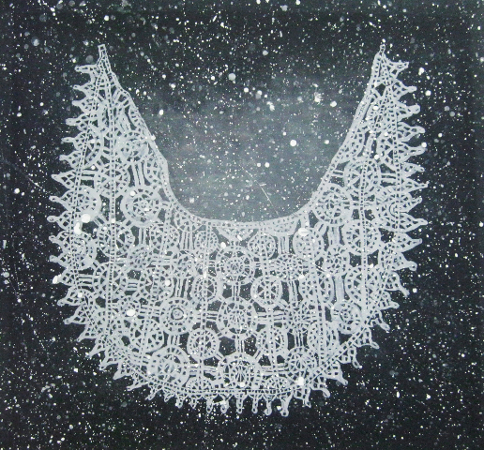
Fig. 1. Paula Metallo, Italy, Kosmos, acrylic on silk, 60x60 cm
Our Universe demonstrates this perspective, which today's communication systems imitates, allowing us the vantage point from which to appreciate
the fullness. Anything anyone can point to in nature is composed of small patterns, which are part of large ones. The new age of communications can provide us, no matter where we find ourselves, with a means of transcending our own patterns, of standing back from a mosiac. Over 1500 years ago, St. Augustine of Hippo wrote in his dialogue De ordine I(2):
If someone had a vision so restricted that, on a floor covered with vermicular mosiac, his gaze could take in no more than the width of a single tessera, he would accuse the artisan of not knowing how either to order or arrange his materials, and would believe the variety of stones utilized to be nothing but a confused jumble – all because of an incapacity to see and grasp how the whole picture in it's fullness and harmony constitutes a single and beautiful image.
This brain-stretching distance allows us to pick out patterns, and then sample and compare supposedly disparate things, elaborating upon them, sometimes combining them gradually and imperceptibly into each other, and at other times just setting them side by side. Above all, this ‘standing back’ pushes us to feel the scale and the way in which we consider ourselves in relation to the world.
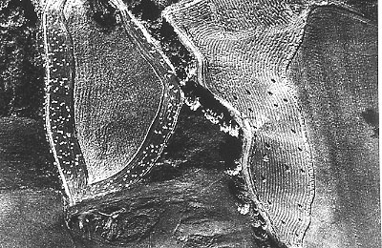
Fig. 2. Mario Giacomelli, Italy, La Terra, 1954
I experienced this personally as an American living in Europe. The interconnectivity and ease of worldwide communications has changed the experience of the immigrant or expatriate, as well as that of their host communities. The result is the widespread seeding of individuals, with cross-cultural backgrounds in many countries, who are trying to find ways to join the new without giving up the old, trying to unify geographical and historical extremes, trying to place and display past atrocities, and trying to reveal as visible the things that were once invisible. It is a critical correspondence between global and local with enormous creative potential.
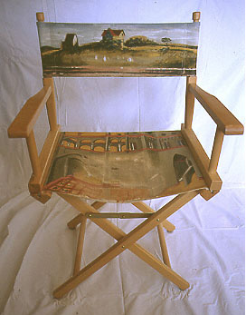
Fig. 3. Paula Metallo, USA, Place, acrylic, 1995
We, artists, today believe that we are at the cross-roads and the time of dynamic change in how we privilege the optical. Art continues to evolve modes of expression and integration of perception beyond the visual. As video artist Bill Viola remarks:
Fifty years from now I do not think optical reality is going to be an issue in visual communications anymore. Experience is so much richer than light falling on your retina. You embody a microcosm of reality when you walk down the street – your memories, your varying degrees of awareness of what's going on around you, everything we call the contextualizing information. Representing that information is going to be
the main issue in the years ahead. We are beginning to shift into a category of information itself as the main conveyor of reality. And the transition periods, when the truth becomes embodied in multiple conflicting forms, are always the most interesting.
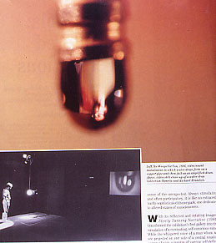
Fig. 4. Bill Viola, USA, He Weeps for You, Video, 2003

Our perspective is linked to understanding through gateways not limited to
the eye. How the world meets our mind, how fast we feel time, and how we digest the pressing, continuous stream of suggestion and information coming at us are also issues for artists today. Mark Kingwell, in ‘Fast Forward’, an article from Harper's Magazine, compares the ecstatic speed of the human in a machine with that of the euphoria of a running human:
The man behind the wheel feels nothing but a mindless; futureless impatience, a desire to go faster that exists only in the present... The running man feels the many past, present, and future costs of speed, the burning of his lungs, the fatigue in his legs. He must play mind games with himself, set intermediate goals, and then set new ones, knowing that eventually he will reach a point where the pain slips away (Kingwell 1998).
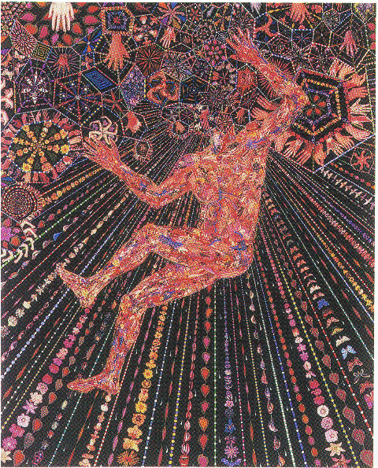
Fig. 5. Fred Tomaselli, USA, Ecstacy and Altered States, leaves and collage, 2005
These interactions that condition us as spectators of art raise questions of process for the artist and for others teaching and sharing knowledge and viewpoint, especially from a Big History perspective.
While considering these challenges to the human spirit and the meaning and purpose of art, I remembered a parenting book I used to consult periodially, Raising Good Children: How to help your child develop a lifelong sense of honesty, decency, and respect for others by Dr. Thomas Lickona, a developmental psychologist:
There are two basic ways to relate to a child's stage of moral reasoning. 1) You can go with the flow, or 2) You can challenge it. When you go with the flow of a child's present stage of reasoning, you meet them where they are. You try to get their cooperation by talking the language of their stage, by fitting into the way they think about the world. When you challenge a child's present stage of reasoning, you try to get them to look at the world in a new way. You make them work at the cutting edge of their minds. You make them reach and stretch. If we were always challenging our kids to develop, we would wear them and ourselves out.
If we were always accommodating, they would have no reason to develop. Both approaches are essential (Lickona 1994: 99).
Environments for learning that incorporate the tension of accommodation and challenge to facilitate the expansion of human perception are needed.
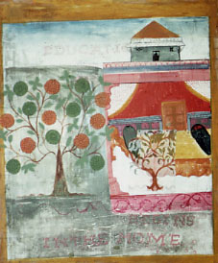
Fig. 6. Paula Metallo, USA, Education Begins in the Home, 1992
The Osservatorio Geologico di Coldigioco (Geological Observatory of Coldigioco) in the Marche region of eastern Italy serves as such a place. It is an interdisciplinary laboratory where science and the arts connect and cross-pollinate. The processes and perspectives of both are honored in our class content and experiences. For example, when I taught drawing to our geology students from Carleton University, I considered how to approach scientific thinkers in a way that would allow them to learn how to draw more accurately. Beginning with anatomical drawing exercises, I built on their already existing skill-sets of recording data – counting and measuring lines and angles – that they had honed in stratigraphy classes, as well as their sharply developed skills of scientific observation. Geology's perspective includes an awareness of deep time. Comprehending millions of years, instead of mere hundreds or thousands of years, means that there is much data to incorporate. Reconciling the ‘slow motion’ of mountain growth with the idea that everything is in constant change opens an exploration of the expression of what is impermanent and enduring.
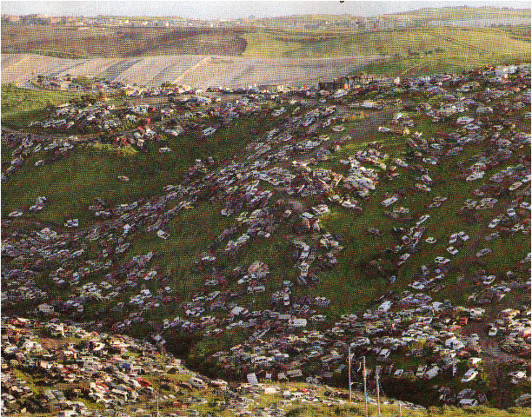
Fig. 7. Aernout Mik, Holland, Insite 05, Osmosis and Excess, 2005

Challenging students at Coldigioco to utilize their scientific perspective to create art has been a rewarding and productive experience. You can see a sample of our efforts on the website and blog, Geology in Art, at http://www.
geologyinart.blogspot.com/.
I would advocate that an art museum is a forum for exhibiting new things, while accommodating and challenging the human spirit to grow. A viewer's subjectivity can be honored, with all its idiosyncrasies, while it is expanded beyond current cultural and existential presumptions. The museum can be a setting in which our skills as ‘art storytellers’ can be nurtured through interaction with the exhibits, guiding us through historical and personal processes, showing us where we may be headed.
Studying only our history as living things on this planet is like observing no more than the width of a single tessera in a mosiac. Adding the history of our planet in the universe challenges us to expand, reach out and position ourselves more appropriately in the whole beautiful picture. The role of art is to accommodate and challenge us to trust our personal responses, feed our curiosity, and encourage openness to stretching the brain to comprehend this interconnectivity. Through art we can become active describers and comparers of our stories, illuminating our small, patterned part of the Universe.
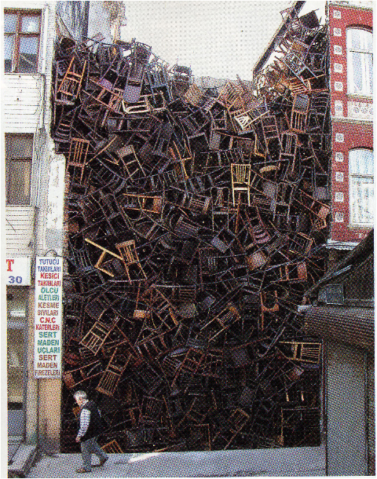
Fig. 8. Doris Salceda, Brazil, Our Place in the Universes, 2003
References
Kingwell M. 1998. Fast Forward: Our High-Speed Chase to Nowhere. Harper's Magazine (New York) 296: 37–48.
Lickona T. 1994. Raising Good Children: How to Help Your Child Develop a Lifelong Sense of Honesty, Decency, and Respect for Others. New York: Bantam Books.
Schneider M. S. 1995. A Beginner's Guide to Constructing the Universe. New York: Harper Perrenial.
Shelton, R. 1986. Foreword. Art and Geology Expressive Aspects of the Desert / R. D. Abbey and G. W. Fiero. Salt Lake City: Peregrine Smith Books.

See Fig. ‘Particular, mosaic, Pompeiano, year 79 CE’ in the electronic version of the Almanac at http://www.socionauki.ru/almanac/issues/evolution_2_en/#metallo
A version of this appears in Photoquotations.com: http://www.photoquotations.com/a/707/ Bill+Viola.
Appreciation is expressed to Penelope Markle for editorial assistance.

