18
A Little Big History of Tiananmen∗

Esther Quaedackers

Abstract

This contribution aims at demonstrating the usefulness of studying small-scale subjects such as Tiananmen, or the Gate of Heavenly Peace, in Beijing – from a Big History perspective. By studying such a ‘little big history’ of Tiananmen, previously overlooked yet fundamental explanations for why people built the gate the way they did can be found. These explanations are useful in their own right and may also be used to deepen our understanding of more traditional explanations of why Tiananmen was built the way it was.
Introduction
Big History, as its name implies, aims to study all of history, from the Big Bang until today. A Big History perspective therefore enables us to integrate knowledge from disciplines, ranging from Astronomy to the Social Sciences and the Humanities into a unified large-scale overview. Big History, however, does not only allow us to create a large-scale overview; it also enables us to study small-scale subjects in new ways. When studying small-scale subjects, applying a Big History lens can help us to focus on the most fundamental patterns that underlie certain processes. These patterns can sometimes be easily overlooked, exactly because they are fundamental; they can seem ubiquitous and as a result not very special and not worth exploring. This may be particularly the case in certain Social Sciences and the Humanities. In such fields of study, many remarkable details abound that can attract attention much more easily than ubiquitous patterns can. Therefore, studying small scale subjects from a Big History point of view, or in other words, studying ‘little big histories’, may be especially useful in these disciplines. I would like to try to demonstrate this usefulness by analyzing a single building with the aid of Big History.
For this purpose, I could have selected any building. For practical and personal reasons, I chose Tiananmen, or the Gate of Heavenly Peace, in Beijing. This choice is a practical one, because, due to the gate's iconic status, many readers will be familiar with it. Tiananmen is also a personal choice; ever since I first visited China, I have been wondering about the reasons for the differences between traditional Chinese and European architecture.
Fundamental patterns
A little big history of Tiananmen has to start with the observation that the building is extremely special. Tiananmen is not only a remarkable building; the fact that it exists as a building is extraordinary. Buildings are a very rare product of nature. They are only constructed by living things, since only living things actively create environments that are beneficial for their own survival. Life is very scarce in our Solar System and probably even scarcer in our Universe. Furthermore, not all of these scarce life forms actually build things. Most famously, insects, spiders, birds and a few mammals build, but many other organisms do not. Why would these animals build whereas so many other species do not?
The answer to this question may be quite simple. The reason why few life forms build may be that building can be expensive. The act of building itself can require a lot of energy. Moreover, there are hidden costs to building that can add up quickly. Using buildings can be costly, particularly for animals that roam wide areas to find enough food. If these animals build stationary structures, they may need to spend a lot of energy either travelling large distances in order to reach and use their buildings, or rebuilding their structures frequently. If they build mobile structures, they may need to spend large amounts of energy moving them around. The ability to build can be costly as well. For instance, learning how to build may require energy in the form of time, effort and larger energy consuming brains.
Because building can be expensive, in many situations there may be cheaper ways to deal with certain problems. Organisms can, for example, grow fur or produce antifreeze proteins (Ebbinghouse et al. 2010: 12210–12211) in order to protect themselves from the weather, instead of building a shelter. They can grow spikes, produce venom or simply flee to protect themselves from enemies, instead of building a protective structure. They can grow claws to catch prey, instead of building a trap. Or they can grow colorful feathers or behave aggressively to impress members of their own species, instead of building an impressive structure. Only in some situations, can building be the best option. It seems to me that there are three types of situations in which it can be worthwhile for animals to build.
First of all, building can be a good idea for animals that frequently stay in a specific place. Such animals do not need to spend lots of energy travelling to and from their buildings, rebuilding, or moving buildings. This may be the reason why birds or mammals that need to protect immobile offspring often build nests or other structures. In contrast, animal species that have mobile offspring seem to spend much less energy building elaborate structures. Rabbits that give birth to altricial young, for example, dig extensive burrows, while hares that produce precocial young do not build much. For more or less sedentary animals, such as certain eusocial insects and beavers, building may be worthwhile as well. For these animals, building is not only cheaper than for most other creatures, it is also more necessary. Organisms that stay at a fixed point can become an easy prey for predators once predators have found them. Moreover, being sedentary often requires food production or storage in the vicinity of the living location. Some bees for example store honey in combs, certain termites maintain fungi garden, and beavers build dams to create ponds full of fish. Such food supplies can attract thieves and can therefore create an even greater need for the sedentary animals to protect both themselves and their food. Because of the lower costs of and greater need for building, sedentary animals build pretty complex structures such as beehives, termite mounds, and beaver dams and lodges.
Secondly, building can be a good idea for animals that standardize their building routines. As pointed out by the British zoologist Mike Hansell, animals that do so do not need large energy-consuming brains (Hansell 2007: 71). The building behavior of certain caddisfly larvae can serve as an example. According to Hansell, the larvae start building by picking up any sand grain they can handle. Subsequently, the larvae perform two fixed tests to determine if the sand grain has the right shape and size. Only sand grains that pass these tests are used as building blocks for the larvae's houses. As a result, the larvae do not need to think about which sand grains they should select for their houses. They also do not need to think about how they should assemble their houses. Because they always use the same building blocks, they can assemble their houses the same way every time. Because the standardized building behavior of the caddisfly larvae is subject to evolutionary pressures, over the course of time the animals will start choosing the most suitable building blocks and applying the best assembly method. There is no need for the larvae to think about the best ways to build. Evolution thinks for them.
Animals that build with their own excretions have taken building standardization a step further. Just like the caddisfly larvae, they do not need to evaluate potential building blocks or think about assembly strategies, and therefore they do not need expensive, large brains. Additionally, the animals do not need to spend energy searching for and collecting building materials (Hansell 2007: 71). And, most importantly, over the course of time, the most energy efficient building excretions will evolve. Silk is perhaps the best example of such a remarkably energy-efficient building secretion. Silk enables all kinds of insects and spiders to build very strong cases and webs with relatively little material. Because such little material needs to be produced, building with silk is not too costly. Some spider species have reduced their building costs even further by recycling silk proteins; they eat their own webs after they have used them (Opell 1998: 621).
Lastly, building can be a good option for animals that use their structures as signals of fitness. Animals that do so, do not build in spite of the costs of building but because of these costs. By spending energy on buildings, and particularly on buildings that do not directly enhance their survival chances, they show other animals that they are fit. Or, in the words of the Israeli evolutionary biologist Amotz Zahavi: ‘The behavior suggests that if an individual is of high quality and its quality is not known, it may benefit from investing a part of its advantage in advertising that quality, by taking on a handicap, in a way that inferior individuals would not be able to do, because for them the investment would be too high’ (Zahavi 2003: 860).
Birds that build bowers may be the best example of animals that use building as a signal of fitness. Certain male bowerbirds build a maypole on a moss platform and often cover it with a large hut, which may weigh tens of kilos (Gould and Gould 2007: 234–244). Next, they collect up to hundreds of flowers, berries, fungi, sticks, stones or other conspicuous objects. They arrange these objects by type and color, and display them in and around their construction (Vogelkop bowerbird, see BBC – Wildlife Finder). The birds maintain their display with great care. They replace old objects with fresh ones and vigorously defend their bowers against other male birds' raids (Diamond 1988: 648). Obviously, construction of the bower, as well as its display and maintenance, requires tremendous amounts of energy. Developing the skills to do so requires energy as well. According to Hansell, juvenile male bowerbirds spend a lot of time studying how to build a proper bower and display. They work together on constructing the basic bower elements, construct partial bowers and dismantle them again, and they observe older males building-behavior and their bowers (Hansell 2007: 241). Birds that build bowers also have larger brains than birds that do not build bowers; they thus spend more energy on maintaining those brains (Madden 2001: 833). Male bowerbirds spend all this energy to attract a mate. Female birds seem to base their mate choice to a large extent on the male's ability to build and maintain a proper bower and display (Hansell 2007: 240). Apparently, this ability is deemed a reliable indication of the fitness of the male.
In sum, I think that building is rare because life generally only builds when it can reduce the costs of building, by becoming sedentary or by standardizing, or use these costs as a means of communication. Interestingly these three conditions seem to apply to almost all forms of human building. They apply to my own home, which I have invested in because I am there a lot. They apply to the houses across my street, which are decorated with cast iron ornaments that tell people something about the artistic taste and wealth of its builders. They apply to the apartment tower at the end of my street, which is clad with white standardized elements because such elements can be produced and handled efficiently. And they also apply to Tiananmen.

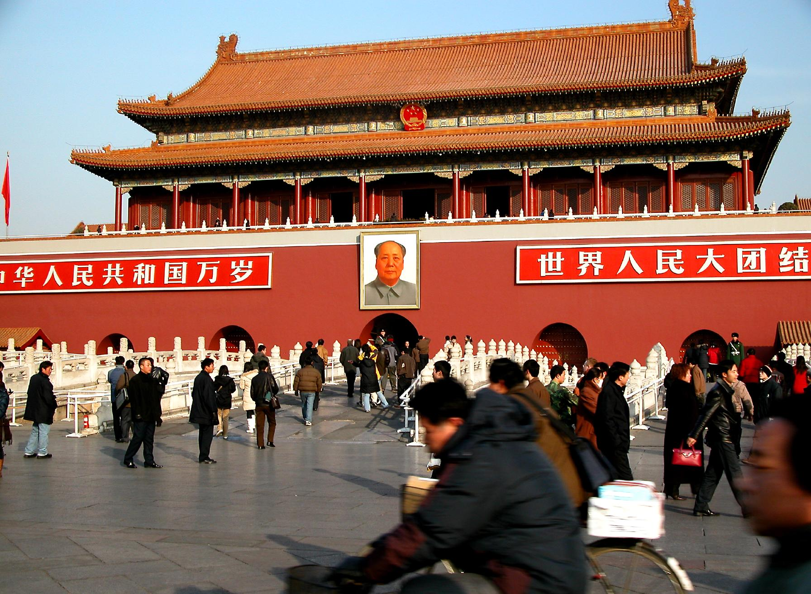
Fig. 1. Tiananmen (photo: Peter Morgan)
Application to Tiananmen
Before trying to explain how the patterns discovered in animal building apply to Tiananmen, I would like to provide some basic background information on the history of the gate (Aldrich 2006; Wu 2005: 56–68; and Zhu 2004). The history of Tiananmen can be traced back to the beginning of the Ming dynasty. In the early 14th century CE, the Yongle emperor ordered the construction of a capital that would later become Beijing. Inside of Beijing, a wall was then constructed around an Imperial City. The southern gate in this wall was called Chengtianmen. This gate was rebuilt by the Qing Shunzhi emperor in the mid-17th century, after it had been burned down following the fall of the last Ming emperor. The gate's design was altered and it received a new name: Tiananmen. Tiananmen was slightly remodeled once more in 1969 and 1970.
In my opinion, the fact that Chengtianmen and Tiananmen were built in the first place can be interpreted as an attempt at reducing building costs in Beijing. Let me explain. Because both the Yongle and the Shunzhi emperors lived in Beijing more or less permanently, the city attracted a lot of people and resources. The city therefore tended to attract enemies and thieves, as do termite mounds, beehives and beaver lodges. For the Yongle emperor, such enemies included the Mongols, whom he was trying to keep out of northern China (Mote and Twitchett 1998: 224–229), whereas for the Shunzhi emperor they included rebel forces whom he had ousted from Beijing as well as some remaining Ming armies (Peterson 2002: 83–89). But the emperors did not only face threats coming from outside their capital. There were threats from the inside as well. The Yongle emperor had made enemies by contesting the mandate of the previous emperor (Mote and Twitchett 1998: 184–205). The Shunzhi emperor had also been at the center of imperial power struggles and had made enemies by starting an anti-corruption campaign and a major fiscal reform (Peterson 2002: 101–116). All these external and internal threats created incentives to build defensive structures. But although the construction of such structures was cheaper for the two more or less sedentary emperors than it was for their nomadic neighbors or other animals roaming wide areas, it was not cheap.
In response to a greater need for costly defensive structures, the emperors may have tried to build a minimum number of structures to the greatest possible effect. They did so by ordering the construction of an elaborate assembly of walls. Because strategically placed walls protect a group of buildings, there is less need to fortify individual structures. This strategy is less expensive, since it requires less fortified surface area. It also provides better security than fortification of individual buildings. Because this arrangement allows for less spaces that are open to the general public, most common people were not able to come close to areas in which important people worked and lived or in which important resources were stored.
I think that it was for these reasons, as well as others, that walls dominated old Beijing. The wall of the Imperial City, with its Chengtianmen (later rebuilt as Tiananmen) was one of these many walls (Figs 2 and 3). It was enclosed by larger city walls, such as those of the Capital City and, to some extent, the Outer City. And it enclosed a number of smaller walled compounds, such as the Palace City (or Purple Forbidden City), imperial parks, important warehouses, and compounds in which princes, officials and important eunuchs lived and worked (Wu 2005: 58; and Zhu 2004).
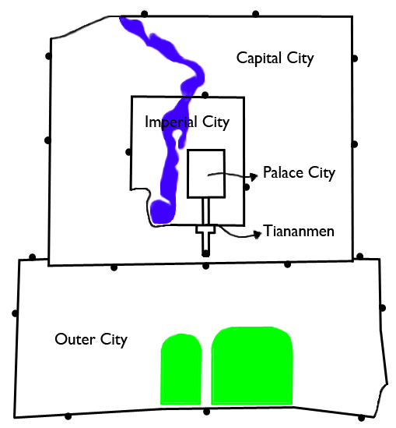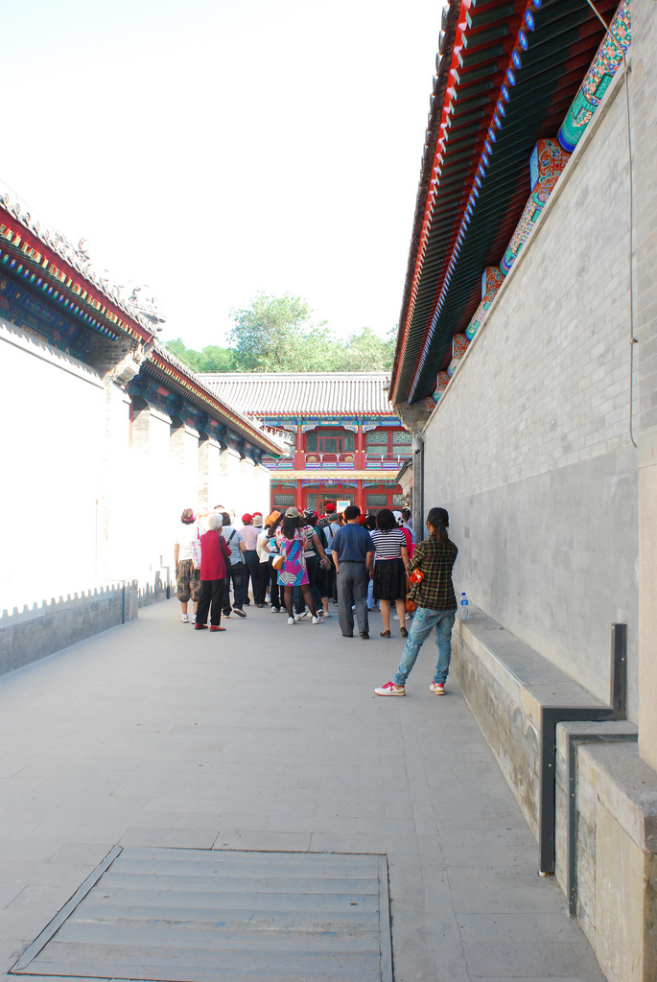
Fig. 2. The walls of old Beijing Fig. 3. Inside a walled compound
inside the Imperial City
(photo: CeciliaC/Flickr)
The emperors' choice to build walls around groups of buildings instead of fortifying individual buildings may have had some important consequences. It may have allowed the Yongle and Shunzhi emperors to use wood as the primary construction material for many buildings within Beijing's walls. In addition, it may have lessened the need to reduce the surface area of buildings within the city's walls. For instance, it may have been less necessary to merge several rooms into one larger or higher building; buildings consisting of only one or
a few rooms could remain small and low, thus exposing their users to a maximum amount of light and fresh air. As a result, attempts at reducing building costs may not only have led to the construction of walls and gates like Chengtianmen and Tiananmen, but may also have sparked a building tradition based on relatively small wooden one or two-story buildings. The watchtower that is part of Tiananmen can be seen as a product of such a tradition (Fig. 1).
The idea that the Yongle and Shunzhi emperors combined walls with relatively small wooden buildings in an attempt to reduce building costs in Beijing raises two important questions. Firstly, if the combination was so efficient, why have not builders in many other places and periods used it like
the Chinese emperors did? In this respect it is important to note that the ability to build lots of walls requires the authority to plan the construction or reconstruction of a whole city. It seems likely that for this reason, builders in many other times and places have not been able to build as many walls as the emperors in China did. Sometimes these builders could build a wall around
a city, but they were rarely in a position to close off larger areas within a city and restrict access to these areas.
Secondly, how can the idea that the two emperors combined walls with relatively small wooden buildings in an attempt to reduce building costs be reconciled with more frequently given explanations for the presence of walls, the use of wood and the shape of buildings in Beijing? The city's walls, for example, are usually regarded as a means to hide power. There are good reasons for thinking that concealing power was important to China's emperors; there are numerous influential texts referring to the need to do so. Laozi, a Taoist philosopher of the 6th century BCE, wrote: ‘The instruments of power in a state must not be revealed to anyone’ (Laozi, Daodejing, from Dovey 1999: 71). And Hanfeizi, a legalist philosopher of the 3rd century BCE, wrote: ‘The way of the ruler lies in what cannot be seen, its function in what cannot be known’ (Hanfeizi, The Way of the Ruler, from Wu 2005: 58). The use of wood is often linked to the value the Chinese attached to the natural orders of materials, in which wood occupied a middle place between Earth and Heaven, which made it the only suitable materials for building vertical constructions (Ronan 1995: 63). Sometimes it is also linked to a lack of value attached to permanence within Chinese society (Boyd 1963: ch. 2). And the practice of constructing relatively small and low buildings is often connected to the Chinese notion that even within buildings, people should be surrounded by nature, in the form of open yards and gardens, as much as possible (Ronan 1995: 46). All these ideological considerations were probably very important to Chinese builders. This does not rule out, however, that cost considerations played an important role as well. The two types of considerations could have easily evolved together. For instance, certain ideological considerations may have been developed to justify certain cost considerations. It would be interesting to investigate such possible links between ideological and cost considerations in more detail.
Combining walls with relatively small wooden buildings was not the only way in which the Yongle and Shunzhi emperors were able to reduce their building costs. Just like spiders and caddisfly larvae, they were able to reduce these costs by standardizing as well. The Shunzhi emperor for instance used bricks to construct the base of Tiananmen (Fig. 1). Bricks could be mass-produced in a process that had become highly efficient over time, just like the production of silk has become highly efficient in the course of evolution. And working with standardized bricks did not require as much skills as for instance working with natural rocks, just like working with standardized sand grains does not require a caddisfly larvae to develop extensive building skills. Working with bricks therefore did not require highly skilled and thus expensive workers. More interestingly, the construction of Tiananmen's wooden watchtower was standardized as well. Chinese builders relied on a fixed repertoire of columns, beams and construction details (Boyd 1963: ch. 2). For certain types of buildings, only certain combination of columns, beams and details could be used (Guo 1998: 7). Neither drawings nor architects in the European sense of the word were required (Boyd 1963: ch. 2); building was perceived as a rather mechanical task and builders were seen as master craftsmen and not as artists (Ronan 1995: 59). By standardizing wooden constructions, the building process was made more efficient as well. Once they had become part of a fixed repertoire, the proportions of columns and beams, as well as construction details became easier to perfect. And, because building with standardized elements required fewer original solutions, it was not necessary to pay for a highly creative and expensive artist.
The high levels of standardization that are characteristic of traditional Chinese wooden buildings are sometimes contrasted to the freedom architects had in Europe. It is often assumed that Chinese builders had less freedom than their western counterparts as a result of the extensive bureaucracy that governed building in China. But while the existence of this bureaucratic system certainly contributed to the standardization of wooden construction, there may have been another, simpler reason as well. Because wood is light, it is easy to standardize large wooden building elements. It is much more difficult to standardize large elements made of heavier materials, such as stone; such elements quickly become too heavy to handle. European architects often had to use heavier materials, because their cities lacked many of the walls that characterized Chinese cities. Therefore they simply may not have been able to standardize their building practices the way the Chinese did.
Although I think that the Yongle and Shunzhi emperors tried to reduce building costs, they also may have tried to use these costs as a means of communication. They may have done so by emphasizing building costs they could not or did not want to reduce. For this reason, the Yongle and Shunzhi emperors may not have put as much emphasis on the costs of individual buildings, which they had reduced in a number of ways, as they did on the spaces and relationship between buildings. Although designers of these spaces and relationships were restricted by a number of traditions as well, they had much more freedom than the master craftsmen that built individual structures. For this reason, designing spaces and relationships between buildings was seen as a much more intellectual activity than designing individual buildings. Consequently, activities such as gardening and city planning were seen as suitable pursuits for high-ranking officials, whereas the design of individual building was not. (Boyd 1963: ch. 2; Ronan 1995: 59; Moffett et al. 2003: 99).
This means that, in order to analyze the way in which the Yongle and Shunzhi emperors used building costs as a means of communication, it is necessary to study more than the gate itself. It is necessary to study the Chengtianmen and Tiananmen in their building context. The gate formed part of a ceremonial axis that started at the southern tip of the city of Beijing. From there, the axis led past the most important temples and through numerous gates like Chengtianmen and Tiananmen to the Hall of Supreme Harmony, where the most important imperial ceremonies took place. The spaces between the temples, gates and halls on this axis were large and decorated with streams, bridges, columns, statues and balustrades. This was all very costly. The relations between buildings on the axis were carefully planned by important and therefore expensive intellectuals.
The emphasis that was put on spaces and relations between buildings by the two emperors is usually attributed to the holistic worldview of the Chinese. According to this view, no objects should be considered in isolation from its context (Ronan 1995: 46); thus no single building should be considered in isolation. Although I think this worldview has greatly contributed to the development of gardening and urban planning in China, I would like to point out that there also may have been a simpler reason for the Chinese attention to spaces and relationships between buildings. The use of walls and relatively small standardized wooden buildings may have limited the opportunities to use individual buildings as honest signals of fitness, while it may have increased the opportunities to use the whole space within a wall.
Conclusion
Big History patterns that apply to building in general, apply to Tiananmen as well. Just like other sedentary creatures, the Chinese emperors who built the gate tried to find the most efficient ways to protect themselves and their court. Just like certain invertebrate builders, Chinese builders tried to reduce costs by working with standardized materials and building blocks. And just like intelligent bowerbirds, the emperors tried to use the costs of building as a signal of their position in their group. Focusing on these patterns in the history of Tiananmen brings to light a number of fundamental reasons for why the gate was built the way it was. I think these fundamental reasons may have been previously overlooked. This may have been the case because traditionally many scholars that have studied buildings like Tiananmen have focused on specific details. As a result, such scholars have come up with different and often more complex explanations of certain aspects of building. I am not arguing that the fundamental explanations that emerge when studying Tiananmen from a Big History perspective should replace these more traditional explanations. Instead, I think it is necessary to consider how we can relate simple Big History explanations to more traditional ones. Doing so might help us deepen our understanding of these more traditional explanations. For instance, connecting attempts to reduce the costs of building to the development of ideas about hiding power and the position of both building elements and man in the order of nature, could deepen our understanding of such ideas.
All in all, I hope I have demonstrated the usefulness of studying small-scale subjects such as Tiananmen from a Big History perspective. I hope to demonstrate this usefulness further by writing a PhD thesis on the ‘little big history’ of Tiananmen Square. And I hope that this contribution will encourage others to start writing ‘little big histories’ of different subjects as well.

References
Aldrich M. A. 2006. The Search for a Vanishing Beijing: A Guide to China's Capital through the Ages. Hong Kong: Hong Kong University Press.
BBC Wildlife Finder. Vogelkop bowerbird. URL: http://www.bbc.co.uk/nature/species/
Vogelkop_Bowerbird. Date accessed March 2011.
Boyd A. 1963. Chinese Architecture and Town Planning, 1500 B.C. – A.D. 1911.
Chicago: The University of Chicago Press.
Christian D. 2004. Maps of Time: An Introduction to Big History. Berkeley: University of California Press.
Dovey K. 1999. Framing Places: Mediating Power in Built Form‎. London: Routledge.
Diamond J. 1988. Experimental Study of Bower Decoration by the Bowerbird Amblyornis Inornatus, Using Colored Poker Chips. The American Society of Naturalists 5: 631–653.
Ebbinghaus S., Meister K., Born B., DeVries A. L., Gruebele M., and Havenith M. 2010. Antifreeze Glycoprotein Activity Correlates with Long-Range Protein−Water Dynamics. Journal of the American Chemical Society 132(35): 12210–12211.
Gould J. L., and Gould C. G. 2007. Animal Architects: Building and the Evolution of Intelligence. New York: Basic Books.
Guo Q. 1998. Yingzao Fashi: Twelfth-century Chinese Building Manual. Architectural History 41: 1–13.
Hansell M. H. 2007. Built by Animals: The Natural History of Animal Architecture. Oxford: Oxford University Press.
Madden J. 2001. Sex, Bowers and Brains. Proceedings of the Royal Society B 268: 833–838.
Moffett M., Fazio M. W., and Wodehouse L. 2003. A World History of Architecture. London: Lawrence King Publishing.
Mote F. W., and Twitchett D. 1998. The Cambridge history of China. Vol. 7.
The Ming Dynasty 1368–1644. Part I. Cambridge: Cambridge University Press.
Opell B. D. 1998. Economics of Spider Orb-webs: The Benefits of Producing Adhesive Capture Thread and of Recycling Silk. Functional Ecology 12(4): 613–624.
Peterson W. J. 2002. The Cambridge History of China. Vol. 9. Part 1. The Ch'ing Empire to 1800. Cambridge: Cambridge University Press.
Ronan C. A. 1995. The Shorter Science and Civilization in China. Vol. 5. Cambridge: Cambridge University Press.
Wu H. 2005. Remaking Beijing: Tiananmen Square and the Creation of a Political Space. London: Reaktion Books.
Zahavi A. 2003. Indirect Selection and Individual Selection in Sociobiology: My Personal Views on Theories of Social Behaviour. Animal Behaviour 65: 859–863.
Zhu J. 2004. Chinese Spatial Strategies: Imperial Beijing, 1420–1911. London: RoutledgeCurzon.

 I would like to thank Marcel Koonen, Fred Spier and Barry Rodrigue for commenting on this article.
The term ‘little big history’ was coined by Fred Spier.
Throughout this article, I will use the Pinyin system to transcribe Chinese characters.
By building, I mean creating structures that are relatively large compared to the builder's body and are not permanently attached to the builder's body.
This answer was inspired by the energy approach to Big History, developed by Eric Chaisson and Fred Spier.
Chinese emperors were given a reign name that differed from the name they were born with. The Yongle emperor, for instance, was born as Zhudi. To prevent confusion, I use emperor's reign names.
During the first years of his reign, the Yongle emperor lived in Nanjing as well.
I have not been able to find any images of Chengtianmen yet. Therefore this paragraph will only deal with Tiananmen.

