14
Once upon a Time…
There was a Story to be Told…

Jos Werkhoven

Abstract
The author was a teacher for more than thirty years. The article starts with
the story of a teacher: the story of everything! For a while, we follow the story in the classroom. But it is a long, very long story. So we leave the classroom and he writes us about his approach to telling this story of Big History to children of the age of six. He calls his story ‘questioning’ – questioning of space and time. He helps the children with three frameworks, which is the core of the article. For the framework of space he uses the concept of the Powers of Ten developed by Kees Boeke. For time, he uses a framework that he himself developed: The Lines of Life, a set of four timelines for use in primary school. For questioning, he uses the material for sentence analysis developed by Dr. Maria Montessori.
The children are aged approximately six years and their teacher tells them the story because s/he thinks it is the best story of all time. And strangely enough, despite being a truly wonderful story, it is almost never told to
the children! Most adults do not even know it! The teacher thinks that is very sad, because s/he believes that every child and every person living anywhere on Earth, rich or poor, white, yellow or black, has the right to hear and to know this story. It is a long, exciting story and it will be unfinished when the children leave school at the age of twelve, but most of them will be able to continue writing and telling the story. Shall we just listen for a while?
‘Good morning, dear children. Today, it is a very special day. I think and hope it will be a day you will never forget in your life. Because today, I'm going to start to tell you a story. I am sure that if you leave this school when you are twelve years old, I will still not be ready with the story. Yet you will not get mad at me if I have not told the outcome. I think that you will be so curious that you, without my help, will seek further how the story goes. I expect, and frankly I hope also, that you will do that together, each of you with his or her own task. Anyway... since we have a few years, I better get started now.
It is a story so special, so wondering, so exciting... the best storyteller could never have imagined it. The most remarkable is the fact that the story is about ourselves. And the story is not just about us or our school or our country... no... it is about all people on Earth. And not just the people living today... no... it is about all the people that ever lived. I am still not finished with my list, because it is not just about all people, but also about all animals. All animals of today and all animals that ever lived. And it is about our Earth, about everything we can see on our planet... and it is even about the time when the Earth was not there...’
Bewildered Jacqueline jumps up and says indignantly: ‘But the Earth has always existed!’
Our teacher is a gentle type and takes her waving hand lovingly and asks: ‘Tell us, Jacqueline, how do you know?’ The answer rolls immediately from her mouth: ‘My mother says.’
‘And tell me, Jacqueline,’ continues the teacher, ‘have you asked your mother how she knows?’
‘Of course,’ says Jacqueline. ‘But Mom says the Earth was already there when people came.’
‘That is interesting,’ says the teacher. ‘And do you know when the first people came?’
Jacqueline hesitates, she does not know so well. The teacher responds with understanding and begins to say that we have a presumption when the first people came and also a presumption when the Earth was created, but we are not sure.
Then I have a question for you all: ‘Do you know the difference between a presumption and a sure thing?’ This question keeps everyone awake, and there are many answers quickly:
‘What you know, you can prove it!’
‘When you presume something, you think it is true.’
‘Yes, sometimes you think you know, or you know something of it, but you can not prove it.’
After hearing many answers, and sometimes a real debate,
the teacher picks up the thread. ‘I probably can help best by continuing my story, because that has to do with knowing something for sure or presumption. The most I am going to tell, you probably have not heard before. And although we know a lot of things for sure, we have only a strong presumption how the story in reality has been told. Therefore, it is good if you remember two things. Try to remember well! There are only two, so it will certainly succeed.
Here comes number one, which we call ‘perception’.
A perception is something we can see, hear, smell, feel, measure. Perception is nearly a sure thing: on any given day you can observe the same thing again, you can also talk or read about something that others have observed. In that case you say: ‘I know, I saw it too.’
Number two is called ‘theory’.
We think something happened a certain way, or could happen and we have seen a lot of things like that, but we do not know for sure. We have not seen it in every situation, and we do not know that we will observe it always that same way. Thinking that something happened a certain way, or could happen, comes close to presumption. You may say: ‘I have much (or little) faith in this theory’.
‘So we know we have perceptions and theories. The story that I continue to tell has a lot of perceptions, but it also has many theories. I will tell you every time when a part of the story is a perception or a theory.’
‘Jacqueline, what do you think? I just spoke about the time that the Earth was not there. Is that a perception or a theory?’ The teacher asked Jacqueline the question, but there is a lot of noise in the classroom. All the children speak together. It seems that almost everyone has an opinion about it.
‘The people could not write!’
‘There was not life at all on Earth!’
‘You can never prove it!’
‘How can we know?’
‘First there was a great super-something!’
Smiling the teacher follows the heated debate a while, then he continues: ‘Let us be honest; I asked the question to Jacqueline and you all gave answers. We do not behave in that way, do we? We do not speak together; everyone gets to speak separately. If I hear all your arguments, then I can tell you that you all are a little bit right.’
‘Then it is a theory!’ said Jacqueline aloud. She found that she still had the right to answer.
If you allow me, we leave the teacher alone with his or her class. In this limited space, we are obviously unable to follow six years of the story that s/he is going to tell the children. We have recently witnessed an enthusiastic teacher who, in any case, made it clear to us that he wants to tell the children a grand and universal story; he wants to tell them that they themselves are a part of it. Often it is not much more than a presumption, but they can continue and discover the story by themselves!
Hopefully you now are curious about how the teacher will develop it.
Our teacher likes simplicity. When telling a universal and great story, it is always useful to keep an overview, and s/he succeeds wonderfully. S/he describes his approach: to query space and time. The teacher uses a number of easily understandable and communicable frameworks, which makes the total space and time accessible to the children, so they learn to question space and time and to apply their knowledge. In order to support these applications,
the teacher prepares an environment, a rich environment, through which
the children can find their own way and can discover relationships. Also, s/he invites each child to create a private portfolio, which reveals how they are forming their relationships with the world. In summary the teacher gives shape to his or her mission ‘to make school’ and accompany the child in his or her relationship with the world by:
• telling a grand and universal story;
• quering space and time;
• preparing (rich) environment to draw upon;
• inviting the child to create an own portfolio.
At the end of this article, I will tell more about ‘making school’, the prepared environment and the portfolio. I continue the article now with the discovery of space and time.
Space
The young child of six years old is not a toddler anymore. As a toddler, they are mostly oriented to their own little world. At about the age of six, a child discovers that the world is much larger, that there is even a very large universe. The child wants to know what is beyond the stars! The child discovers not only that the world is larger, but that there also exists large worlds in very small parts!!! Give a child a microscope and s/he will investigate everything; it will open new worlds for them.
Kees Boeke, the Dutch educator and educational reformer, felt very good about what to offer children in primary education from the age of six years.
We all, children and adults tend to live in our own world... as we do, we can easy forget how vast the area of the existing reality is and our attitude may be slightly narrow and chauvinistic. It is necessary that we obtain a broader view, so we can learn to see ourselves in our relative position in the great and mysterious universe in which we are born and live. The school brought us into contact with different aspects of life but often they are not linked together, so the danger is that we collect a large number of separate images, without our realizing that they all form a great whole. Therefore it is important for our education as men, that we have resources available that can give us a broader and more continuous image of our world and thus a truly cosmic view of the universe and our place in it, so a cosmic orientation (Boeke 1959).
Although Boeke wrote these words in 1959, they are still highly topical today. His brilliant idea appears as follows (see Fig. 1 for a few of Boeke's original drawings).
Kees Boeke and his children made a macro-trip from 1 meter height, where a student was seated in a chair on the playground, in 26 steps of the powers of ten to the frontiers of human knowledge. From the same starting position,
a micro-journey was also undertaken. With the powers of ten, children travelled in 13 steps deep into the atoms of the human body.
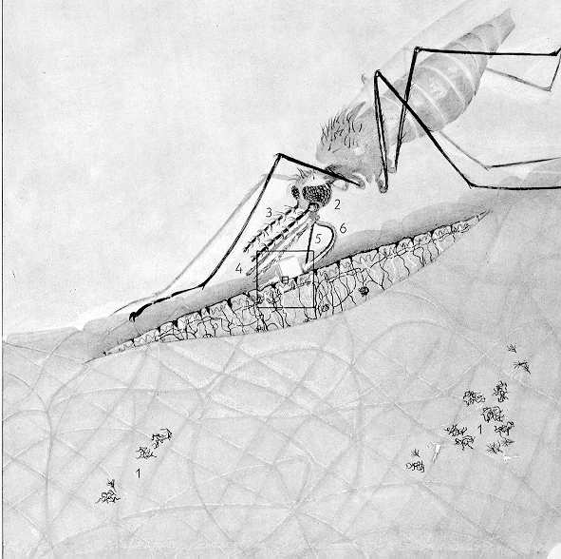 | 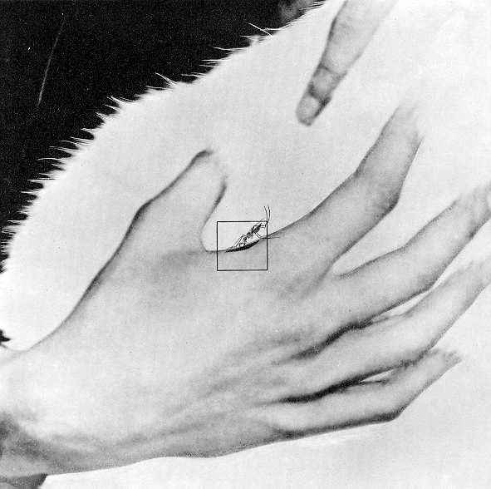 | 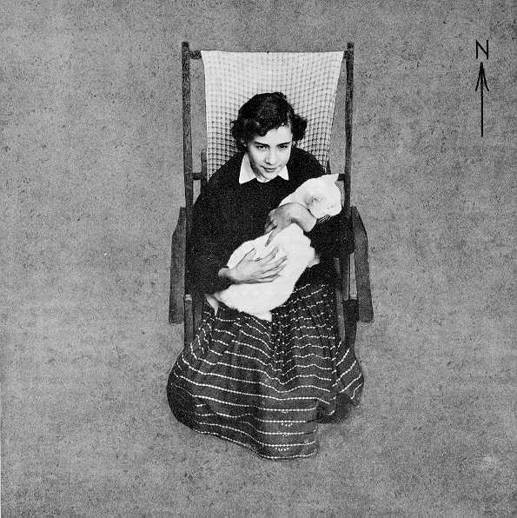 | 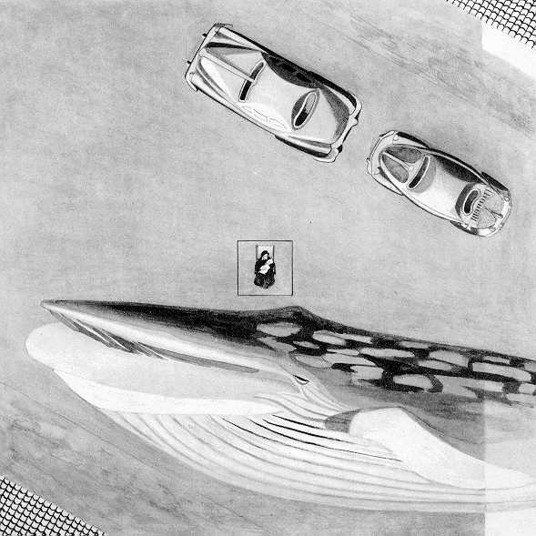 | 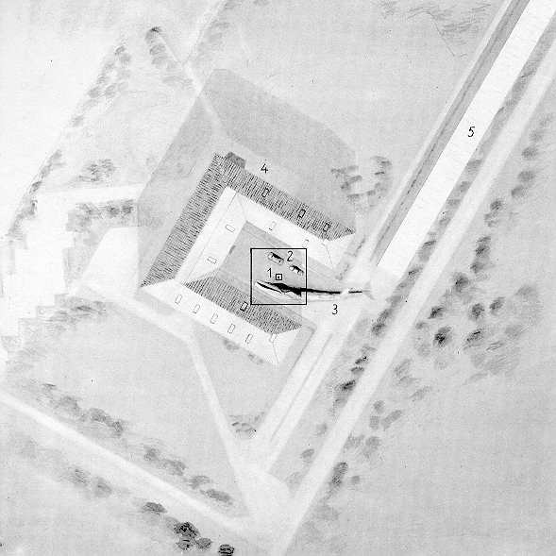

1 cm | 10 cm | 1 m | 10 m | 100 m

Fig. 1. From We in the Universe, the Universe in Us, Kees Boeke (1959: 5–6, 32–34)
Travelling and telling, the curiosity of the children grew bigger and bigger. They wanted to know! They wanted to investigate!
Was that what was told to the teacher in training: make the children curious by tickling them, then they want to learn naturally? I can tell, after thirty years of working with children, that I never saw any so curious and inquisitive as during the intellectual trip organized by Kees Boeke. They were, despite all their questions, satisfied, at rest; they better understood the complex world than ever before.
You understand that during this cosmic journey various teaching materials naturally arise. Not only in separate disciplines such as Geography, Biology and Mathematics, but also through integrated and interrelated studies. What a great value! The school, the teacher and the child make choices about the topics they want to offer and to investigate. In line with the powers of ten, the learning potential is not only in the subjects, but more in the way that
the child learns to organize the access to knowledge through these topics. About this interesting information I will tell you more in the later sections. After the discovering of space, we now discover time.
Time
As a teacher, I was long looking for a way to organize knowledge that would have more value for children and could give more coherancy to the standard curriculum. On a cold November evening in the 1980s, I thought about a workable overview of ‘total time’. I was drawing some timelines and suddenly found an overview.
Wow! It seemed I had addressed time! In one simple overview I understood:
• total time, a line of everything = 13.7 meters long;
• time of humanity = 10 meters, enlarged from 1 cm on the line of everything);
• time of human culture = 10 m long, enlarged from 1 cm on the line of
humans);
• time of a school child = 10 meters, enlarged from 1 cm on the line of
culture).
The mathematical beauty appealed to me, especially in relation to the history of everything: humanity, culture and the child. Later, when I came into contact with the work of Kees Boeke, with its own mathematical beauty, it felt as an additional reward. I was very pleased to have ‘frameworks’ that can give us an overview of space and time.

Fig. 2. The Lines of Life, Jos Werkhoven (1997)
For me it was clear that I not only should use this idea in my own classroom, but I had to share it with anyone else who wanted to use it. In 1997 I published the four timelines as The Lines of Life for schools (Werkhoven 1997) For this edition every timeline had name cards and illustrations of moments of development to support the telling of the story.
• The line of everything has name cards and pictures of the Big Bang; formation of matter; evolution of galaxies, Earth and life on Earth; continental drift; development of mountain ranges; etc.
• In the line of humans, there are many illustrations and name cards of
the ancestors of humans, their tools, moments for the rise of many animal species, ice ages, cave paintings, the first use of calendars, etc.
• In the line of culture, the emphasis is on universal human history as well as particular history (though present) of individual cultures. There are illustrations and name cards of the first appearances of agriculture and livestock, weaving, irrigation, shelters, writing, use of copper and iron, etc. Important people such as Newton or Mandela are also present.
• In the line of ‘myself’, there are illustrations and name cards of birth, birthdays, the first time walking, etc. The child fills the line with their own pictures of various events.
The finest work in this series is always done by the children. Their own research and work are linked to the timeline. Books, artwork, fossils, handmade art objects, galaxies, Earth and planets, and the other examples create what is essentially a school museum and research centre for the timelines of life, which is revisited frequently by students. Indeed, there is a lot exchange of information between groups.
The Question
The teacher brings children into the wonderful story of space and time, making them curious, and, as a result, they ask a lot of questions. One of our resources comes from educator Maria Montessori, who developed an ingenious process to analyze sentence structure (Fig. 3). It is however, also possible to use her technique in reverse: to make language. Every child has his or her own questions, so the teacher helps them develop at their own level towards graduation. This process helps the child organize questions and construct a format for their work, similar to a university dissertation, but at a more basic level (Fig. 4).
t
Fig. 3. Material for sentence analysis from Maria Montessori (1953)
Ultimately, the work of the child in our program takes on the structure shown in the bottom right image, where the lines show the relationship between various sub-topics. The material from sentence analysis is extremely stimulating for the child's research. It introduces a very important value, in contrast to the traditional rote style of only answering questions about standard material from
a book.
Fig. 4. Structure of a textbook compared with the structure of sentence analysis
Repeating Patterns
As a result of combining the ‘Powers of Ten’ and the ‘Lines of Life’ and
the ‘Material for Sentence Analysis’, a teacher can use easily understandable and transferable frameworks to study our complex Cosmos as a whole. No matter how complex elements of our universe are or how deeply we zoom-in on
the smallest details, we are never lost and never lose sight of the whole.
But there is even more that we gratefully use in education!
When we are questioning space and time, the repetition of patterns supports a child in establishing their relationship with the world. It is not a coincidence that we find repeating patterns in human language that are similar to patterns in the Cosmos. If we study space and time with children, we see one thing all the time: there is always ‘development’. ‘To develop’ is – in linguistic terms –
a verb and, in reality, it is an activity or energy. How about the origin of everything, the Big Bang? What an activity! What an energy! With the material for sentence analysis of Maria Montessori we can make a linguistic representation.
The linguistic representation of a predicate is:
As time progresses, a subject is created from matter. The linguistic representation of the subject is:
And then there is meaning!
There is a linguistic sentence formed by a subject and a verb. There is meaning, what we, humans, see as the connection of energy and matter. (In Dutch we have the same word for ‘meaning’ and ‘sentence’ – zin, which makes this comparison more beautiful!)
Wherever we look in the Cosmos, there is always the beginning of something. In the physical universe, this often occurs under the influence of gravity, while it takes place through attraction forces in the living universe. The interaction of these things and forces lead to ‘something new’ being created all the time.
As humans, we can duplicate this process of creation in space and time, and then express it in language. Fig. 5 can be seen as a highly simplified picture of this evolution in space and time, where the greatest circle represents the Cosmos that repeats itself.

Fig. 5. Simple representation of the recurrence of development in space and time
The Prepared Environment
The teacher takes the child into a grand and universal story, helping to guide them through their developing relationship with the world by encouraging them to look at and to understand space and time. They provide a rich environment for the children, including books, maps, charts, illustrations, selections from the Internet, movies, art and other source materials. This ‘prepared environment’ for teaching, research and study encourages children to do their own investigations and find answers on their own (Fig. 6). The teacher utilizes four key planning principles, which constantly interact with each other.
- The cosmic order, which fits with overall time and space.
- The social order, consistent with conditions and covenants in our society.
- The biological order, consistent with the biological development of children.
- The personal order which suits the individual child.
Fig. 6. The prepared environment with the starting points of Maria Mon-tessori
The Portfolio
The teacher follows the child's development and helps them to create a ‘masterpiece’ for each subject. This masterpiece is an embodiment of the child's thinking about a given topic. It illustrates what the child has learned in a beautiful way, and justifies the work to the teacher and their fellow students. During their time in school, each masterpiece is saved in a portfolio. The portfolio embodies the child's pride in achievement; it is a collection in which their development is visible through images, language and in every way that the child wants to express himself, both physical and digital. This could include a ‘dance of the Big Bang’, for which a movie is made. It is not about comparing, but serves to represent what the child has made ​​on their own, showing what they have come up against and how it has been resolved. It therefore represents the child's own strengths. The kids present their portfolios to each other, and so get a chance to see that everyone has made something different, something characteristic of their own selves.
Making School
I described earlier how, when we make the journey through space and time, all learning appears to be ‘natural’. Using the ‘making language’ tool, as shown in Fig. 5, it is not difficult to make choices among essences (the smaller striped circles). If we look in this way at the Line of Everything (Fig. 2), without even pretending to be exhaustive, we see things that are normally not integrated into or even offered in traditional primary education:
• the Big Bang;
• gravity, the binding force of the cosmos;
• matter;
• aggregation states of matter;
• formation of galaxies;
• life cycle of stars;
• our solar system as a product of a second generation star;
• geological processes on Earth.
In the same way, we meet such essential development if we inventory
the other timelines or when we investigate the journey through space with Kees Boeke. With the help of the structure of our language, which follows repetitive patterns of the Cosmos, it is pretty simple to identify and to select basic curriculum for basic education, as well as to offer it in an integrated and narrative format. For the child such an integrated presentation in story form is a very logical approach.
A teacher can have confidence that the repeating patterns, which they had previously encountered in the Lines of Everything will appear in the other Lines. For example, in the Line of Life, this appears as:
– the Line of Humans shows human self-awareness;
– the Line of Culture shows the results of human self-awareness;
– the Line of Myself shows the individual child as a repeating pattern of
the Cosmos, with strength, self-awareness and a capacity for planning, research and building.
The child gets the opportunity to develop their own individual potential through a free choice of work within a well-prepared environment, in which
the teacher is the guide for them to ‘do it by yourself’. And ‘appearance’ is always surprising!
Now, from the point of view of a teacher, we get a number of important points to consider.
• The holistic structure of the topical frameworks, along with repeating patterns, gives the teacher and children a chance to comfortably contemplate things within the complexity of everything.
• The teacher and child learn how to deal with new situations in later stages by having learned from previous situations.
• Studied choices reinforce the teacher and the child in making new choices.
• The teacher and the child will never lose their way.
• For the teacher and the child it is pleasant to find out that they cannot know everything, but – at the same time – they have an overview of what they do not know yet, and this consciousness can be very stimulating for their later studies.
I see the investigation of relationships and connections that occur in our Universe to be the main task of good teaching. They can give us answers to all questions. It is important that school is therefore open to the Cosmos as a whole, as one great whole that we are part of. It is not for others to place any fence that can separate us from other knowledge. Everyday we consider
the knowledge of today, the things that really matter: everything is there and everything should be there too so we can make our choices. No one should put on the brakes! Without limiting in advance, humans have a greater chance to find answers for tomorrow. Thus we can arrive ‘through the child to a new world’!! (Montessori 1953)
Finally
The remarkable thing is that the teacher tells a universal story and that story will be different with every teacher, but uniform and universal. It requires the teacher to be very careful. The teacher does not have to know all the answers – s/he knows the ways to find an answer! And the child is not questioning the teacher, but questions time and space. There is room for the teacher to tell about ‘not knowing’ things. The point is obvious that a teacher does not know everything and that s/he is searching too. Answers are examples. The teacher has set an example for the child. S/he is also an example of working together. If you work together, everyone can gain new knowledge and together know even more!
In this context, I like to share some quotes from two of my sources of inspiration.
Let us give the child a vision of the entire universe. The universe is a reality and an impressive answer to all questions. We will investigate
the path of life together, but all things are part of the universe, all are linked together into a comprehensive unit. This image helps the mind of
the child to focus, to stop wandering around in an aimless quest for knowledge. It is satisfied, it has the universal center of himself and all things found. It is essential to address the interest of the child at a center point. The methods commonly used today, are not effective. How is it possible that the spirit of a young person stays active and interested as all of us remain engaged in teaching a particular subject with a limited scope and limited to the transfer of knowledge with those little details that he is able to learn by heart? How can we force the child to be interested as interest can come only from within? Only obligation and fatigue may be induced from the outside, never interest! Let this be very clear (Maria Montessori 1947).
In fact, we can imagine the best the pattern that connects as a dance of interacting parts.
And a powerful thought that he formulated in a letter complaining about
the shortcomings of Western education:
Break the pattern that connects the curriculum and inevitably you destroy all quality (Gregory Bateson 1979).
Thinking about the last words of Gregory Bateson, I dare to say from experience that, especially since the time of writing forty years ago, still not much has changed in education. Bateson calls this stagnation a ‘contagion of teachers’. Great thinkers of the past have stimulated me, often in opposition to
the uncomprehending or indifferent attitude of my own colleagues. Their statements read like poetry (Weate and Lawman 1998):
• Socrates (469–399 BCE): ‘Ignorance is the only evil’.
• Aristotle (384–322 BCE): ‘There is something wonderful in all natural things’.
• Descartes (1596–1650 CE): ‘I think, therefore I am’.
• Spinoza (1632–1677 CE): ‘Joy can never be too much’.
• Kant (1724–1804 CE): ‘Two things fill my mind with ever increasing admiration and awe, the starry heavens above me and the moral law within me’.
• Wittgenstein (1889–1951 CE): ‘The limits of my language are the limits of my world’.
• Sartre (1905–1980 CE): ‘A man makes himself’.
• Maria Montessori (1870–1952 CE): ‘Help me to do it by myself’.
The (still very conservative) acceptance of Big History in the scientific world and the establishment of the International Association Big History is encouraging. It gives me extra motivation to promote Big History and Cosmic education as a liberating and potentially very strong alternative in education.
References
Bateson G. 1979. Mind and Nature. Amsterdam: Uitgeverij Bert Bakker. In Dutch (Bateson G. Het verbindend patron. Amsterdam: Uitgeverij Bert Bakker).
Boeke K. 1959. We in the Universe, the Universe in Us. Purmerend: Muusses and Meulenhof. In Dutch (Boeke K. Wij in het heelal, het heelal in ons. Purmerend: Muusses and Meulenhof).
Montessori M. 1953. Through the Child to a New World. Heiloo: Kinheim Uitgeverij. In Dutch (Montessori M. Door het kind naar een nieuwe wereld. Heiloo: Kinheim Uitgeverij).
Montessori M. 1973. To Educate the Human Potential. Madras: Kalakshetra Publications.
Morrison P., and Morrison P. 1985. Powers of Ten. Maastricht: Natuur en techniek. In Dutch (Morrison P., and Morrison P. Machten van tien. Maastricht: Natuur en techniek).
Weate J., and Lawman P. 1998. A Young Person's Guide to Philosophy. London: Dorling Kindersley.
Werkhoven J. 1997. The Lines of Life. Kortenhoef: Uitgeverij De Arend. In Dutch (Werkhoven J. De lijnen van het leven. Kortenhoef: Uitgeverij De Arend).

See also Fig. ‘Just 42 steps to explore the whole cosmos’ from coloured edition Power of Ten by P. and P. Morrison (1985: 21–103) in the electronic version of this Almanac at http://www.socionauki.ru/almanac/issues/evolution_2_en/#werkhoven
Montessori M. (1870–1952). Italian physician and educator who propagated learning by free choice of work within a well-prepared environment.

