II. Biological and Social Forms of Evolution:
Connections and Comparisons

3
Constructing a General Theory of Life: The Dynamics of Human
and Non-human Systems

Graeme D. Snooks

Introduction
It is doubtful that a single workable theory of ‘evolution’ – which I prefer to call ‘dynamics’ – will ever be constructed to explain the emergence and development of both inanimate and animate systems, owing to their fundamentally different existential properties. But it is possible to construct a single general theory of life that can explain and predict the dynamics of both human and non-human systems. This has always been the objective of those studying living systems: to explain and predict the emergence of order and complexity in
a universe subject to increasing entropy.
While the need for a general dynamic theory – sometimes called a ‘unified theory of complexity’ – has been discussed in the literature for more than
a decade, the consensus is that its achievement is no closer now than in the past (Holland 1995, 1998; Casti 1999). Some scholars, however, are beginning to feel that the task is too complex, perhaps even impossible (Horgan 1996; Sardar and Ravetz 1994). It has even been suggested that an overarching theory may not really be desirable after all, and that we may have to be content with detailed empirical studies of complex systems or with simulation models of different types of agent-based systems (Chu et al. 2003).
A new approach to this important issue is developed in this paper. It is only possible, I argue, to explain, predict, and formulate corrective policy regarding living systems if we possess a general dynamic theory and fully understand its underlying laws. Certainly the task is difficult, but, I hope to demonstrate, it is not impossible. Indeed, the degree of difficulty has been increased unnecessarily by two research strategies pursued in complexity circles. First, many complexity theorists have attempted to develop a theory that can explain systems of both an inanimate and animate kind. I will suggest that separate dynamic theories are needed for this purpose. By employing the physics model of inanimate systems to explain the exploration of living systems, we distort those systems. Second, all complexity theorists have focused, in adopting the physics model, on the supply-side mechanisms in both types of system – on the local interactions between large numbers of constituent members. In the process they have totally ignored the demand side, which, I have long claimed, is essential to the understanding and analysis of living systems. It is argued here that by separating living from inanimate systems, and by embracing the entire demand-supply mechanism in living systems, it is possible to develop a workable general dynamic theory of life and human society – a general dynamic theory constructed on a solid foundation of laws of both life and human society (Snooks 1998; 2003: ch. 15). Both the method and the theory will be outlined briefly in this paper, as this discussion is based on a series of major books and articles published by the author over the past decade.

A Methodological Struggle
The field of complexity has become a battleground for different methods. Essentially there are three combatants: those employing the physics model are exponents of the deductive approach; those employing the agent-based models are advocates of the analogical method; and those who reject the supply-side physics model entirely, favour the inductive method of realist theory-construction. There are some, such as Joshua Epstein (1999), who wish to persuade us that agent-based modelling constitutes a new approach to knowledge creation, which can be called ‘generative’. I will argue, however, that this amounts to elevating an estimating technique to the level of a scientific method. It is important to emphasise that, as all scientists employ a mix of methods in their work, advocates of a particular method are merely saying that this is
the main source of the knowledge generated by their work. Nonetheless, in an interesting echo of the late nineteenth-century battle between the deductive and historical branches of economics, the current clash between methods for understanding complex systems could be thought of as the new methodenstreit –
the new battle of the methods between deduction and induction in the wider arena of the life sciences.

The Supply-side Physics Approach
Existing approaches to complexity are based to varying degrees on the physics model of self-organisation. This deductively developed theory is often illustrated by reference to the sand-pile model made famous by Per Bak (1997). In this model, the application of an external energy source to an open system consisting of a large number of particles, causes those particles to interact energetically so as to create complex structures that build up to a critical point, and then collapse in unpredictable ways, resulting in a ‘phase transition’. It is a cycle that recurs for as long as the exogenous driving force, and the resulting state of self-organised criticality (SOC), continue to exist. This process of self-organisation is the outcome of an inanimate system obeying simple laws of physics, including those of motion, gravity, and friction.
Both the macro and micro outcomes of this model are unpredictable owing to the large number of interacting objects in real-world systems. As is well known, Newtonian precision is only possible when any interaction is confined to two or three objects. How then do we account for the order we observe in the real world of large numbers? Unpredictable outcomes are said to obey a power law – the law of large numbers – that governs the probability of fluctuations of a given size. This law tells us that while physical events of any size – such as avalanches in the sand-pile – can be generated at any time by small triggers, the probability of large events is considerably less than that of small events.
A distribution obeying a power law can be thought of as a modified random walk – a random walk punctuated by steps of any size, where the probability of occurrence decreases as the steps get bigger. In a normal random walk, all steps are the same size. But this is merely description, not explanation. What we want to know is how physicists attempt to explain these power laws.
M. E. J. Newman (2005) suggests that there are a number of ‘physical mechanisms’ underlying power laws. The chief among them are the ‘Yule process’, often characterised as ‘the rich get richer’, and theory of self-organised criticality. An example of the Yule process can be found in the differential impact of population growth on the pattern of urbanisation – namely when a nation's largest cities acquire more inhabitants than its smaller cities in proportion to the existing pattern of population size. And an example of SOC is the sand-pile model discussed above. SOC is a far-from-equilibrium state, generated by
a constant flow of energy from outside the system. In this state, the addition of just a single grain of sand will cause the pile to generate either a single large avalanche or a series of smaller avalanches (Bak et al. 1989).
These ‘explanations’, however, are unsatisfactory because they are ad hoc, partial, and not part of a general dynamic theory. But even more importantly,
it is clear that the interactions between particles in the physics model are
the result not of ‘choice’ but of the flow of energy from outside the system. ‘Self-organisation’, therefore, is a misnomer. ‘Forced-organisation’ would be
a more appropriate label. While nomenclature is unimportant, provided usage is clear and consistent, in this case it does give the misleading impression that
the physics model might be applicable also to living systems.
What can the physics model tell us about the process of change in inanimate systems? What pathways do complex systems take? Classical thermodynamics is unable to analyse, let alone resolve, this issue, because its method is limited to comparative statics rather than dynamics. It is, in other words, concerned with the equilibrium conditions that exist both before and after the occurrence of a phase transition. In contrast, complexity theory, which is an outcome of
the more recent statistical physics, is concerned with non-equilibrium processes of change. What this implies is that there has been a belated recognition by physicists that real-world processes of change rarely take the form of sudden leaps between equilibrium states. With this change of focus, the challenge for the physics model became how to analyse the growth path of physical systems by employing a supply-side model of forced physical interaction. The solution, based on work by Ilya Prigogine (1981) and others from the 1950s, was to view the growth process as the outcome of a succession of bifurcations, or crisis points that offer two very different paths forward. And the path taken (rather than chosen) will be the outcome of historical contingency. While the phase-transition and non-equilibrium-bifurcation approaches are distinct, what links them is the underlying model of forced interactions.

The Supply-side Agent-based Models
The key question in complexity theory is: How relevant is the simple physics model to the analysis of living systems? The dominant contemporary answer, somewhat surprisingly, is that this physical model of supply-side interactions is highly relevant. At one end of the spectrum are those physicists who believe that the creation of a ‘social physics’ is highly feasible (Buchanan 2000; Ball 2004; Gribbin 2005), and at the other end are those who reject the idea of society obeying the laws of physics but maintain that adaptive agents can be substituted for particles within the basic supply-side physics model (Epstein and Axtell 1996; Axelrod 1997; Tesfatsion and Judd 2006). In between these extremes are those working on the ‘evolution’ of technology, who still see some advantage in focussing on the supply-side interaction between units of technology in the absence of agents (Arthur and Polak 2006). While it is not difficult to refute the idea of social physics (Snooks 2007), the work of the agent-based modellers (ABM) requires further discussion here. As will be shown, the source of all their problems is the commitment to an inappropriate analogical method –
the assumption that the basic self-organisation model of inanimate systems is applicable to living systems.
The most sophisticated ABMs have been developed by economists who are unhappy with the dominant comparative-static approach adopted by their discipline. As a long-term campaigner against the static equilibrium approach in orthodox economics (Snooks 1993, 2000), I sympathise with their desire to develop a more dynamic form of economics. But their adoption of the structural characteristics of the physics model rather than the development of a realist general dynamic theory is unfortunate, as it involves a rejection of the inductive for the analogical method. In other words, by opting for the supply-side dynamic approach of statistical physics in preference to the supply-side comparative-static approach of their own discipline, ABM'ers have totally ignored
the possibility of a realist demand-side approach.
The pioneers of this movement appear to have been influenced by statistical physics initially via game theory and later through contact with complexity theory (Epstein 1999; Axelrod 1984, 1987). This agent-based computational economics (ACE) group is concerned with the complex outcomes that arise from the interaction between agents that possess computing abilities and operate with bounded (rather than perfect) information. While they replace ‘particles’ with ‘people’, they accept and adopt the causal mechanism that lies at
the centre of the physics model – the local interaction between agents – to explain the emergence of complexity. The ACE model, therefore, is a physics-influenced, supply-side approach to complex systems. In their own words, it is a theory about ‘artificial societies’ rather than real-world societies. While they have abandoned the laws of physics as an explanation of local interaction, they have imposed a set of simple artificial rules on living systems in order to mimic observed orderly patterns.
The influence of a supply-side physics is clearly reflected in the central question posed by ACE advocates, such as Epstein's (1999: 41): ‘How could the decentralized local interactions of heterogeneous autonomous agents generate the given [macroscopic] regularity?’ To answer this highly physics-biased question, ACE advocates develop sets of simple rules of local interaction that, through computer simulation, mimic the real-world patterns in which they are interested. In other words, they develop computerised ‘artificial societies’ based on the insights of complexity generated by physical systems to ‘explain’ the regularities in human society. It must be emphasised that the ACE model is determined not by computer simulation but by analogy. Computer simulation
is merely a technique for establishing a set of artificial rules, within the context of a deductive model borrowed from statistical physics. It does not constitute
a new approach – the ‘generative’ approach thought of as equivalent to deduction and induction – to the creation of knowledge as suggested by Epstein (1999).
This is a highly risky, even reckless, approach. If the supply-side physics model is not relevant to living systems – if the analogy is false – then the entire ACE program is in jeopardy. In such circumstances this approach will construct a model not of the universe we actually inhabit, but of a parallel and alien universe. The ACE program, therefore, runs the very real risk of entirely distorting our understanding of reality. The question that should have been asked is: What is the real-world mechanism actually responsible for the macro-societal patterns we observe, and how can it be employed to construct a general dynamic theory of life and human society? While this question is considerably more difficult to answer, it is not based on the reckless assumption that living systems can be explained using the supply-side physics model. As it turns out, this assumption cannot be substantiated. Consequently, the ACE program has difficulties explaining the dynamics of real-world (as opposed to ‘artificial’) living systems.
The method employed by agent-based modellers is not without its critics in
the complexity community. In an interesting article in Complexity, Chu, Strand and Fjelland (2003: 27) argue:
The degree of complexity involved [in living systems] is usually beyond
the reach of the conventional methods of physics, but ABMs (and other approaches to complex systems, such as neural networks, genetic algorithms, etc.) have proven to be powerful methods in this context...
But there is more to complexity; this addition cannot be adequately represented in ABMs, because by their very nature they are not radically open and can therefore only represent reducible contextuality. This does not mean that ABMs cannot be usefully applied to systems that are complex in this extended sense; it only means that one has to be aware of the inherent limitations of the model, which stem from the fact that
the models cannot represent the full complexity of the system.
The physics and ABM models, they claim, provide oversimplifications of real-world complexity in living systems. They do not believe that these models are basically inappropriate and distorting, just that they have less than universal applicability. Chu, Strand and Fjelland (2003: 27) tell us: ‘the oversimplification that we find in physics is of broad applicability, but by no means of universal applicability’. Their solution is ‘to focus more on properties of complex systems, rather than the detailed mechanism. For instance, we would like to encourage empirical investigations into the presence and nature of radical openness and contextuality’, keeping in mind ‘that there is something inherently uncomputable about complex systems’ (Chu et al. 2003: 29).

A New Demand-side Approach to Living Systems
The central argument in this paper is that the physics model for analysing complex living systems is not just an oversimplification resulting in less than universal applicability, but that it is entirely inappropriate. By assuming that complexity emerges from the local interactions of adaptive agents, and by establishing a set of rules of engagement that can, through computer simulation, mimic the real-world pattern in which we are interested, we are constructing ‘artificial societies’ that have little in common with the world we inhabit. By employing this analogical approach we are, in effect, creating alien worlds.
How should we proceed in order to avoid this problem? While it may cause angst to many, we must abandon the deductive supply-side physics model and its analogical spin-off, the supply-side agent-based model. If, that is, we wish to understand the dynamics of real-world living systems. Yet this is not to say that these models do not have important uses. Clearly the physics model has been useful in analysing and predicting outcomes in extreme and restricting circumstances, such as traffic jams, panicking crowds in confined spaces, and even short-term fluctuations on the stock exchange. And ACE simulations, like similar work in traditional econometrics, can be useful for ‘black-box’ predictions, when it does not matter how unrealistic the model is, provided its predictions are fairly accurate, if only in the short-run.
The only way to proceed is by employing the method of induction. By careful and systematic observation of the way living systems, both human and non-human, change over time, it is possible to construct a realist general dynamic theory. It was for precisely this reason that I have been engaged on a large-scale project – the ‘global dynamic systems’ (GDS) project – for the past couple of decades. In a series of books published over that time, I have been able to develop a general dynamic theory of living systems – the so-called ‘dynamic-strategy theory’. As it turns out, the construction (rather than the ‘emergence’) of complex systems is the outcome of a process of ‘strategic exchange’ between the demand and supply sides of dynamic living systems, rather than
the outcome of supply-side local interactions between agents. This is the breakthrough required in the quest for a general theory of complexity.
The essence of the dynamic-strategy theory is to be found in the strategic exchange between purposeful agents and their society's unfolding dynamic strategy. It is this exchange that lies at the very heart of the self-sustaining dynamics of living systems. Social agents are self-motivated and self-driven, and they construct complexity and order in a creative response to the continuously changing needs – via what I call ‘strategic demand’ – of their society. It is this creative exchange between the demand and supply components of a dynamic living system that generates changing genetic structures, technologies, ideas of all types, institutions, and organizations. By continuously attempting to meet society's constantly changing strategic demand, both the agents and their civilization are transformed in the long run. The creative process of exchange by which this takes place constitutes the ‘life system’ for the group of social agents in whom we are interested. Living systems, therefore, are ‘autogenous’ – or selfcreating – systems, as I have demonstrated elsewhere (Snooks 2006, 2007).
Selfcreation is an entirely new concept. In the selfcreation model, strategic exchange determines all other relationships, including the interaction between its constituent members, in any given life system. Strategic exchange, therefore, is the core dynamic process, whereas agent interaction is a derived and, hence, secondary process. What this implies is that cooperation is central to what I call the ‘strategic pursuit’ – or life process – while competition between agents is
an attempt at the margin to improve individual strategic advantage. And cooperation is the outcome not of reiterative interactions between agents as claimed by game theorists but of the need to ensure the success of a joint strategic pursuit. A society's strategic success is immeasurably more important to every individual than changes in the individual pecking order are. Theorists of self-organisation appear to have lost sight of this critically important point – a point that has major implications for biotransition as well as technotransition.
A General Dynamic Theory of Living Systems
The concept of selfcreation is based on a realist general dynamic theory called the ‘dynamic-strategy theory’. This demand-side theory, which is based on long-term, systematic observation of the fluctuating fortunes of living systems in the natural and human worlds, has been published by the author in a series of books and articles over the past two decades (Snooks 1993, 1996, 1997, 1998, 1999, 2002, 2003, 2005, 2006, 2008). It is the only endogenous demand-side dynamic theory ever to have been formally developed. As I can provide only
a schematic version of the dynamic-strategy theory here, interested readers might like to consult some of these publications.
Overview
Essentially the dynamic-strategy theory consists of a self-starting and self-sustaining interaction between the organism and its society. This endogenous dynamic process occurs within the context of a largely stable physical environment, which occasionally changes in random and unsystematic ways. Most other theories, in which life is driven by asteroid impacts, massive volcanic eruptions, major climatic change, or other erratic energy inflows, are exogenous in nature. The origin of life in this theory is identified not with the ability to replicate, as the Darwinists claim, but with the establishment of an internal metabolic process (Snooks 2005). This process generates a metabolic demand for fuel that can be met only by the pursuit of a four-fold set of dynamic strategies. Replication, once the trick had been learned, was merely one of those strategies.
The dynamic-strategy approach leads us to an important conclusion, which will be of interest to all scientists concerned with the origin of life. It is that life emerged many times before the dynamic strategy of replication was finally discovered, thereby transforming it into a cumulative and exponential process.
The significance of the emergence of systematic replication is that it made possible the beginning of what I have called the ‘law of cumulative biological/technological change’ (Snooks 2003: 287–288). This law underlies the exponential growth of life over the past 3,800 million years, which has taken place at a constant compound rate of growth. This discovery (Snooks 1996: 79–82,
92–95, 402–405) revealed that each major biological/technological transformation during the history of life on earth (Figs 1–3) took only one-third
the time of its predecessor. In other words, the coefficient of acceleration of life on earth is a constant 3.0. A more complete explanation can be found in my article on ‘The Origin of Life on Earth’ in Advances in Space Research (Snooks 2005: 229–31). This relationship has become known as the Snooks-Panov algorithm (Nazaretyan 2005a, 2005b).
In its most general form the dynamic-strategy theory consists of four interrelated elements and one external and random force. These elements and forces include the following.
- The internal driving force, which arises from the need of all organisms to survive and prosper, provides the theory with its self-starting and self-sustaining nature. This is the concept of the ‘materialist organism’, which is driven by the basic need to fuel its metabolic process. The only alternative
is starvation and death.
- The four-fold ‘dynamic strategies’ – genetic/technological change, family multiplication (procreation plus migration), commerce (symbiosis), and conquest – are employed by individual organisms, or ‘strategists’, through
the process of ‘strategic selection’ to achieve their material objectives. Strategic selection displaces natural selection as the key not only to biological, but also technological, change.
- The ‘strategic struggle’ is the main ‘political’ instrument by which established individuals and species (‘old strategists’) attempt to maintain their control over the sources of their prosperity, and by which emerging individuals and species (‘new strategists’) attempt to usurp such control. This is the real nature of ‘agent interaction’.
- The constraining force operating on the dynamics of a society/species/ dynasty is the eventual exhaustion not of natural resources but of the dominant dynamic strategy – or, at a higher level in the dynamic process, the genetic/ technological paradigm (see Figs 2 and 3). This leads to the emergence of internal and external conflict, environmental crisis, collapse, and even extinction. This is the outcome of strategic laws and not power laws.
- Exogenous shocks, both physical (continental drift, volcanic action, asteroid attack, climate change) and biological (disease and unforseen invasion), impact randomly and marginally on this endogenously driven and shaped dynamic system. Only exhausted systems that would have collapsed anyway are terminally affected; viable ones shrug off these external impacts.
The dynamic-strategy theory, therefore, views life as a ‘strategic pursuit’ in which organisms adopt one of the four dynamic strategies in order to achieve the universal objective of survival and prosperity. The ‘choice’ is based on
a trial-and-error process of what works best in any given strategic and paradigmatic environment. In the pre-human world, at times of resource abundance
the genetic strategy is chosen and speciation is the outcome; when competition is moderate, organisms switch to either the family-multiplication or commerce strategies, and take their ‘genetic style’ to the rest of the accessible world; and when competition is intense, organisms adopt the conquest strategy, which leads to declining species diversity (negative speciation), environmental crisis, collapse, and extinction. The operation of this strategic sequence is the real explanation of the ‘punctuated equilibria’ genetic profile apparent in the fossil record. Over the history of human society the sequence has been: family-multiplication (Paleolithic era), conquest or commerce (Neolithic era), and technological change (modern era). This strategic sequence explains the dynamic profiles in Figs 2 and 3.
Dynamic Mechanism
The all-important driving force in this dynamic system, which provides
the self-starting and self-sustaining process, is the ‘materialist organism’ (or ‘materialist man’), striving at all times, irrespective of the degree of competition, to increase its access to natural resources in order to ensure sufficient fuel to maintain its metabolic processes. It is the most basic force in life – a force
I call ‘strategic desire’ – which can be detected in man as well as in other life forms (Snooks 2003: chs 9 and 11). More intense competition merely raises
the stakes of the strategic pursuit, and leads to conquest rather than genetic change.
As organisms and their ‘societies’ exploit their strategic opportunities,
the dominant dynamic strategy unfolds (until it is finally exhausted), generating
a ‘strategic demand’ for a wide range of inputs required by this life-generating process. These essential inputs, which include natural resources, institutions (rules), organizations (net-working), and ‘ideas’ (genetic, technological, and cultural), are supplied within social groups in response to the promise of prosperity. This strategic exchange between the organism and its society is the dynamic mechanism that generates the long-run increase in biomass/GDP at
the local and global levels.
The mechanism of strategic exchange is a creative process, involving an innovative response of individuals and groups to the changing requirements of their life system. It is responsible for generating new ways, both genetic and technological, of exploiting natural resources. The long-run outcome of this strategic exchange is the transformation of both the individual and its ‘society’. While the driving force originates with the individual organism, the directing and shaping force is strategic demand. Strategic demand shapes all relationships in a given society, including those between its interacting members. Hence, strategic exchange is a cooperative process aimed at maximising
the success of a joint strategic pursuit, while member (or ‘agent’) interaction is merely a secondary process. This is why the physics and ABM approaches, which focus exclusively on the supply-side, are unable to generate a workable general dynamic theory of real-world living systems.
Dynamic Pathways
The development path taken by a society/species/dynasty, which consists of
a series of ‘great waves’ as shown in Fig. 1, is determined by the unfolding dynamic strategy and sequence of dynamic strategies adopted by the majority of organisms. There is nothing teleological about this unfolding process, which is the blind outcome of organisms exploring their strategic opportunities on
a daily basis in order to gain better access to natural resources. They do so within the framework of opportunities provided by strategic demand by ‘investing’ time and effort in this endeavour. Successful individual strategies for survival and prosperity become the dynamic strategies of entire societies/spe-
cies/dynasties through the process of ‘strategic imitation’, whereby the conspicuously successful pioneers are imitated by the vast mass of followers (Snooks 1996: 212–213; 1997: 37–50). Choice is definitely not based on complex cost-benefit calculations even in modern human society, owing to the need to economise on what I suggest is the scarcest resource in the universe – intelligence (Snooks 1997: 46–49). Those that pioneer new dynamic strategies do so on a trial-and-error basis in response to strategic demand, while all others in that ‘society’ follow those who are conspicuously successful.
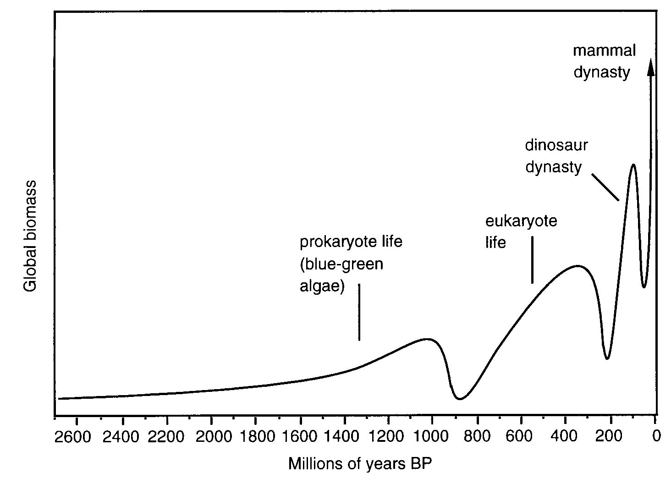
Fig. 1. The great waves of life – the past 4,000 million years
The development path of life, therefore, is an outcome of the individual/group exploitation and eventual exhaustion (when the costs of additional investment are as great as the returns) of a dynamic strategy or sequence of strategies. Once replacement strategies are no longer available, the society/
species/dynasty stagnates and eventually collapses. Hence, the rise and fall of groups of organisms at all levels of existence, which generates the great-waves patterns shown in Figs 1–3, is the outcome of the strategic pursuits of the individual organisms they contain. The demand-side dynamic-strategy theory, therefore, can explain both the micro and macro aspects of both human society and life. This is something that the usual supply-side theories of complexity and self-organisation are unable to do.
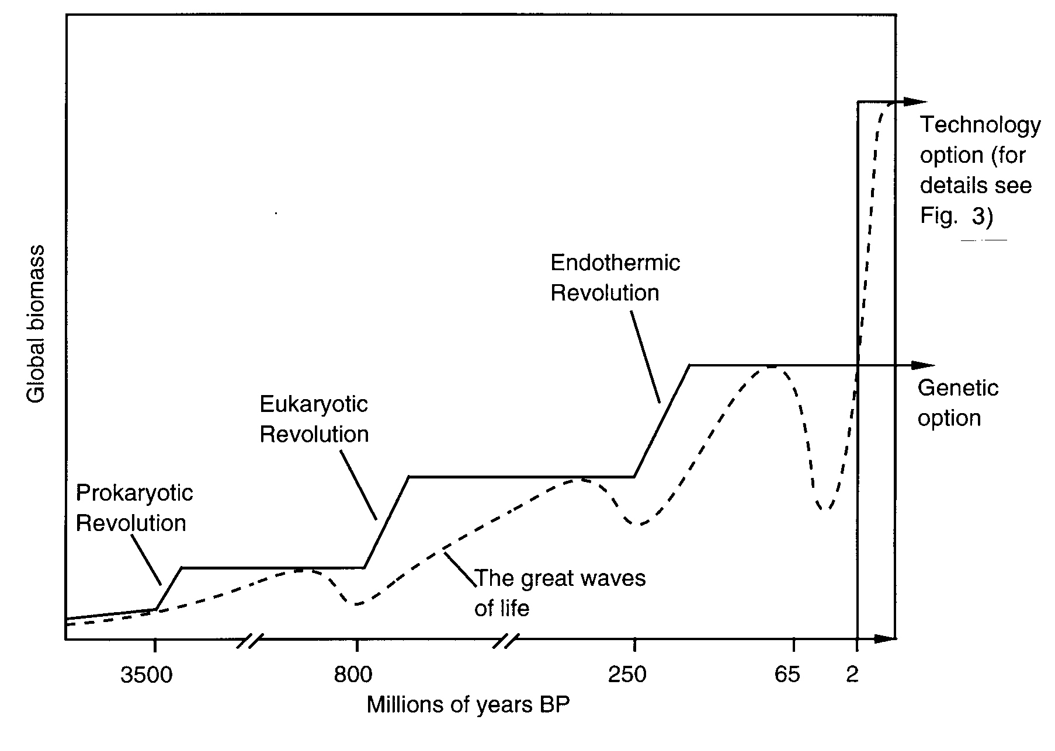
Fig. 2. The great steps of life – the past 4,000 million years
It is important to realise that dynamic pathways – the great waves of biological and technological change – taken by complex living systems are shaped by strategic demand as dynamic strategies and technological paradigms unfold. They are not the outcomes of supply-side constructs such as ‘attractors’, ‘energy landscapes’, self-organised criticality, or historical contingency. In other words, the dynamic pathways of living systems are the outcomes of systematic and creative decision-making in response to long-run structural changes in societal parameters. They are responses not to power laws but to strategic laws.
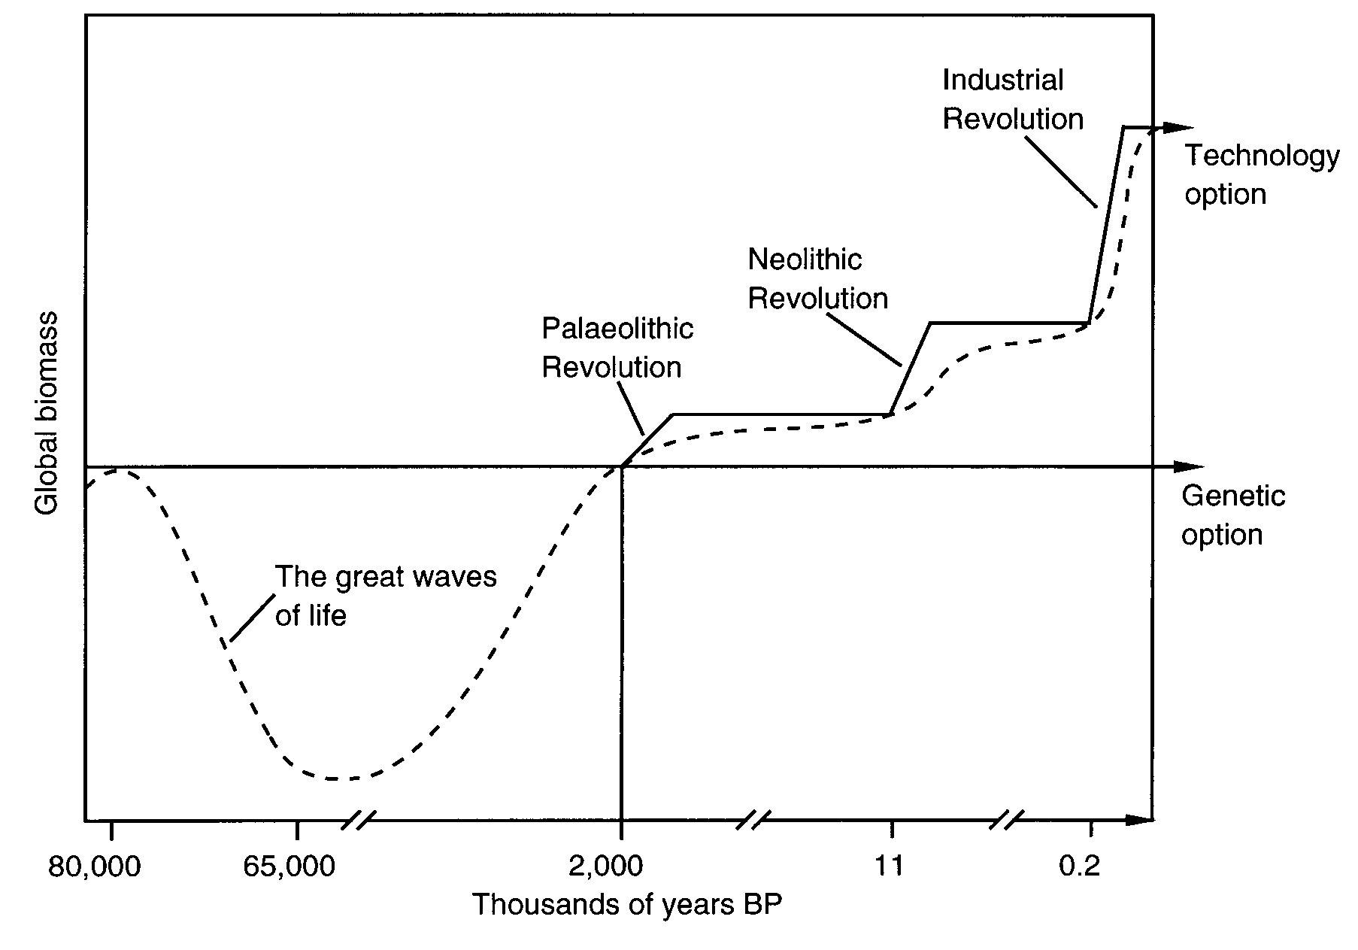
Fig. 3. The great steps of life – the past 80 million years
Strategic Selection – the Key to Selfcreation
The choice of dynamic strategies is central to this theory. Under the dynamic strategy of genetic change, the physical and instinctual characteristics of organisms are gradually transformed in order to use existing natural resources more intensively or to gain access to previously unattainable resources. The outcome of pursuing the genetic strategy is the emergence of new species, or what I call ‘genetic styles’ (to be compared with ‘technological styles’ in human society). On the other hand, the family-multiplication strategy, which consists of procreation and migration, generates a demand for those characteristics that increase fertility and mobility, in order to bring more natural resources under
the control of the extended family; the commerce or symbiotic strategy requires characteristics that enable organisms to gain a monopoly over certain resources and/or services that can be exchanged for mutual benefit; and the conquest strategy demands weapons of offence and defence to forcibly extract resources from, and to defend resources against, one's neighbours. The mechanism by which these physical and instinctual changes in organisms are achieved brings us to the centrally important, and radically new, concept of ‘strategic selection’.
Strategic selection distinguishes the dynamic-strategy theory from all other theories of life. It displaces the ‘divine selection’ of the creationists and the ‘natural selection’ of the Darwinists. Strategic selection empowers the organism and removes it from the clutches of gods, genes, entropy, and blind chance. It formally recognises the dignity and power that all organisms clearly possess and, in particular, reinstates the humanism of mankind that some ultra-Darwinists and physical theorists deny. But this is not why it has been adopted. Strategic selection has been adopted because, unlike all other equivalent concepts, it works.
While only a brief outline of strategic selection can be given here, a full explanation can be found elsewhere (Snooks 2003: chs 10 and 12). Organisms respond to the ever-changing strategic demand for a variety of biological and instinctual inputs into the strategic pursuit. The reason they do so is to satisfy ‘strategic desire’ by maximising the probability of survival and prosperity. Those possessing the characteristics required by the prevailing dynamic strategy will be, on average, conspicuously more successful than their peers in gaining access to natural resources. This success will attract the attention of other organisms with similar characteristics. Through cooperative activity, these similarly gifted organisms will maximise their individual as well as group success. If of different gender they will mate and pass on their successful characteristics to at least some of their offspring, through the mechanism of ‘selective sexual reproduction’. They may even cull – or allow their stronger offspring to cull – those offspring that do not share these successful characteristics. This occurs in animal and human society alike to increase the probability of their survival and prosperity.
In the strategic selection process, only those mutations that assist the prevailing dynamic strategy are taken up, by selective sexual reproduction and cooperation between the individuals possessing them; all others are ignored by avoiding, boycotting, even destroying those regarded as ‘freaks’ and ‘mutants’. The theory of strategic selection possesses two unique characteristics. The first is that individual organisms are responsible for the process of selection, which is employed to maximise the probability of their survival and prosperity and not that of their genes. And the second is that strategic selection operates under
the full range of competitive conditions, ranging from high to low levels of intensity. Strategic selection, therefore, can explain not only the origin of life and recovery from major extinctions, but also all the great diasporas of life and its great conflicts, crises, and collapses. It also explains the choice of dynamic strategies in human society (Snooks 1996, 1997).
Strategic Struggle – the Real Nature of Competitive
Interaction
The real nature of competitive interaction is explained by the process of strategic struggle, which takes place within the boundaries dictated by strategic exchange. Strategic struggle is undertaken by individuals and groups in order to maintain/gain some control over their society's dynamic strategy. To do so they employ the dynamic tactics of order and chaos. The tactics of order, which include the threat of punishment or ostracism and the enforcement of customary rules, are employed by insiders to maintain and exploit the status quo; and
the tactics of chaos, which include attempts to undermine the authority of
the existing leadership, are employed by outsiders to disrupt the existing order as the basis of takeover. In both cases the aim is to maintain or gain some control over the dominant dynamic strategy – not to destroy it – because it is the source of survival and prosperity. In the process, political structures are transformed.
In the non-human world, combat between males of many species is not primarily about sex as usually argued, but about a struggle to maintain/gain control over the sources of their dynamic strategy – namely the territories needed to provide access to food and shelter (Snooks 2003: 209–210). These struggles permeate the entire society but are particularly significant when between leaders of different dynamic strategies or dynasties (such as between the archosaurs and therapsids) as they determine the rise and fall of genetic paradigms. Similarly in human society, these struggles occur both to maintain/gain control of the dominant dynamic strategy (such as the civil wars in Rome between the supporters and slayers of Julius Caesar) and to enable a new dynamic strategy to triumph over an old one (such as the political struggle in Britain during the first half of the nineteenth century between the new industrialists and the old commerce-based, land-owning aristocracy). The point is that these struggles and the resulting change in political structures are outcomes not of supply-side local interactions but of a systematic response to the changing strategic and paradigmatic conditions in society that are communicated via strategic demand.
Conclusions
Our understanding of the dynamics of complex living systems has been handicapped by the scientific methods we have adopted. By assuming that the supply-side physics model could be transferred either whole (as in social physics) or in part (as in ABMs) from inanimate to living systems, we have distorted the picture of reality. And we have delayed the construction of a general dynamic theory of living systems. This impasse could only be overcome by substituting the inductive for the deductive and analogical methods. Only by systematically observing the fluctuating fortunes of nature and human society has it been possible to discover the forces driving and shaping living systems. This discovery shows that the physics assumption that complexity is the outcome of supply-side interactions between local agents cannot be substantiated. Social reality is far more complex. The universal core mechanism in social reality is what I have called strategic exchange, which is a demand-supply phenomenon. It was this discovery that enabled theorists of complex systems to finally break through the physics ceiling and to achieve what many have come to think of as undoable – to construct a general dynamic theory of life. It was this discovery that enabled the construction of the dynamic-strategy theory presented in this paper.

references
Arthur W. B., and Polak W. 2006. The Evolution of Technology within a Simple Computer Model. Complexity 11(5): 23–31.
Axelrod R. 1984. The Evolution of Cooperation. New York: Basic Books.
Axelrod R. 1987. The Evolution of Strategies in the Iterated Prisoner's Dilemma. Genetic Algorithms and Simulated Annealing / Ed. by L. Davis, pp. 32–41. London: Pitman.
Axelrod R. 1997. Advancing the Art of Simulation in the Social Sciences. Complexity 3: 193–199.
Bak P. 1997. How Nature Works. New York: Oxford University Press.
Bak P., Chen K., and Creutz M. 1989. Self-organized Criticality in the ‘Game of Life’. Nature 342: 780–81.
Ball P. 2004. Critical Mass. London: Arrow Books.
Buchanan M. 2000. Ubiquity. London: Weidenfeld & Nicolson.
Casti J. 1999. The Computer as a Laboratory. Complexity 4(5): 12–14.
Chu D., Strand R., and Fjelland R. 2003. Theories of Complexity. Complexity 8(3): 19–30.
Epstein J. M. 1999. Agent-based Computational Models and Generative Social Science. Complexity 4(5): 41–60.
Epstein J. M., and Axtell R. 1996. Growing Artificial Societies. Cambridge, MA: MIT Press.
Gribbin J. 2005. Deep Simplicity. London: Penguin.
Holland J. 1995. Hidden Order. Reading, MA: Addison-Wesley.
Holland J. 1998. Emergence. Oxford: Oxford University Press.
Horgan J. 1996. The End of Science. New York: Broadway Books.
Nazaretyan A. P. 2005a. The Snooks-Panov Vertical. The Global Studies Dictionary / Ed. by A. N. Chumakov, and I. I. Mazow. Moscow: Dialog Raduga Publishers.
Nazaretyan A. P. 2005b. Big (Universal) History Paradigm: Versions and Approaches. Social Evolution & History 4(1): 61–86.
Newman M. E. J. 2005. Power Laws, Pareto Distributions and Zipf's Law. Contemporary Physics 46: 323–351.
Prigogine I. 1981. From Being to Becoming. New York: W. H. Freeman.
Sardar Z., and Ravetz J. 1994. Complexity: Fad or Future? Futures 26/6: 563–67.
Snooks G. D. 1993. Economics without Time. A Science Blind to the Forces of Historical Change. Ann Arbor – London: University of Michigan Press/Macmillan.
Snooks G. D. 1996. The Dynamic Society. Exploring the Sources of Global Change. London – New York: Routledge.
Snooks G. D. 1997. The Ephemeral Civilization. Exploding the Myth of Social Evolution. London – New York: Routledge.
Snooks G. D. 1998. The Laws of History. London – New York: Routledge.
Snooks G. D. 1999. Global Transition. A General Theory of Economic Development. New York – London: St Martins Press/Macmillan.
Snooks G. D. 2000. The Global Crisis Makers. An End to Progress and Liberty? New York – London: St Martins Press/Macmillan.
Snooks G. D. 2002. Uncovering the Laws of Global History. Social Evolution & History 1(1): 25–53.
Snooks G. D. 2003. The Collapse of Darwinism or the Rise of a Realist Theory of Life. Lanham – Oxford: Lexington Books, Rowman & Littlefield Group.
Snooks G. D. 2005. The Origins of Life on Earth: A New General Dynamic Theory. Advances in Space Research 36: 226–234.
Snooks G. D. 2006. The Selfcreating Mind. Lanham – Oxford: University Press of America, Rowman & Littlefield Group.
Snooks G. D. 2007. Self-organisation or Selfcreation? From Social Physics to Realist Dynamics. Social Evolution & History 6(1): 118–144.
Snooks G. D. 2008. A General Theory of Complex Living Systems: Exploring the Demand Side of Dynamics. Complexity 13(6): 12–20.
Tesfatsion L., and Judd K. L. 2006. (Eds.) Handbook of Computational Economics. Vol. 2. Agent-based Computational Economics. Amsterdam: Elsevier/North Holland.

Abstract
The ultimate objective of theorists studying living systems is to construct a general theory of life that can explain and predict the dynamics of both human and non-human systems. Yet little progress has been made in this endeavour. Why? Because of the inappropriate methods adopted by complexity theorists. By assuming that the supply-side physics model – in which local interactions are said to give rise to the emergence of order and complexity – could be transferred either entirely (social physics) or partially (agent-based models, or ABMs) from the physical to the life sciences, we have distorted reality and, thereby, delayed the construction of a general dynamic theory of living systems. Is there a solution? Yes, but only if we abandon the deductive and analogical methods of complexity theorists and adopt the inductive method. With this approach it is possible to construct a realist and demand-side general dynamic theory, as in the case of the dynamic-strategy theory presented in this paper.

