Cycles of Rise and Fall, Upsweeps
and Collapses: Changes in the scale
of settlements and polities
since the Bronze Age

Christopher Chase-dunn, Richard Niemeyer,
Alexis Alvarez, Hiroko Inoue, Kirk Lawrence, James Love

The evolution of global governance
All systems of interacting polities oscillate between relatively greater and lesser centralization as relatively large polities rise and fall. This is true of systems of chiefdoms, states, empires and the modern system of the rise and fall of hegemonic core states. But there has also been a long-term trend in which polities have increased in population and territorial size since the Stone Age and the total number of polities has decreased. These trends have been somewhat masked in recent centuries because the processes of decolonization and the emergence of nation-states out of older tributary empires have increased the number of smaller polities. But the general trend toward larger polities can be seen in the transition from smaller to larger hegemonic core states (from the Dutch, to the British to the United States), and in the emergence of international political organizations and an expanded and active global civil society that participates in contemporary world politics (Arrighi 1994; Grinin and Korotayev 2006).
This paper reports preliminary results from a project that is assembling and analyzing data on the population sizes of cities and the territorial sizes of empires and is constructing causal models that explain changes in the scale of human settlements and polities and potential future world state formation. We empirically identify "upward sweeps", when the scale of cities and states dramatically increased. We review and synthesize explanations of chiefdom-formation, state-formation, empire-formation and the rise and fall of modern hegemonic core states in order to produce formal explanatory models. And we study the emergent characteristics that distinguish these different scales in order to comprehend how the processes have qualitatively evolved, and in order to consider what kinds of qualitative transformation might occur in the future. Our approach avoids the unscientific pitfalls of progressivist, functionalist, inevitabalist and teleological presumptions that have plagued many earlier approaches to socio-cultural evolution. We do not identify complexity and hierarchy with progress, but neither do we assume that they are the opposites of progress.
Cycles, upward sweeps, collapses and ceilings
Our project compares relative small regional systems with larger continental and global systems, thus we must abstract from scale in order to examine changes in the structural patterns of small, medium and large human interaction networks (Grinin 2006). That said, we are also interested in medium term change in the scale of polities and settlements. We are not considering very long-term trends in this discussion. When an interacting set of polities or settlements is the unit of analysis nearly all systems oscillate in what we may term a normal cycle of rise and fall – the largest city or polity reaches a peak and then declines and then this or another city or polity returns to the peak again. We call this a normal cycle of rise and fall. It roughly approximates a sine wave, although few cycles that involve the behavior of groups of humans actually display the perfect regularity of amplitude and period found in the pure sine wave. In Figure 1 the cycle of rise and fall is half way down the figure and is labeled "normal rise and fall". At the top of Figure 1 is a depiction of an upward sweep in which the size of the largest entity (state or city) increases by
a factor of 2. Such a sweep may be relatively rapid or may be slow, and Rein Taagepera (1978a) contends the speed of the rise is often related to the sustainability of the upsweep, at least in the case of empires. Taagepera notices that empires that rise more slowly tend to last longer than those that rise abruptly. When an upward sweep is sustained and a new level of scale becomes the norm we call this an upward sweep. When it is temporary and returns to the old lower norm we call it a "surge" (see the 2nd line from the top in Figure 1). We also distinguish between three types of decline, a "normal" decline which is part of the normal rise and fall cycle, a short-term collapse in which a decline goes significantly below what had been established as the normal trough, and a sustained collapse in which the new lower scale becomes the norm for some extended period of time. Jared Diamond (2005) has examined the complex causes of a large collection of collapses, though he does not rely on quantitative indicators of collapse and he often focuses on particular societies or settlements that collapsed while ignoring neighboring societies or settlements that rose. If intersocietal interaction networks (world-systems) had been his unit of comparison instead of single societies some of the cases he studied have been shown to be instances of normal rise and fall cycles rather than instances of system-wide collapse. A genuine collapse is when all the societies in a region go down and stay down for a long period.
Figure 1. Types of medium-term scale change in the largest settlement or polity in an interacting region
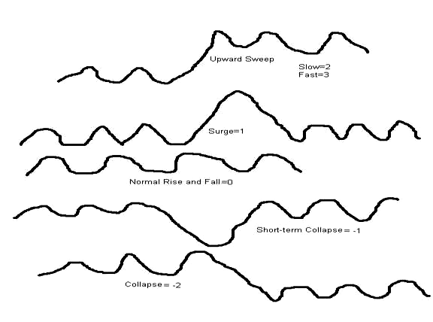

Our project is assembling an inventory of all the instances of the types of scale change of city population sizes and the territorial sizes of states and empires for the regions and state-system networks for which we have quantitative data (Korotayev 2006a; Korotayev and Grinin 2006). We will use this inventory to identify instances of each type of change, and will use these as cases for testing our models.
Figure 2 is a stylized depiction of the rise and fall of large polities and occasional upward sweeps that portrays not the history of a single world region, but rather the general evolution of what has happened over the past 12,000 years as many small polities (bands, tribes and chiefdoms) have been consolidated into a much smaller number of larger polities (states, empires and a possible future world state).
Figure 2. Rise, fall and upward sweeps of polity size
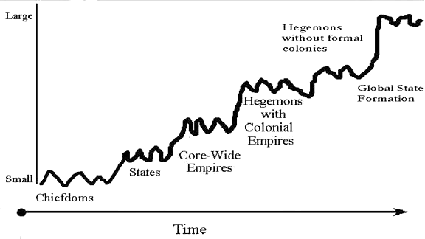

George Modelski's (2003) recent study of the growth of cities over the past 5000 years points to a phenomenon also noticed and theorized by Roland Fletcher (1995) – cities grow and decline in size, but occasionally a single new city will attain a size that is much larger than any earlier city, and then other cities catch up with that new scale, but do not much exceed it. It is as if cities reach a size ceiling that it is not possible to exceed until new conditions are met that allow for that ceiling to be breached. This notion of size ceiling will also be useful for studying changes in the sizes of polities.
Figure 3 plots Rein Taagepera's (1978a, 1978b, 1979, 1997) estimates of
the territorial sizes of the largest and second largest empires in the "Central System" for the purpose of identifying empire upsweeps. We know that an early upsweeps occurred in the Uruk expansion out of Southern Mesopotamia (Algaze 1993) and the Old Kingdom in Egypt but we do not have quantitative estimates of territorial sizes of polities before these upsweeps. After several centuries of competing city-states in Mesopotamia the Akkadian Empire emerged as the first core-wide empire. Taagepera estimates its territorial size and so it appears in Figure 3.
Figure 3. Rise, fall and upward sweeps as revealed by Taagepera's estimates of the territorial sizes of the largest empires in the Central System
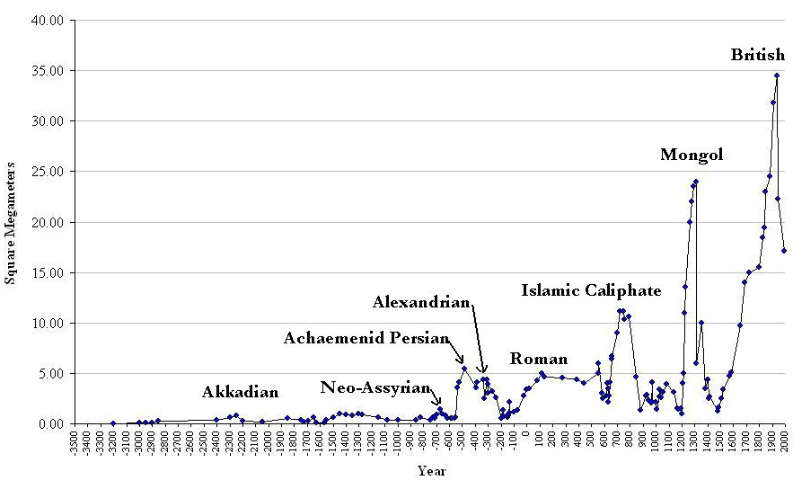
After the fall of the Akkadian Empire there was a millennium of no comparably large states until Egypt managed to attain a size as large as that of the Akkadian Empire (around .8 square megameters). That was the ceiling until the rise of the Neo-Assyrians to a size twice as large, which was then quickly superseded by much larger empires – Achaemenid Persia and the Hellenic Empires. They reached a new ceiling that was as large as Rome and Parthia at their height several centuries hence. The metric used in Figure 3 is square megameters of territorial size, and so we can readily see when upsweeps or collapses are quantitatively much larger than normal rises and falls. But using such a real metric also makes it very hard to see what is happening in the Bronze Age because the long-term upward trend in empire sizes dwarfs the early changes. One way to solve this problem is to log the values, as we do in Figure 4 below. But that disturbs the metric and makes it harder to judge whether an increase is an upsweep or a regular rise. Another approach that does not disturb the natural metric is to examine subperiod separately or to leave out the modern phase.
A new upward sweep was made by the Islamic caliphates, but then there was a trough followed by the Eurasian-wide, but brief, Mongol conquest, and then another trough that was transcended by the emergence of the modern colonial empires of the European states, with the largest of these being the British Empire of the nineteenth century. So there have been five major measurable polity upward sweeps in the Central System that we may label: 1. Akkadian-Egyptian, 2. West Asian-Mediterranean, 3. Islamic, 4. Mongol, and 5. Modern.
Figure 4. Largest cities in the central PMN, 3500 BCE to 1900 CE
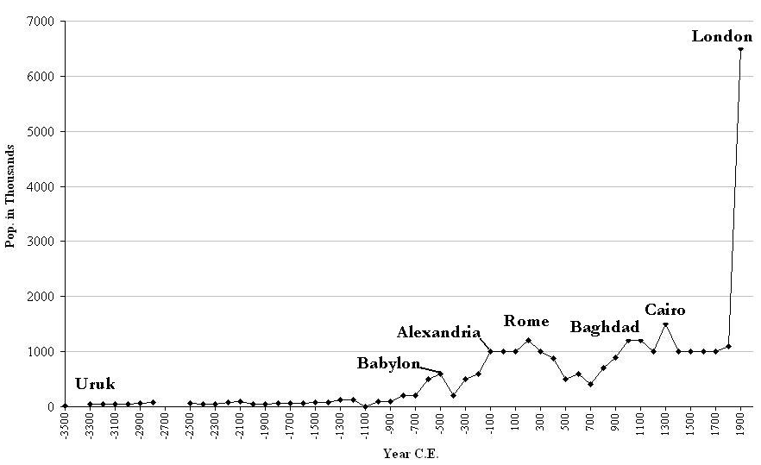
Urban upward sweeps
Figure 4 depicts the logged population sizes of the largest cities in the Central PMN over the past five millennia. The first city size upsweep corresponds with the Uruk expansion in early Bronze Age Mesopotamia. Then there is another upsweep in the Iron Age, a fall-back and then the rise of Islamic Baghdad. The huge size of Baghdad in the tenth century did not really constitute a new ceiling in the evolution of city sizes because it was an outlier that was not replicated for 1000 years. Thus we should call this a surge rather than an upsweep (see Figure 1). So there have been four upward sweeps that led to new plateaus of city growth in the Central System: the original heartland of cities in Mesopotamia and Egypt, the rise of Alexandria and Rome in the Iron Age, then a decline followed by the Baghdad surge, and then the well-known rapid upsweep of modernity in East Asia, Europe, and North America. After the 1950s a new ceiling of around 20 millions is reach by the largest urban agglomerations. Megacities in Brazil, Mexico and China caught up with the largest core cities in this period, causing the global size distribution of cities to flatten in the second half of the 20th century (Chase-Dunn et al. 2006a, 2006b).
Theories of rise, fall and upward sweeps
There are many theories about why systems of interacting polities experience cycles of rise and fall. A thorough overview of the anthropological literature on "cycling" – the rise and fall of large chiefdoms – is presented in David G. Anderson's (1994) The Savannah River Chiefdoms. Chase-Dunn (2005) presents an overview of earlier theories and a new theoretical synthesis based on Peter Turchin's (2003) model of the dynamics of agrarian state growth and decline, network theory, a population pressure iteration model and explanations of the rise and fall of modern hegemons. This approach is further modified below to reincorporate the operation of trade networks. Explaining the upsweeps requires adding a discussion of emergent properties and the increasing geographical scale of interaction networks to the theories of rise and fall. Explaining collapses requires taking account of environmental fragility and resilience, cultural and technological flexibility and other factors examined by Jared Diamond (2005).
Explaining upsweeps
Earlier work on socio-cultural evolution has produced a synthesized "iteration model" of the processes by which hierarchies and new technologies have emerged in regional world-systems since the Paleolithic (Chase-Dunn and Hall 1997: ch. 6). The iteration model assumes a system of societies that are interacting with one another in ways that are important for the reproduction and transformation of social structures and institutions. This comparative world-systems theory uses interaction networks rather than spatially homogenous characteristics to bound regional systems. Bulk goods exchanges are an important network in all systems, and so are alliances and conflicts among polities (the so-called political-military network – PMN). Some systems are also importantly linked by the long-distance exchanges of prestige goods.
While Chase-Dunn and Hall used trade networks to spatially bound world-systems, they left trade out of the iteration model that explains why world-systems evolve. More recent works by McNeill and McNeill (2003) and Christian (2004) have stressed the importance of trade and communications networks in the processes of human socio-cultural evolution. Both of these recent works employ a network node theory of innovation and collective learning that is similar to the human ecology approach developed earlier by Amos Hawley (1971). Innovations are said to be unusually likely to occur at transportation and communications nodes where information from many different sources can be easily combined and recombined.
One advantage of using world-systems as the explicit unit of analysis and of examining the possibility that world-systems may be organized by core/periphery structures is that it allows us to see that there are important and repeated exceptions to the network node theory of innovation. It is often societies out on the edge of a system rather than at the center that either innovate or that successfully implement new strategies and technologies of power, production and trade. Chase-Dunn and Hall (1997: ch. 5) synthesize earlier formulations into a theory of semiperipheral development in which a few of the societies that are in between the core and the periphery of a system are the ones that are most likely to come forth with strategies and behaviors that produce evolutionary transformations and upward mobility. This phenomenon takes various forms in different kinds of systems: semiperipheral marcher chiefdoms, semiperipheral marcher states, semiperipheral capitalist city states, the semiperipheral position of Europe in the larger Afroeurasian world-system, modern semiperipheral nations that rise to hegemony, and contemporary semiperipheral societies that engage in and support novel and potentially transformative economic and political activities.
The network node theory does not well account for the spatially uneven nature of evolutionary change. The cutting edge of evolution moves. Old centers are often transcended by societies out on the edge that are able to rewire network nodes in a way that expands the spatial scale of networks.
There are several possible processes that might account for the phenomenon of semiperipheral development. Randall Collins (1999) has argued that the phenomenon of marcher states conquering other states to make larger empires is due to the marcher state advantage. Being out on the edge of a core region of competing states allows more maneuverability because it is not necessary to defend the rear. This geopolitical advantage allows military resources to be concentrated on vulnerable neighbors. Peter Turchin (2005) argues that the relevant process is one in which group solidarity is enhanced by being on a "metaethnic frontier" in which the clash of contending cultures produces strong cohesion and cooperation within a frontier society, allowing it to perform great feats. Carroll Quigley (1961) distilled a somewhat similar theory from the works of Arnold Toynbee.
But Toynbee also suggested another way in which semiperipheral regions might be motivated to take risks with new ideas, technologies and strategies. Semiperipheral societies are often located in ecologically marginal regions that have poor soil and little water or other disadvantages. Patrick Kirch relies on this idea of ecological marginality in his depiction of the process by which semiperipheral marcher chiefs are most often the conquerors that create island-wide paramount chiefdoms in the Pacific (Kirch 1984). It is quite possible that all these features combine to produce what Alexander Gershenkron (1962) called "the advantages of backwardness" that allow some semiperipheral societies to transform and to dominate regional world-systems.
Iteration revised
For the purposes of explaining upward sweeps we have reformulated the iteration model to focus on state-based systems by adding trade, marcher states, capitalist city states, cities and empires (see Figure 5). The top and right side of the revised iteration model is only slightly modified. Here we have the basic ideas from Marvin Harris and Robert Carneiro as reformulated by Allen Johnson and Timothy Earle (1987) regarding population growth, intensification, environmental degradation, population pressure, emigration, circumscription and conflict, which then lowers or reverses population growth. This is a general model of population ecology and the Malthusian demographic regulator that works for humans as well as for other animal populations. Human world-systems that are unable to invent institutions that protect natural resources, to regulate population growth or to evolve larger polities, hierarchies and/or new technologies of production get stuck in the "nasty right side" of the iteration model (e.g., see Patrick Kirch's [1991] study of the Marquesas). Systems that increase population and that fail to sustain their natural resources, especially those that occupy marginal or fragile environments, may collapse back to a lower level of complexity and hierarchy (Diamond 2005). All human world-systems tend eventually to return to the nasty right side, at least so far, because the scale of resource use, ecological degradation and population growth tends eventually to exceed existing institutional capabilities.
Figure 5. Revised iteration model for empire and city upsweeps in state-based systems
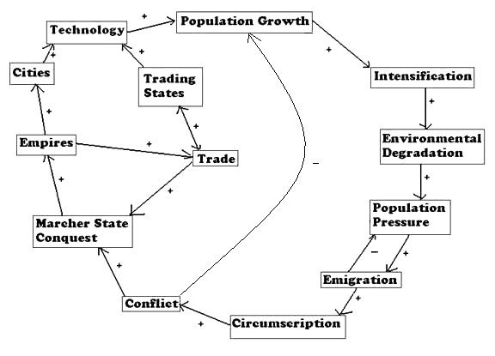

In state-based systems periods of intensified conflict within and between societies lower the resistance to empire formation. A semiperipheral marcher state can "roll up the system" under such circumstances. Thus did the Neo-Assyrians, the Achaemenid Persians, Alexander, the Romans, the Islamic Caliphates and the Aztecs produce the core-wide empires that constitute the great upward sweeps of state size in the age of state-based systems.
During the Bronze and Iron Age expansions of the tributary empires a new niche emerged for states that specialized in the carrying trade among the empires and adjacent regions. These semiperipheral capitalist city states were usually "thalassocratic" entities that used naval power to protect sea-going trade (e.g., the Phoenician city-states, Venice, Genoa, Malacca), but Assur on the Tigris, the "Old Assyrian city-state and its colonies", was a land-based example of this phenomenon that relied mainly upon donkey caravans for transportation (Larsen 1976). The semiperipheral capitalist city-states did not typically conquer other states to construct large empires, but their trading and production activities promoted regional commerce and the emergence of markets within and between the tributary states.
The expansion of trading and communication networks facilitated the growth of empires and vice versa. The emergence of agriculture, mining and manufacturing production of surpluses for trade gave conquerors an incentive to expand state control into distant areas. And the apparatus of the empire was itself often a boon to trade. The specialized trading states promoted the production of trade surpluses, bringing peoples into commerce over wide regions, and thus they helped to create the conditions for the emergence of larger empires.
Capitalist city-states and ports of trade
Sabloff and Rathje (1975) contend that the same settlement can oscillate back and forth between being a "port of trade" (neutral territory that is used for administered trade between different competing states and empires – see Polanyi et al. 1957) and a "trading port" (an autonomous and sovereign polity that actively pursues policies that facilitate profitable trade). This latter corresponds to what Chase-Dunn and Hall (1997) mean by a semiperipheral capitalist city-state. Sabloff and Rathje also contend that a trading port is more likely to emerge during a period in which other states within the same region are weak, whereas a port of trade is more likely during a period in which there are large strong states.
Figure 6. Mayan depiction of a large canoe
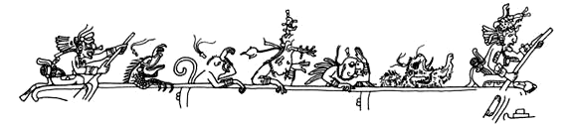

The archaeological investigation of Cozumel carried out by Sabloff and Rathje was designed to try to test the hypothesis that Cozumel had been a trading state with a cosmopolitan and tolerant elite during the so-called Decadent period of the Mayan state system just before the arrival of the Spanish in the sixteenth century. If Sabloff and Rathje are right, trading ports (semiperipheral capitalist city-states) may more likely to be autonomous and to prosper during the fall part of the cycle of rise and fall when tributary states and empires are relatively weak.
Several analysts have contended that world-systems oscillate between periods in which they are more integrated by horizontal networks of exchange versus periods in which corporate and hierarchical organization is more predominant (Ekholm and Friedman 1982; Blanton et al. 1996; White, Tambayong, and Kejzar, 2008). Arrighi (1994, 2006) contends that modern "systemic cycles of accumulation" display a somewhat similar alternation, with the Genoese-Portuguese network-based cycle followed by a more corporate Dutch organized cycle and that by a more network-based British cycle and then a more corporate US cycle. These oscillations may be composed by the alternative successes and failures of tributary marcher states and capitalist city-states, but in the long run it was the capitalist city-states that transformed the state-based systems into the global capitalist system of today. The long-term trend toward commercialization and the integration of large regions into networks of market exchange may have made greater gains during periods in which tributary states were relatively weak. But Arrighi contends that the deepening of commodity production made gains under both network and corporate forms of hegemony.
So what does this have to do with upward sweeps of empires and upward sweeps of city sizes? Regarding upward sweeps of empires, if semiperipheral capitalist city states were major agents of the spread of commodified exchange and the expansion and intensification of trade, then upward sweeps in which larger states emerged to encompass regions that had already been unified by trade should have occurred after a period in which semiperipheral capitalist city-states had been flourishing.
Regarding upward sweeps of city sizes, these should have followed upward sweeps of empire sizes because it was empires that created the largest cities as their capitals. The settlements of semiperipheral capitalist city-states were typically smaller than the capital cities of empires. It was not until the rise of London that a capitalist city became the largest city in a world-system.
The question of the timing of upward sweeps to new levels is entirely germane to the problem of modeling global state formation. So also is the issue of how unusually large states have been formed in the past. Upward sweeps have mainly been instances of a semiperipheral marcher state conquering and unifying adjacent older core states and nearby peripheral areas. Conquest of adjacent territories has been the main mechanism of large-scale political integration in the past. But the pattern of hegemonic rise and fall in the modern world-system has been different. The most powerful states, the hegemons (the Dutch, the British and the United States), have fought semiperipheral challengers (e.g., Napoleonic France and Germany) to prevent the emergence of core-wide empires. We contend that this is because the hegemons are the most capitalist states in the system, the ones for whom economic success is most closely tied to the ability to make superprofits on the technological rents that return from new lead technologies.
Figure 7. Core-wide empire vs. modern hegemony
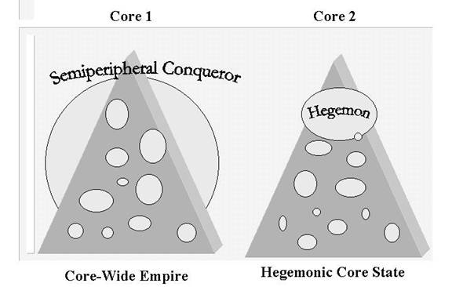
Only during hegemonic decline have the modern capitalist hegemons shown a tendency toward "imperial overreach" in which their military power is employed in a last ditch effort to prop up a declining economic hegemony. These efforts have not been successful, and a new hegemon only emerges after a period of hegemonic rivalry and world war. This is a primitive method of choosing "global leadership" that we can no longer afford to employ because of the existence of weapons of mass destruction. This is analogous to the succession problem within states. The further construction and strengthening of institutions that can peacefully resolve the struggle for hegemony is of the first importance for our very survival as a species.
The approach that we propose is to model the main causes of state formation and upward sweeps taking into account the ways in which the basic processes have been altered by the emergence of new institutions (Korotayev 2006b). We elaborate and improve upon the recent work of Robert Bates Graber (2004). Graber develops both an ahistorical and an historical population pressure model of political integration. His ahistorical model is a very simplified version of the iteration model that includes population growth rates and the number of independent polities. Graber's historical model takes account of the emergence of the League of Nations and the United Nations. But we add the rise and fall cycle, the emergence of markets and capitalism, and the growth of other international political organizations and non-governmental organizations to our model of the evolution of global governance.
The main political structure of global governance in the modern world-system has been, and remains, the international system of states as theorized and constituted in the Peace of Westphalia. This international system of competing and allying national states was extended to the periphery of the modern world-system in two large waves of decolonization of the colonial empires of core powers. The modern system already differed from earlier imperial systems in that its core remained multicentric rather than being occasionally conquered and turned into a core-wide empire. Instead, empires became organized as distant peripheral colonies rather than as conquered adjacent territories. Earlier instances of this type of colonial empire were produced by thalassocratic states, mainly semiperipheral capitalist city-states that specialized in trade (e.g., Carthage, Venice, etc.). In the modern system this form of colonial empire became the norm, and the European core states rose to global hegemony by conquering and colonizing the Americas, Asia and Africa in a series of expansions (see Figure 8). The international system of sovereign states was extended to the colonized periphery in two large waves of decolonization (see Figure 8). After a long-term trend in which the number of independent states on Earth had been decreasing, that number rose again with decolonization and the core states decreased in size when they lost their colonial empires.
Extension of the state system to the periphery
The decolonization waves were part of the formation of a truly global polity of states. The system of European core states, each with its own colonial empire in Asia, Africa and the Americas, became reorganized as a global system of sovereign states. Most of the former colonies remained in the non-core and new forms of neo-colonialism emerged to allow the core states to continue to exploit the non-core states. But one of the early decolonized regions, "the first new nation", rose to core status and then to become the largest hegemon the modern world-system has yet seen – the United States of America. The doctrine of the national self-determination, long a principle of the European state system, was extended in principle to the periphery, but new forms of economic imperialism continued to reproduce the core/periphery hierarchy.
Figure 8. Waves of colonization and decolonization based on Henige's Colonial Governors (1970)
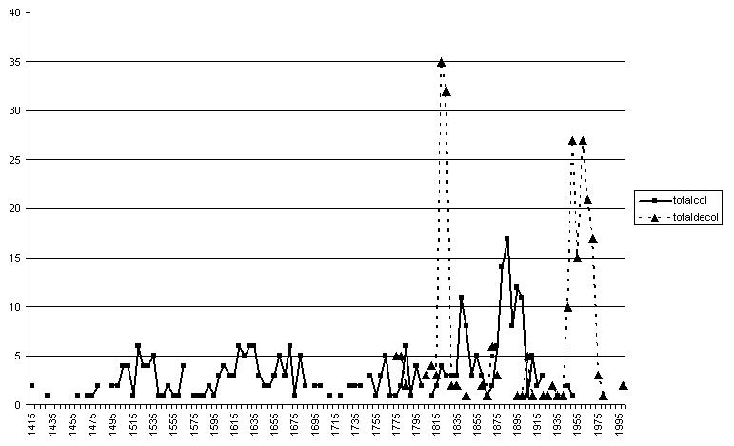
Our historical model adds marketization, decolonization, new lead technologies, the rise and fall of hegemons, and the rise of international political organizations to the population pressure model in order to forecast future trajectories of global state formation. Because we are sensitive to the cyclical nature of many processes, we can easily consider how downward plunges and possible collapses might affect the probable trajectories of global state formation.
We also take into account the structural differences between recent and earlier periods. For example, the period of British hegemonic decline moved rather quickly toward conflictive hegemonic rivalry because economic competitors such as Germany were able to develop powerful military capabilities. The US hegemony has been different in that the United States ended up as the single superpower after the decline of the Soviet Union. Some economic challengers (Japan and Germany) cannot easily play the military card because they are stuck with the consequences of having lost the last World War. This, and the immense size of the US economy, will probably slow the process of hegemonic decline down relative to the speed of the British decline (See Figure 9 and Chase-Dunn, Jorgensen, Reifer, and Lio 2005).
Figure 9. Trajectory of United States hegemony as indicated by shares of
the GDP of Core States
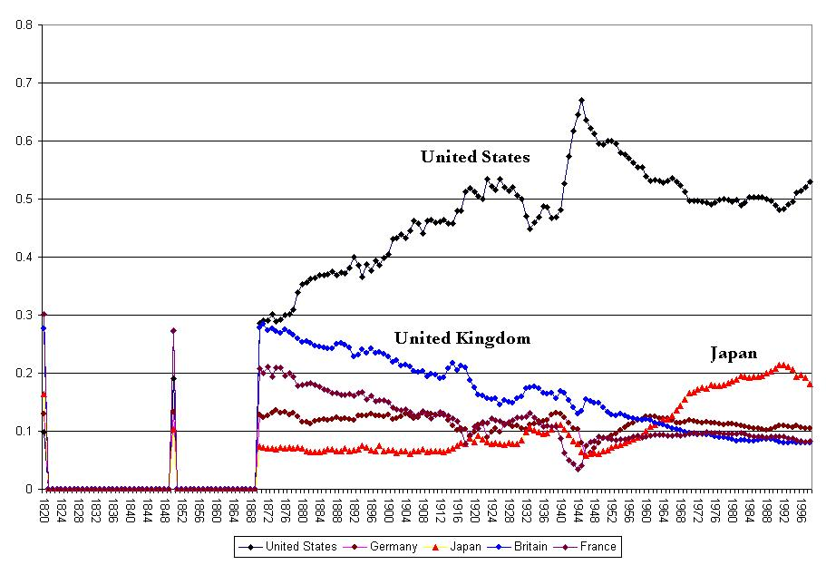

Our modeling of the global future also considers changes in labor relations, urban-rural relations, the nature of emergent city regions, and the shrinking of the global reserve army of labor (Silver 2003).
The trajectory of modern global governance and political
globalization
Global governance refers to the nature of power institutions in a world-system. So there has been global governance all along. It has not emerged. But it has changed its nature. The modern world-system was originally the European interstate system in which states allied and fought with one another for territory, control of trade routes, and other resources. As Europe became hegemonic over the rest of the world this system became the predominant form of global governance. The basic logic is the anarchy of nations and geopolitics, but this anarchy had a cultural backdrop that the English school of international relations calls international society (Buzan and Little 2000). In earlier millennia Christendom and the other world religions proclaimed and elaborated an ethic that differentiated the world into civilized, barbarian and savage peoples. Cannibalism, ritual human sacrifice and polygyny were banned. A degree of individualism and humanism emerged in the context of the European enlightenment, and the rules of this civilized culture were applied in geopolitical alliances and conflicts. Wars with other civilized peoples were somewhat different than wars with barbarians or savages. Thus did a moral order come to stand behind the anarchy of nations, a moral order that condoned less ethical forms of coercion when dealing with the peoples of the non-core.
The interstate system that emerged in Europe soon adopted institutions that had previously been elaborated in relations among the Italian city-states during the Renaissance. Diplomatic immunity and rules of engagement came to regulate warfare within the core. These rules were made explicit in the treaty of Westphalia in 1644. The balance of power among states was reinforced by the notion of "general war", which prescribed that all states should band together against any "rogue state" that aggressively attacked another. Theorists of the international system often portray this as a great discovery that distinguished the European interstate system from others, especially those more hierarchical interstate systems known to exist in South Asia and East Asia. But similar institutions are known to have existed in much earlier interstate systems (e.g., the system of Sumerian city-states in the early Bronze Age). The European balance of power system coincided with the emergence of Dutch hegemony in the seventeenth century, and indeed it was the Dutch state, arguably the first capitalist nation-state, that played a pivotal power-balancing role in that century. The growing importance of the accumulation of profits shifted the logic of state power increasingly away from tribute and taxation without dispensing with these entirely. Indeed, some states continued to pursue the tributary logic, but they were consistently beaten in competition with newly emerging capitalist states in the core. Thus did the logic of adjacent tributary empires become increasingly supplanted by a new imperial logic that sought the control of trade routes and access to valuable raw materials and labor that could contribute to the profitable production of commodities.
The emergence of colonial empires corresponded with the reproduction of a multicentric core in which several European states allied with and fought each other. This system came to be taken for granted by international relations theorists as the natural mode of global governance. Despite that earlier systems had repeatedly seen the emergence of "universal states" such as the Roman Empire, the notion of a global state is now unthinkable because IR theorists define states in relationship to each other. This is part of the strong institutionalization of the modern interstate system – an historically constructed structure that has come to be seen as natural.
The oscillation of earlier systems morphed into the rise and fall of hegemonic core powers in the modern system. A series of hegemons emerged from the semiperiphery – the Dutch, the British and the United States. This cycle or sequence has itself evolved, with the hegemons becoming increasingly larger with respect to the size of the whole system, and with the institutional nature of states and finance capital getting reorganized in each "systemic cycle of accumulation" (Arrighi 1994). Tributary empires survived into the nineteenth century, but they were increasingly supplanted by nation-states. And the colonial empires of the European states brought the whole Earth into a single relatively homogenous global polity for the first time. The penetration of Qing China in the 19th century brought this last semi-independent center into the fold of the now-predominant Europe-centered system of states.
The evolution that occurred with the rise and fall of the hegemonic core powers needs to be seen as a sequence of forms of world order that evolved to solve the political, economic and technical problems of successively more global waves of capitalist accumulation. The expansion of global production involved accessing raw materials to feed the new industries, and food to feed the expanding populations (Bunker and Ciccantell 2004). As in any hierarchy, coercion is a very inefficient means of domination, and so the hegemons sought legitimacy by proclaiming leadership in advancing civilization and democracy. But the terms of these claims were also employed by those below who sought to protect themselves from exploitation and domination. And so the evolution of hegemony was produced by elite groups competing with one another to stay on top or to rise in a context of successive powerful challenges from below. World orders were contested and reconstructed in a series of world revolutions that began with the Protestant Reformation (Arrighi, Hopkins, and Wallerstein 1989; Boswell and Chase-Dunn 2000). The idea of world revolution is a broad notion that encompasses all kinds of resistance to hierarchy regardless of whether or not it is coordinated. Years that symbolize the major world revolutions after the Protestant Reformation are 1789, 1848, 1917, 1968 and 1989. Arguably another one is brewing now.
Political globalization and global party formation
The nineteenth century saw the beginning of what we shall call political globalization – the emergence and growth of an overlayer of regional and increasingly global formal organizational structures on top of the interstate system. We conceptualize political globalization analogously to our understanding of economic globalization – the relative strength and density of larger versus smaller interaction networks and organizational structures (Chase-Dunn, Kawano, and Brewer 2000). The most obvious indication of political globalization is the evolution of the uneven and halting upward trend in the transitions from the Concert of Europe to the League of Nations and the United Nations. The waves of international political integration began after the Napoleonic Wars early in the nineteenth century. Britain and the Austro-Hungarian Empire organized the "Concert of Europe" that was intended to prevent future French revolutions and Napoleonic adventures. After World War I the League of Nations emerged as a weak proto-state designed to provide collective security by preventing future "Great Wars". The failure of the United States to take up the mantle of British hegemony during the Age of Extremes, and the weakness of the League (which the US never joined) led to another round of unbelievably destructive world war. After World War II a somewhat stronger proto-world-state, the United Nations Organization, emerged and the United States stepped firmly into the role of hegemon.
The trend toward political globalization can also be seen in the emergence of the Bretton Woods institutions (the International Monetary Fund and the World Bank) and the more recent restructuring of the General Agreement of Tariffs and Trade as the World Trade Organization, and the heightened visibility of other international fora (the Trilateral Commission, the Group of Seven [Eight]).
Some of the proponents of a recent stage of global capitalism contend that strong transnational capitalist firms and there political operatives working within national states have combined with existing international organizations to constitute an emerging transnational capitalist state (e.g., Robinson 2004). This version of the global state formation hypothesis claims that a rather integrated transnational capitalist class has emerged since the 1970s, and that this global class uses both international organizations and existing national state apparatuses as coordinated instruments of its rule. A related perspective holds that the US has so completely dominated the other core powers since World War II that it constitutes a world empire (Gowan 2006). These approaches probably overstate the degree of integration of class governance on a global scale.
The current reality is that both the old system of nationally competing capitalist classes and a very high degree of global integration now exist and these contend with one another to an extent that is much greater than in the past. An internationally integrated global capitalist class was also in formation in the second half of the nineteenth century, but this did not prevent the world polity from descending into the violent interimperial rivalry of the two twentieth century World Wars (Barr et al. 2006). The degree of integration of both elites and masses is undoubtedly greater in the current round of globalization, but will it be strongly integrated enough to allow for readjustments without descent into a repetition of the Age of Extremes? That is the question.
In addition to the formation of regional and global international organizations, the nineteenth and twentieth centuries also saw the emergence of transnational social movements and the enlargement of what has come to be known as global civil society. These have also altered the form of global governance by providing expanded arenas in which individuals and organizations participate directly in world politics rather than through the mediating shell of national states. Specialized international and transnational non-governmental organizations (e.g., the International Postal Union) exploded in the middle of the 19th cen-tury (Murphy 1994; Mattelart 2000). Abolitionism, feminism and the labor movement became increasingly transnational in nature. Earlier local movements had also had a transnational aspect because sailors, pirates, slaves and indentured servants carried ideas and sentiments back and forth across the Atlantic (Linebaugh and Rediker 2000) but the large global consequences of these movements occurred when many mainly local developments (e.g., slave revolts) occurred synchronously.
The Black Jacobins of the Haitian revolution, by depriving Napoleonic France of important sources of food and wealth, played a role in the rise of British hegemony (Santiago-Valles 2005). These kinds of effects of resistance from below became stronger in the middle decades of the 19th century – the years around the world revolution of 1848. This is usually thought of in terms of developments in Europe, but millenarian and revolutionary ideas traveled to the New World to play a role in the "burned over district" in upstate New York, where several important new Christian sects and utopian communes emerged. And in China the huge Taiping peasant and landless rebellion was fomented by a charismatic leader who became convince that he was Jesus Christ's younger brother after reading some pamphlets supplied by a millenarian Baptist preacher from Tennessee. Non-elites were becoming transnational activists. Elites had long been involved in international and transnational activism as statesmen, churchmen, businessmen and scientists. The decreasing costs of long-distance communications and transportation were now allowing some non-elites to play a more important and direct role in world politics.
These developments ramped up during the "Age of Extremes" (Hobsbawm 1994), the first half of the twentieth century. Internationalism in the labor movement had emerged in the second half of the nineteenth century. Global political parties were becoming active in world politics, especially during and after the world revolution of 1917. The Communist International (Comintern) convened large conferences of representatives from all over the globe in Moscow in the early years of the 1920s. The history and evolution of global party formation is treated in several recent works on this topic that are considering current developments at the World Social Forum (Chase-Dunn and Reese 2010; Sehm-Patomaki and Ulvila 2007). Global party formation is playing a role in deepening the participation of the peoples of the Earth in world politics, and thus in the process of global state formation.
The Comintern was abolished in 1943, though the Soviet Union continued to pose as the protagonist of the world working class until its demise in 1989. In 1938 Trotskyists organized the Fourth International to replace the Comintern, which they saw as having been captured by Stalinism. The Fourth International suffered from a series of sectarian splits and the huge communist-led rebellions that emerged during and after World War II were led by either pro-Soviet or Maoist organizations that held the Fourth International to be illegitimate. The Bandung Conference in 1954 was an important forum in which the leaders of the emerging nations explicated Third World interests. But the heady days of transnational social movements were overshadowed by the Cold War and the hegemonic Keynesian national development project. It was only after the attack on the developmental state model by Reaganism-Thatcherism and the demise of the Soviet Union that a new wave of transnational activists began to form into a global justice movement.
Ulrich Beck's (2005) effort to rethink the nature of power in a globalized world makes the claim that the power of global capitalist corporations is based mainly on the threat of the withdrawal of capital investment, and thus it does not need to be legitimated. Beck further argues that the transnational capitalist class does not need to form political parties, because its power is translegal and does not need legitimation. While this may be true to some extent, it is still the case that one may discern an evolution of political ideology that is promulgated by the lords of capital and the states that represent them. The Keynesian national development project that was the hegemonic ideology of the West from World War II to the 1970s was replaced by neoliberalism, a rather different set of claims and policies. William Carroll (2007) traces the history of liberalism and neoliberalism as it emerges from the eighteenth century, takes hiding in monastery-like think tanks during the heyday of Keynesianism, and then reemerges as Reaganism-Thatcherism in the 1970s and 1980s. The further evolution can be seen in the rise of the neoconservatives in the 1990s, and concerns for dealing with those pockets of poverty that seem impervious to market magic in the writings of such neoliberals as Jeffrey Sachs (2005). Stephen Gill's (2000) suggestive discussion of "the post-modern prince" – a left global political party emerging out of the global justice movement, also proposes an analysis of corporate media, think-tanks, and institutions such as the World Economic Forum as participants in a process of global political contestation. Necessary or not, the transnational capitalist class and its organic intellectuals engage in efforts to legitimate its own power, and this can be seen to interact with popular forces. Thus did the advertised concerns of the World Economic Forum shifted considerably after the rise of the World Social Forum.
It is likely that the US will be "the last of the hegemons" (Taylor 1986). New economic challengers are emerging, but the role of political hegemon played by a single national state is likely to be played within a much stronger context of multilateral global governance. Some see the Peoples' Republic of China as a potential future hegemon. There is little doubt that the PRC will play an important economic and political role in future global governance despite its daunting environmental problems and extreme dependence on the bubble economy of the US dollar.
The European Union process itself only creates a larger core state that can contend with the United States, and as such it does not change the logic of the interstate system and global governance by hegemony. But the example of the emergence of a multinational state apparatus out of a process of peaceful politics, rather than as a result of conquest, holds important lessons, both positive and negative, for the larger process of global state formation. It shows it can be done.
The revised iteration model presented above both explains upsweeps of the past and continues to be relevant for understanding the present and the future. The multiple local and regional and largely disconnected human interaction networks have become strongly linked into a single global system. The treadmill of population growth has been stopped in the core countries, and it appears to be slowing in the non-core. The global human population is predicted to peak and to stabilize in the decades surrounding 2075 at somewhere between eight and twelve billion. Thus population pressure will be a major challenge in the decades of the twenty-first century. The exit option is mainly blocked off and a condition of global circumscription exists. Malthusian corrections are not a thing of the past, as illustrated by continuing warfare and genocide. Famine has been brought under control, but future shortages of clean water, good soil, non-renewable energy sources, and food might bring that old horseman back. Huge global inequalities complicate the collective action problem. First world people have come to feel entitled, and non-core people want to have their own cars, large houses and electronic geegaws. The ideas of human rights and democracy are still contested, but they have become so widely accepted that existing institutions of global governance are illegitimate even by their own standards. The demand for global democracy and human rights can only be met by reforming or replacing the existing institutions of global governance with institutions that have some plausible claim to represent the will and interests of the majority of the world's people. That means global state formation, although most of the contemporary protagonists of global democracy do not like to say it that way.
There is nothing inevitable about global state formation, especially within the next several decades. But the continuing decline of US hegemony and the issue of hegemonic transition put the problem in the middle of the table of world politics. A United States of Earth will be needed to deal with the social, political, economic and environmental problems that our species has produced for itself. The question is whether that upward sweep will occur soon and relatively painlessly or after a long period of Malthusian correction similar to what happened in the first half of the twentieth century.
Bibliography
Algaze, G. 1993. The Uruk World-System. Chicago, IL: University of Chicago Press.
Amin, S. 1997. Capitalism in the Age of Globalization. London: Zed Press.
Anderson, D. G. 1994. The Savannah River Chiefdoms. Tuscaloosa, AL: University of Alabama Press.
Arrighi, G. 1994. The Long Twentieth Century. London: Verso.
Arrighi, G. 2006. Spatial and Other "Fixes" of Historical Capitalism. Global Social Change: Historical and Comparative Perspectives / Ed. by C. Chase-Dunn and S. Babones, pp. 201–212. Baltimore, MD: Johns Hopkins University Press.
Arrighi, G., T. K. Hopkins, and I. Wallerstein. 1989. Antisystemic Movements. London: Verso.
Barr, K., S. Lio, Ch. Schmitt, A. Carlson, K. Lawrence, J. Krause, Y. Hsu, C. Chase-Dunn, and T. E. Reifer. 2006. Global Conflict and Elite Integration in the 19th and Early 20th Centuries. IROWS Working Paper No. 27 (http://irows.ucr.edu/ papers/irows27/irows27.htm).
Beck, U. 2005. Power in the Global Age. Malden, MA: Polity Press.
Bergesen, A., and R. Schoenberg. 1980. Long Waves of Colonial Expansion and Contraction 1415–1969. Studies of the Modern World-System / Ed. by A. Bergesen, pp. 231–278. New York: Academic Press.
Blanton, R., G. M. Feinman, S. A. Kowalewski, and P. N. Peregrine. 1996. A Dual-Processual Theory for the Evolution of Mesoamerican Civilization. Current Anthropology 37: 1–14, 65–68.
Boswell, T., and C. Chase-Dunn. 2000. The Spiral of Capitalism and Socialism: Toward Global Democracy. Boulder, CO: Lynne Reinner.
Brenner, R. 2002. The Boom and the Bubble. London: Verso.
Bunker, S., and P. Ciccantell. 2004. Globalization and the Race for Resources. Baltimore, MD: Johns Hopkins University Press.
Buzan, B., and R. Little. 2000. International Systems and World History. New York, NY: Oxford University Press.
Carneiro, R. L. 1978. Political Expansion as an Expression of the Principle of Competitive Exclusion. Origins of the State: The Anthropology of Political Evolution / Ed. by R. Cohen and E. R. Service, pp. 205–223. Philadelphia, PA: Institute for the Study of Human Issues.
Carneiro, R. L. 2004. The Political Unification of the World: Whether, When and How – Some Speculations. Cross-Cultural Research 38(2): 162–177.
Carroll, W. K. 2007. Hegemony and Counter-Hegemony in a Global Field. Studies in Social Justice 1(1): 36–66.
Chase-Dunn, C. 1990. World State Formation: Historical Processes and Emergent Necessity. Political Geography Quarterly 9(2): 108–30 (http://irows.ucr.edu/papers/ irows1.txt).
Chase-Dunn, C. 1998. Global Formation. Lanham, MD: Rowman and Littlefield.
Chase-Dunn, C. 2005. Upward Sweeps in the Historical Evolution of World-Systems. IROWS Working Paper No. 20 (http://irows.ucr.edu/papers/ irows20/irows20.htm).
Chase-Dunn, C., A. Alvarez, H. Inoue, R. Niemeyer, A. Carlson, B. Fierro, and K. Lawrence. 2006a. Upward Sweeps of Empire and City Growth since the Bronze Age. IROWS Working Paper No. 22 (http://irows.ucr.edu/papers/irows22/irows22.htm).
Chase-Dunn, C., A. Alvarez, A. Jorgenson, R. Niemeyer, D. Pasciuti, and J. Weeks. 2006b. Global City Networks in World Historical Perspective. IROWS Working Paper
No. 28 (http://irows.ucr.edu/papers/irows28/irows28. htm).
Chase-Dunn, C., A. Alvarez, and D. Pasciuti. 2005. Power and Size: Urbanization and Empire Formation in World-Systems. The Historical Evolution of World-Systems / Ed. by C. Chase-Dunn and E. N. Anderson, pp. 92–112. New York: Palgrave.
Chase-Dunn, C., and T. D. Hall. 1997. Rise and Demise: Comparing World-Systems. Boulder, CO: Westview.
Chase-Dunn, C., A. Jorgenson, T. Reifer, and S. Lio. 2005. The US Trajectory:
A Quantitative Reflection. Sociological Perspectives 48(2): 233–254.
Chase-Dunn, C., Y. Kawano, and B. Brewer. 2000. Trade Globalization since 1795: Waves of Integration in the World-System. American Sociological Review 65: 77–95.
Chase-Dunn, C., and E. S. Manning. 2002. City Systems and World-Systems: Four Millennia of City Growth and Decline. Cross-Cultural Research 36(4): 379–398.
Chase-Dunn, C., and B. Podobnik. 1995. The Next World War: World-System Cycles and Trends. Journal of World-Systems Research 1(6) (http://jwsr.ucr.edu/archive/ vol1/ v1_n6.php).
Chase-Dunn, C., and E. Reese. 2010. Global Party Formation in World Historical Perspective. Global Party Formation / Ed. by K. Sehm-Patomaki and M. Ulvila. London: Zed Press (forthcoming).
Chase-Dunn, C., E. Reese, M. Herkenrath, R. Alvarez, E. Gutierrez, L. Kim, and C. Petit. 2010. North-South Contradictions and Bridges at the World Social Forum. North and South in the World Political Economy / Ed. by R. Reuveny and
W. R. Thompson. Blackwell (forthcoming).
Christian, D. 2004. Maps of Time. Berkeley, CA: University of California Press.
Collins, R. 1999. Macro-History: Essays in the Sociology of the Long Run. Palo Alto: Stanford University Press.
Denemark, R., J. Friedman, B. K. Gills, and G. Modelski. 2000. (Eds.). World System History: The Social Science of Long-Term Change. London: Routledge.
Diamond, J. 2005. Collapse. New York: Viking.
Ekholm, K., and J. Friedman. 1982. "Capital" Imperialism and Exploitation in the Ancient World-Systems. Review 6(1): 87–110.
Fletcher, R. 1995. The Limits of Settlement Growth. Cambridge, NY: Cambridge University Press.
Florini, A. 2005. The Coming Democracy: New Rules for Running a New World Order. Washington, D.C.: Brookings Institution.
Frank, A. G., and B. K. Gills. 1993. (Eds.). The World System: Five Hundred Years or Five Thousand? London: Routledge.
Gershenkron, A. 1962. Economic Backwardness in Historical Perspective. Cambridge, MA: Harvard University Press.
Gill, S. 2000. Toward a Post-Modern Prince? The Battle of Seattle as a Moment in the New Politics of Globalization. Millennium 29(1): 131–140.
Glasius, M., and J. Timms. 2006. The Role of Social Forums in Global Civil Society: Radical Beacon or Strategic Infrastructure. Global Civil Society 2005/6 / Ed. by M. Glasius, M. Kaldor, H. Anheier, and F. Holland, pp. 190–238. London: Sage.
Goldfrank, W. L. 1999. Beyond Hegemony. The Future of Global Conflict / Ed. by
V. Bornschier and C. Chase-Dunn. London: Sage.
Gowan, P. 2006. Contemporary Intra-Core Relations and World Systems Theory. Global Social Change / Ed. by C. Chase-Dunn and S. Babones, pp. xxx. Baltimore, MD: Johns Hopkins University Press.
Graber, R. B. 2004. Is a World State Just a Matter of Time? A Population-Pressure Alternative. Cross-Cultural Research 38(2): 147–161.
Grinin, L. E. 2006. Periodization of History: A Theoretic-Mathematical Analysis. History and Mathematics: Analyzing and Modeling Global Development / Ed. by L. E. Gri-nin, V. de Munck, A. V. Korotayev, pp. 10–38. Moscow: KomKniga/URSS.
Grinin, L. E., and A. V. Korotayev. 2006. Political Development of the World System: A Formal Quantitative Analysis. History and Mathematics. Historical Dynamics and Development of Complex Societies / Ed. by P. Turchin, L. Grinin, A. Korotayev, V. de Munck, pp. 115–153. Moscow: KomKniga/URSS.
Hawley, A. 1971. Urban Society: An Ecological Approach. New York: Ronald Press Co.
Henige, D. 1970. Colonial Governors. Madison, WI: University of Wisconsin Press.
Hobsbawm, E. J. 1994. The Age of Extremes: A History of the World, 1914–1991. New York: Pantheon.
Johnson, A. L. 2004. Why not to Expect a "World State". Cross-Cultural Research 38(2): 119–132.
Johnson, A. W., and T. Earle. 1987. The Evolution of Human Societies: From Foraging Group to Agrarian State. Stanford, CA: Stanford University Press.
Kaldor, M. 2003. Global Civil Society: An Answer to War. Cambridge: Polity Press.
Keck, M. E., and K. Sikkink. 1998. Activists beyond Borders: Advocacy Networks in International Politics. Ithaca, NY: Cornell University Press.
Kennedy, P. 1988. The Rise and Fall of the Great Powers: Economic Change and Military Conflict from 1500–2000. New York: Random House.
Kirch, P. V. 1984. The Evolution of Polynesian Chiefdoms. Cambridge, NY: Cambridge University Press/
Kirch, P. V. 1991. Chiefship and Competitive Involution: The Marquesas Islands of Eastern Polynesia. Chiefdoms: Power, Economy and Ideology / Ed. by T. Earle, pp. 119–145. Cambridge, NY: Cambridge University Press.
Korotayev, A. 2006a. The World System Urbanization Dynamics: A Quantitative Analysis. History and Mathematics: Historical Dynamics and Development of Complex Societies / Ed. by P. Turchin, L. Grinin, A. Korotayev, V. C. de Munck, pp. 44–62. Moscow: KomKniga/URSS.
Korotayev, A. 2006b. The World System History Periodization and Mathematical Models of Socio-Historical Processes. History and Mathematics: Analyzing and Modeling Global Development / Ed. by L. Grinin, V. C. de Munck, and A. Korotayev, pp. 39–98. Moscow: URSS.
Korotayev, A., and L. Grinin. 2006. Urbanization and Political Development of the World System: A Comparative Quantitative Analysis. History and Mathematics. Historical Dynamics and Development of Complex Societies / Ed. by P. Turchin,
L. Grinin, A. Korotayev, and V. de Munck, pp. 115–153. Moscow: KomKniga/ URSS.
Larsen, M. T. 1976. The Old Assyrian City-State and Its Colonies. Copenhagen: Akademisk Forlag.
Linebaugh, P., and M. Rediker. 2000. The Many-Headed Hydra: Sailors, Slaves, Commoners and the Hidden History of the Revolutionary Atlantic. Boston, MA: Beacon.
Mattelart, A. 2000. Networking the World, 1794–2000. Minneapolis, MN: University of Minnesota Press.
Marano, L. A. 1973. A Macrohistoric Trend toward World Government. Behavior Science Notes 8(1): 35–39.
McMichael, Ph. 2000. Development and Social Change: A Global Perspective. Thousand Oaks, CA: Pine Forge.
McNeill, J. and W. H. McNeill. 2003. The Human Web. New York: Norton.
Modelski, G. 2003. World Cities: –3000 to 2000. Washington, D.C.: Faros 2000.
Modelski, G. 2005. Long Term Trends in World Politics. Journal of World-Systems Research 11(2): 195–206.
Modelski, G., and W. R. Thompson. 1996. Leading Sectors and World Powers:
The Co-evolution of Global Politics and Economics. Columbia, SC: University of South Carolina Press.
Moghadam, V. 2005. Globalizing Women. Baltimore, MD: Johns Hopkins University Press.
Murphy, C. 1994. International Organization and Industrial Change: Global Governance since 1850. New York: Oxford.
Naroll, R. 1967. Imperial Cycles and World Order. Peace Research Society: Papers 7: 83–101.
O'Rourke, K. H., and J. G. Williamson. 2000. Globalization and History. Cambridge, MA: MIT Press.
Peregrine, P. N., M. Ember, and C. R. Ember. 2004. Predicting the Future State of the World Using Archaeological Data: An Exercise in Archaeomancy. Cross-Cultural Research 38(2): 133–146.
Pijl, K. van der. 1984. The Making of an Atlantic Ruling Class. London: Verso.
Polanyi, K., C. M. Arensberg, and H. W. Pearson. 1957. (Eds.). Trade and Market in the Early Empires. Chicago, IL: Regnery.
Quigley, C. 1961. The Evolution of Civilizations. Indianapolis, IN: Liberty Press.
Rennstich, J. 2005. Chaos or ReOrder? The Future of Hegemony in a World-System in Upheaval. Journal of World-Systems Research 11(2): 209–238 (http://jwsr.ucr.edu/ archive/vol11/number2/pdf/jwsr-v11n2-rennstich.pdf).
Robinson, W. R. 2004. A Theory of Global Capitalism. Baltimore, MD: Johns Hopkins University Press.
Roscoe, P. 2004. The Problems with Polities: Some Problems in Forecasting Global Political Integration. Cross-Cultural Research 38(2): 102–118.
Sabloff, J., and W. J. Rathje. 1975. A Study of Changing Pre-Columbian Commercial Systems. Cambridge, MA: Peabody Museum of Archaeology and Ethnology, Harvard University.
Sachs, J. 2005. The End of Poverty: Economic Possibilities for Our Time. New York: Penguin.
Sanderson, S. K. 1990. Social Evolutionism. Cambridge, MA: Blackwell.
Sanderson, S. K. 2007. Evolutionism and Its Critics. Boulder, CO: Paradigm.
Santiago-Valles, K. 2005. World Historical Ties among "Spontaneous" Slave Rebellions in the Atlantic. Review 28(1): 51–84.
Sehm-Patomaki, K., and M. Ulvila. 2007. (Eds.). Global Party Formation. London: Zed Press.
Smith, J., M. Karides et al. 2008. Global Democracy and the World Social Forums. Boulder, CO: Paradigm Publishers.
Smith, M. 2005. Networks, Territories and the Cartography of Ancient States. Annals of the Association of American Geographers 95(4): 832–849.
Silver, B. 2003. Forces of Labor. Cambridge, NY: Cambridge University Press.
Taagepera, R. 1978a. Size and Duration of Empires: Systematics of Size. Social Science Research 7: 108–127.
Taagepera, R. 1978b. Size and Duration of Empires: Growth-Decline Curves, 3000 to 600 B.C. Social Science Research 7: 180–196.
Taagepera, R. 1979. Size and Duration of Empires: Growth-Decline Curves, 600 B.C. to 600 A.D. Social Science History 3(3–4): 115–138.
Taagepera, R. 1997. Expansion and Contraction Patterns of Large Polities: Context for Russia. International Studies Quarterly 41(3): 475–504.
Tarrow, S. 2005. The Dualities of Transnational Contention: "Two Activist Solitudes" or a New World Altogether? Mobilization 10(1): 53–72.
Taylor, P. 1986. The Way the Modern World Works: Global Hegemony to Global Impasse. New York: Wiley.
Taylor, P. 2004. World City Network: A Global Urban Analysis. London: Routledge.
Turchin, P. 2003. Historical Dynamics: Why States Rise and Fall. Princeton, NJ: Princeton University Press.
Turchin, P. 2005. War and Peace and War: The Life Cycles of Imperial Nations. New York: Pi Press.
Thompson, W. R. 2001. (Ed.). Evolutionary Interpretations of World Politics. London: Routledge.
Wallerstein, I. 1984. The Three Instances of Hegemony in the History of the Capitalist World-Economy. Current Issues and Research in Macrosociology, International Studies in Sociology and Social Anthropology, Vol. 37 / Ed. by G. Lenski, pp. 100–108. Leiden: E. J. Brill.
Wallerstein, I. 2000. The Essential Wallerstein. New York: New Press.
Wendt, A. 2003. Why a World State is Inevitable. European Journal of International Relations 9(4): 491–542.
White, D. R., L. Tambayang, and N. Kejzar. 2008. Osciliatory Dynamics of City-Size Distributions in World Historical Systems. Globalization as Evolutionary Process / Ed. by G. Modelski, T. Devesas, and W. R. Thompson, pp. 190–225. London: Routledge.
Wilkinson, D. 1987. Central Civilization. Comparative Civilizations Review 17: 31–59.
Wilkinson, D. 1991. Core, Peripheries and Civilizations. Core/Periphery Relations in Precapitalist Worlds / Ed. by C. Chase-Dunn and T. D. Hall, pp. 113–166. Boulder, CO: Westview Press (http://www.irows.ucr.edu/cd/books/c-p/chap4.htm).
Abstract
This paper uses estimates of the sizes of settlements and polities to examine patterns that need to be understood in order to explain the growing scale of human socio-cultural institutions.
Keywords: settlements, cities, polities, empires, evolution, cycles, population pressure, trade, global governance.

Our National Science Foundation proposal is at http://irows.ucr.edu/research/citemp/globstat/ globstatprop.htm.
We use the term evolution despite its tawdry history. We are talking about socio-cultural evolution, not biological evolution, and we are well aware that teleology and progress need to be washed out of the concept of evolution before it can be scientifically useful (Sanderson 1990, 2007).
The notion of hegemonic or power cycle transition as employed in discussions of the modern interstate system usually does not address the issue of different kinds of scale change, but many have observed that hegemons or system leaders have tended to get larger with each transition in the modern system.
The idea of the Central System is derived from David Wilkinson's (1987) definition of "Central Civilization". It spatially bounds a system in terms of a set of allying and fighting states, and the Central System (or Political-Military Network) is the one that emerged in Mesopotamia with the birth of cities and states, then merged with the Egyptian system around 1500 BC and subsequently engulfed the rest of the Earth. Because it is an expanding system its spatial boundaries change over time. That is the unit of analysis used in Figures 3 and 4, but we also study constant regions.
There were a few instances in which new core-wide empires were formed by internal revolt (e.g., the Akkadian Empire, the Mamluk Empire) or conquest by peripheral marchers (e.g., the Mongol Empire), but by far the majority of new empires were the work of semiperipheral marcher conquests.
The city population estimates used in Figure 4 are mainly based on George Modelski's (2003) study of world cities.
See Footnote 4 on page 67 for a definition of the Central System. We will examine the Central and Eastern PMNs for city and empire scale changes, and will also use constant regions as a unit of analysis. The constant regions for which we have quantitative data on city populations and empires sizes are: West Asia / Mediterranean, East Asia, South Asia, Central Asia, and the whole world. We are also making an effort to develop quantitative estimates of city populations and polity territorial sizes in the Mexican and Mayan regions.
This unilateral policy of might-makes-right has been characterized as "imperial over-reach" by Paul Kennedy (1988) and as the "imperial detour" by George Modelski (2005). These scholars of hegemony and geopolitics see a repeated pattern in which a formerly powerful hegemon that has lost its economic preeminence tries to substitute unilaterally exercised military supremacy in place of its former ability to gain compliance based on economic comparative advantage and political legitimacy. The result is to mobilize significant resistance and counter-hegemony on the part of those who feel that power is being exercised illegitimately.

