Age of Globalization:
Studies in Contemporary Global Processes
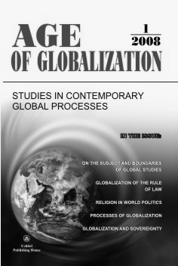
Age of Globalization is a special brief English version of the Russian journal Vek globalizatsii. The first and second sections contain complete articles and in the subsequent section one can find abstracts and annotations of the rest of the papers from the Russian-language original.
papers:
Alexander N. Chumakov
On the Subject and Boundaries of Global Studies
William C. Gay
Processes of Globalization and the Discipline of Global Studies
Leonid E. Grinin
Globalization and the Transformation of National Sovereignty
Sergey Kashkin and Paul Kalinichenko
Globalization of the Rule of Law: experience of Russia and the EU countries
Anastasia V. Mitrofanova
Religion in World Politics and the Problem of ‘Civilizations’

please, visit http://old.uchitel-izd.ru/index.php?option=content&task=view&id=155&Itemid=97
to read the papers.

