HIERARCHY AND POWER IN THE HISTORY OF CIVILIZATIONS
The human history has evidenced various systems of hierarchy and power, various manifestations of power and hierarchy relations in different spheres of social life from politics to information networks, from culture to sexual life. A careful study of each particular case of such relations is very important, especially within the context of contemporary multipolar and multicultural global world. In the meantime it is very important to see both the general features typical for all or most of the hierarchy and power forms, and their variation, especially in the turbulent period of globalization.

Hierarchy and Power in the History of Civilizations:
Political Aspects of Modernity
Edited by Leonid E. Grinin, Dmitri D. Beliaev, and Andrey V. Korotayev
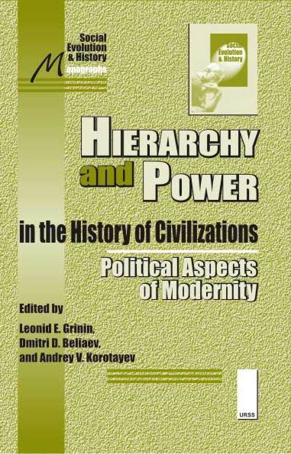
The relations of hierarchy and power penetrate the whole of social life but naturally they are most visible in the political sphere. The careful study of each particular case of such relations is of great significance. In the meantime, it is very important to see both the general features typical for all or most of the hierarchy and power forms, and their variation. The relations of power and hierarchy in the modern political world system demonstrate
a great number of variants, levels and dimensions, especially in the conditions of increasing globalization. In the present edited volume the focus lies on three aspects of this important subject. In the volume entitled Hierarchy and Power in the History of Civilizations: Political Aspects of Modernity the aspects of revolutionary changes, violence and globalization are analyzed in the following sections:
- Hierarchy and Power before and after the Revolutions – this section includes papers united by the idea that in various types of state systems the main subject has always been the distribution of power. In each type we see opposed classes and groups that develop their opposition to a point when the revolution starts and the whole old system collapses.
- Interpreting Violence – the section is dedicated to the problems of the relations between faith and violence, and the interpretation of violence at different levels and in various dimensions.
- Hierarchy and Power: Aspects of Globalization – in the section several quite important issues of this many-sided phenomenon are analyzed.

Hierarchy and Power in the History of Civilizations: Cultural Dimensions
Edited by Leonid E. Grinin and Andrey V. Korotayev
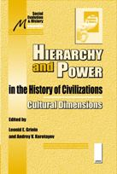
The relations of hierarchy and power are relevant for every sphere as they penetrate the whole life of a society and represent a sort of framework for an individual's activity. The cultural sphere (in the wide sense of the word) is not an exception, although, of course, it has great peculiarities in the manifestation of power-hierarchical relations. The relations here are usually informal and more often connected with traditions than with norms, there are much less power structures that have the legal right for coercion. The book consists of two main parts. The papers included in the first section discuss the dynamics and potentials of newly emerging socio-cultural network structures and the ways in which they re-conceptualize socio-cultural organization through innovative forms of spatial practice. The second section is dedicated to the study of new models of communication whose influence overcomes states' borders and which have a great potential and capabilities for destroying the basis and cultural values of the society.
The contributions of this edited volume entitled Hierarchy and Power in the History of Civilizations: Cultural Dimensions study the role of modern mass media in the public sphere which has become a zone of modern discourse distorted by unequal access to information, power and prosperity issues that are especially relevant in the epoch of globalization.
- The papers included in the section ‘Networked Cultures: Negotiating Cultural Differences in Contested Spaces’ discuss the dynamics and potentials of newly emerging socio-political network structures and the ways in which they reconceptualise socio-political organization through innovative forms of spatial practice.
- The section ‘Modern mass media and Public Sphere’ is dedicated to the study of the new models of communication whose influence overcomes states' borders and which have a great potential and capabilities for destroying the basis and cultural values of a society.
For more details on the volumes, please, visit the Internet-shop of Editorial URSS www.urss.ru

