Towards yet another age of creative destruction?
Arno Tausch
This article analyses economic growth and social development in 173 countries. With global economic gravitation shifting to the Indian Ocean/Pacific region (Frank 1998), the article analyses especially the role of foreign capital penetration as the key variable of past quantitative dependency studies for contemporary economic growth and social performance. In a Schumpeterian fashion, multinational corporations (MNC) penetration reflects the power, which transnational oligopolies wield over local economies. Today, social polarization and stagnation increase as a consequence of the development model, based on high MNC penetration.
Economic growth in the long run in the outgone Kuznets-cycle 1990–
2005 was strongly determined by the long-run positive effects of foreign direct investments per GDP of the host countries, while at the same time – and contrary to the traditional expectations of neo-classical economics – the more short-term effects of heavy foreign direct investment inflows on the host countries of foreign direct investment (FDI) were very negative. Other results reported here also confirm our reasoning: the logic of the Kondratiev cycle 1975–2005; inequality, gender empowerment, the Human Development Index, and life expectancy all confirm our Schumpeterian explanation, presented in this article. East and South-East Asia emerge as the real growth engines of the world economy.
Keywords: international relations, international political economy, economic development, technological change, economic growth.
1. Introduction
The current economic and social crisis is a temptation for social scientists to reconsider well-established assumptions of the discipline. The depth of the crisis, especially in the Northern-Euro-Atlantic region of our globe and its peripheries, and the apparent shift in the centre of gravitation of the world economy away from the Atlantic towards the Indian and the Pacific Ocean will renew not only the global research community interest in the later work of Frank (1998), but also in the centre-periphery models in the tradition of Prebisch (1950, 1983, 1988), and dependency theories in the tradition of such authors as Cardoso (1977, 1979), Cardoso and Faletto (1971), Furtado (1963, 1964, 1976, 1983), Sunkel (1966, 1973, 1978), and in the quantitative research inspired by these theories, namely by Galtung (1971), Sunkel (1973) and later Chase-Dunn (1975), Bornschier, Chase-Dunn, and Rubinson (1978), Bornschier and Ballmer-Cao (1979). All these theorists claimed that relations of dependency block long-run economic growth and bring about a socially unbalanced development, short spurts of economic growth notwithstanding.
The master variable in this study is ‘multinational corporations’ (MNC) penetration. It is measuring the share of the value of cumulated foreign direct investments by transnational corporations in the gross domestic product of the host country, and is thus reflecting the power, which transnational oligopolies wield over local economies (UNCTAD, World Investment Report 2009, and previous issues).
Our approach is Schumpeterian in character. Schumpeter, the great economist of the waning 19th Century and the early 20th Century, in his writings, published in 1908, 1912, 1939, 1950 strongly foresaw that capitalist development takes the form of ‘creative destruction’; and that innovation by entrepreneurs/companies is the force that sustains long-term economic growth, even as it destroys the value of established companies that enjoyed some degree of monopoly power. The monopolistic power, wielded by transnational corporations over their host countries, is also a measure of the temporary market power of the waning market leaders, facing new inventions, championed by the global emerging competitors of the old centres in the North Atlantic arena, especially in China and India.
The rest of this study is organized as follows. In Section 2 we shortly outline the main theories under scrutiny here, namely the Schumpeterian economic development theory; the five monopolies of the international system according to Amin (1997); world system analysis in the tradition of Polanyi (1957); Arrighi (1995) and Wallerstein (2000); the dependency model, formulated by Cardoso (1979); and the analysis of transnational capitalism and national disintegration according to Sunkel (1973). MNC dependency, reflecting the economic, social and political power of transnational oligopolistic corporations over their host countries as the key to analyzing contemporary changes is discussed in Section 3. The data, the development of the research design and the OLS-standard regression analyses are presented in Section 4. A final section concludes this study.

2. The main theories under scrutiny here
The writings of Joseph Alois Schumpeter (1908 [2009], 1912 [1934], 1939), and later world system and dependency analyses by Amin (1976, 1994, 1997); Bornschier (1982); Cardoso (1979), Cardoso and Faletto (1971); Prebisch (1950, 1983), and Sunkel (2003), were always aware of the emergence of crises, cyclical imbalances, regional shifts and their possible causes and consequences, as well as of the rise and decline of entire regions and even continents in the process of capitalist development. The world economy thus returns to the ‘old Galicia’ of 1909, when and where the young Schumpeter started his job as a University Professor in Czernowitz (then a German-language university on the very eastern outer rim of the Austro-Hungarian Empire, now Chernivtsi University in Northern Bukovina, Ukraine), gaining valuable insights into the nature of world development in the Galician periphery of the Empire, with all the ‘creative destruction’, which surrounded him. Several of his major works, like ‘The Nature and Essence of Theoretical Economics’ (1908, translated 2009) ‘The Theory of Economic Development: An Inquiry into Profits, Capital, Credit, Interest and the Business Cycle’ (1912, first translated 1934) were all heavily influenced by his early and short experience at the outer rim (1909–1911) of the Empire.
As is well-known, according to Schumpeter (1913, 1939) the entrepreneur is the prime mover of economic development, which is cyclical in character, connecting innovations, cycles, and development. Schumpeter strongly believed in the very long, 50–
60 year economic cycles, the Kondratiev waves (for empirical studies on Kondratiev waves, see the posthumous editions of Kondratiev's works in Kondratiev 2004; for
a general analysis Devezas 2006; furthermore Bornschier 1996; Goldstein 1988; Tausch 2007, 2008; for a sceptical view also Kuznets 1940). Capitalist development takes
the form of ‘creative destruction’ (Schumpeter 1950). Innovation by entrepreneurs/companies is the force that sustains long-term economic growth, even as it destroys the value of established companies that enjoyed some degree of monopoly power. Successful innovation is a source of temporary market power, eroding the profits and position of old firms, yet ultimately losing to the pressure of the new inventions, championed by the competitors (for a formal model of Schumpeterian growth economics, see Aghion and Howitt 1992).
Like many other development theories of the first generation of growth economists after the Second World War, whose stars began to rise long after Schumpeter already went to America, like Mandelbaum (1945); Rosenstein-Rodan (1964); Rothschild (1944); Singer (1975); Singer and Ansari (1988); Singer and Roy (1993) all shared with Schumpeter the observation that capitalism never was a smooth equilibrium process. Mandelbaum, Rosenstein-Rodan and Singer, and the early dependency theorists in Latin America, whom they so heavily influenced, were deeply convinced that capitalism is NOT crisis-free growth, full employment, environmental sustainability and the end to social exclusion.
The contemporary international system, more and more, seems to resemble such
a perpetual rise and fall of companies, regions, sectors, even nations. Several world systems approaches have taken up the basic idea of the Schumpeterian competition and stipulated that even the international system itself since the 1450s is characterized by hegemonies, international system de-concentration, the de-legitimation of the international order, and recurrent global wars over the hegemony in the system (see Devezas 2006; furthermore Arrighi 1995; Goldstein 1988; Tausch 2007; Wallerstein 2000). That currently economic growth dramatically shifts away from the North Atlantic arena to other regions of the world economy seems to indicate that such a major fundamental shift is taking place with the force of a real tsunami. Everywhere, the monopolies of power, which the old dominant transnational oligopolies wielded, are eroding.
Enlightening, as critical political economy might be in times of global crises, there are also some profound contradictions of the ongoing shifts in the global political economy with some of what seems today the all too narrowly and stable, geographically defined foundations of ‘dependency’ and ‘world systems research’. Let us recall here that for dependency and later world systems theory, going back to the writings of its four ‘founding fathers’ Amin (1994), Arrighi (1995), Frank (1967) and Wallerstein (2000), ascent and decline in world society is largely being determined by what Amin (1976) called the following ‘five monopolies’ of the international system:
- the monopoly of technology, supported by military expenditures of the dominant nations,
- the monopoly of control over global finances and a strong position in the hierarchy of current account balances,
- the monopoly of access to natural resources,
- the monopoly over international communication and the media, and
- the monopoly of the military means of mass destruction.
Let us also recall here that dependency authors generally explained backwardness and stagnation by the ever-growing dependent insertion of the global, ex-colonial South into the world economy. Starting with the writings of Prebisch (1950), their leading spokespersons all would stress the unequal and socially imbalanced nature of development in these regions. Short-term spurts of growth notwithstanding, long-term growth in the countries of Africa, Asia and Latin America will be imbalanced and unequal, and will tend towards high negative current account balances.
Later world system analyses – that started with the writings of the Austro-Hungarian socialist Karl Polanyi (Polanyi 1957) after the First World War – also tended to confirm and expand this dependency argument (Wallerstein 2000). Capitalism in the periphery, like in the centres, is characterized by strong cyclical fluctuations, and there are centres, semi-peripheries and peripheries. The rise of one group of semi-peripheries tends to be at the cost of another group, but the unequal structure of the world economy based on unequal transfer tends to remain stable.
Cardoso once, at the height of the debate, summarized the quantifiable essence of dependency theories as follows:
- there is a financial and technological penetration by the developed capitalist centres to the countries of the periphery and semi-periphery,
- this produces an unbalanced economic structure both within the peripheral societies and between them and the centres,
- this leads to limitations on self-sustained growth in the periphery,
- this favours the appearance of specific patterns of class relations, and
- these require modifications in the role of the state to guarantee both the functioning of the economy and the political articulation of a society, which contains, within itself, foci of inarticulateness and structural imbalance (Cardoso 1979).
The Chilean social scientist Osvaldo Sunkel, whose work is closely connected with the United Nations Economic Commission for Latin America (CEPAL/ECLA), was more cautious than most other dependency and world systems researchers by proposing in his ‘Transnational Capitalism and National Disintegration (in Latin America)’ (Sunkel 1973) – the thought that transnational investment and integration might go hand in hand, under certain conditions, with an increasing global relative social polarization between rich and poor in the host countries of the evolving transnational system. In his 1973 essay he said:
The advancement of modernization introduces, so to speak, a wedge along the area dividing the integrated from the segregated segments [...]. In this process, some national entrepreneurs are incorporated as executives into the new enterprises or those absorbed by the TRANCO (i.e. transnational corporations), and others are marginalized; some professionals, forming part of the technical staff and the segment of employees are incorporated, and the rest are marginalized; part of the qualified labor supply and those that are considered fit to be upgraded are incorporated, while the remainder are marginalized. [...] Finally, it is very probable that an international mobility will correspond to the internal mobility, particularly between the internationalized sectors [...]. The process of social disintegration which has been outlined here probably also affects the social institutions which provide the bases of the different social groups and through which they express themselves. Similar tendencies to the ones described for the global society are, therefore, probably also to be found within the state, church, armed forces, political parties with a relatively wide popular base, the universities etc. (Sunkel 1973: 18–42).
3. MNC dependency as the key to analyzing contemporary changes
MNC penetration measures the different shares of GDP, which foreign capital investments have in the host countries, i.e. the UNCTAD percentages of the stocks of multinational corporation investments per total host country GDP. This research tradition has been especially developed by the Swiss sociologist Volker Bornschier and his school (Bornschier 1976, 1980, 1981, 1982, 1983, 2002; Bornschier and Ballmer-Cao 1979; Bornschier and Chase-Dunn 1985; Bornschier, Chase-Dunn, and Rubinson 1978). MNC penetration captures the power, which international oligopolies wield in the different countries of the world system, and it also ideally measures dependency theory as expressed in Sunkel 1973, and Cardoso 1979.
There were dozens of attempts to quantitatively study this very simple and basic logic of dependency, which also can be linked to the formal economic models developed by the Polish political economist Michal Kalecki (1899 to 1970), many of them originally published already in the 1930s, 1940s and 1950s (Kalecki 1972, 1979; furthermore Rothschild 1954, 1957, 1958, 1959, 1964, 1965), stressing the linkage between mono-poly power, the conditions of dependency (measured by Kalecki by raw material prices), and income distribution (measured by Kalecki by the wage share).
Later tests of the Bornschier hypotheses could nothing but support and refine the original argument, independently of the research design, for different indicators and different time periods and different samples and different methods (see inter alia Beer 1999; Bornschier 1982, 2002; Dutt 1997; Heshmati 2006a, 2006b, 2007; Kentor 1998; Klitgaard and Fedderke 1995; Tausch 2003; Tausch and Prager 1993; Tsai 1995, just to mention a few samples from this vast literature).
By and large, our present research results build on the original dependency theory arguments, reported in Bornschier, Chase-Dunn and Rubinson (1978), and Bornschier and Ballmer-Cao, which both were based on analyses of the then ‘B-phase’ in the waning Kondratiev cycle from 1960 to the mid 1970s, now being applied as well for the current period in the world economy. Our period (i.e. ending before the big current crash of 2008–2011) is well comparable to the depression of the late 1970s and early 1980s, and the Great Depression of the 1930s. The fact that some later research results on MNC penetration, reported in the literature of the 1980s and 1990s, do not exactly correspond to other research results, must be qualified in the light of the following phenomena:
- The time frame of the study in the 50 – to 60 year long wave economic Kondratiev cycle and in the 18/22 year Kuznets cycles in the world economy since
the oil crisis of 1973, with its very strong fluctuations.
- Differences of methods used and periods studied,
- The sample composition of the study by location and level of development of countries, and
- The influence of other predictors, like development level, urbanization rate etc.
Arguments in the literature, which stress that cycle space and time play an important role in the logic of development, can be already found, among alia, in Bobrovnikov (2004) and Bornschier (1996). Cycle time requires certain conditions to be fulfilled to be able to be responsive to a development wave and attraction of development forces. Our study is the first world-system-wide study in the literature, linking MNC penetration in the mid 1990s and its growth until 2005 with social and economic development in
the contemporary world economic crisis.
4. The empirical results
Our quantitative results can be only briefly presented here. They are based on standard, SPSS XIV–XV ordinary least squares multiple regressions.
The 15 predictors in our equations measure the already achieved development level as an important control variable for possibly diminishing returns on capital as well as four variables of globalization, four variables measuring state sector influence in the economy, and four variables measuring demography and balancing work and family life.
The choice of the 173 countries was determined by the availability of a complete data series for these independent variables (if not mentioned otherwise, UNDP data):
Independent variables
1 | TRF04^{^2} total fertility rate, squared, 2004 (UNDP 2006)
2 | MNC PEN 1995 MNC penetration per GDP (UNCTAD 2000)
3 | DYN MNC PEN (increase MNC penetration, 1995–2000, UNCTAD 2000)
4 | public education expenditure per GNP, 1998 (time-lagged) (UNDP 2000)
5 | public health expenditure per GDP, 2003/2004 (UNDP 2006)
6 | tax revenue as % of GDP, 1998 (time-lagged) (UNDP 2000)
7 | age6504 percentage of people above 65 per total population, 2004 (UNDP 2006)
8 | EXP 90 exports per total GDP, 1990 (time-lagged) (UNDP 2006)
9 | female economic activity rate as % of male rate 2004 (UNDP 2006)
10 | GDP per capita (PPP US$) rank minus HDI rank (priority of human development as a social policy goal over economic growth; UNDP 2006)
11 | ln GDP natural logarithm of GDP per capita in real purchasing power parities, 2004 (UNDP 2006)
12 | ln GDP^2 natural logarithm of GDP per capita in real purchasing power parities, squared, 2004 (UNDP 2006)
13 | comparative price level – low comparative price level: GDP PPP/GDP exchange rate, 1998 (time-lagged, calculated from UNDP 2000)
14 | TFR04 total fertility rate, 2004 (UNDP 2006)
15 | UNDP type Balancing work and family life index (calculated by a UNDP/Sen-type of index, built after the model of the human development index, composed of the sub-indices, ranging from 0 (worst value) to 1.0 (best value) for: Female economic activity (ages 15 and older), 2004; Probability at birth of surviving to age 65 female, 2004; TFR04 (total fertility rate 2004); under-five mortality rate 2004, all based on UNDP 2006)
The list of our dependent variables is the following. We claim to present with this analysis a fairly comprehensive synopsis of the logic of post-1989 development and its effects on the ‘human condition’:
Dependent variables
16 | GDPPC90-2004, GDP per capita growth, 1990–2004 in real terms (UNDP 2006)
17 | GDPPC75-2004, GDP per capita growth, 1975–2004 in real terms (UNDP 2006)
18 | GDPPC90-2004, GDP growth, 1990–2004 in real terms
19 | Gemvalue Gender empowerment index, UNDP 2006 (A composite index measuring gender inequality in three basic dimensions of empowerment – economic participation and decision-making, political participation, and decision-making and power over economic resources. 0 – worst value, 1.0 best value)
20 | Human development index (HDI) value 2004 (UNDP 2006)
21 | Life expectancy at birth 2000/2005 (UNDP 2006)
22 | RAT2020 Quintile ratio – differences in real incomes between the top 20 % and the bottom 20 % in society (UNDP 2006)
In general, terms, we explain development performance by the following standard multiple cross-national development research equation:
(Equation 1) development performance _{1990–2004} = a₁.

DIMENSION DEVELOPMENT LEVEL AND ITS NON-LINEAR TRADE-OFFS WITH DEVELOPMENT PERFORMANCE

+- b₁*first part curvilinear function of development level +- b₂*second part curvilinear function of development level + ε.

DIMENSION GLOBALIZATION

+- b_{3.. .} *stock of transnational investment per GDP (UNCTAD) _{mid 1990s} +- b_{4.. .} *unequal exchange (ERDI, low comparative price levels) +- b_{5.. .} * DYN MNC penetration +- b_{6.. .} * world economic openness (exports per total GDP, time-lagged) + ε.

DIMENSION STATE SECTOR INTERVENTION IN THE ECONOMY

+- b_{7.. .} * public education expenditures per GDP (state sector variable 1) +-b₈ * public health expenditures per GDP (state sector variable 2) +- b₉ * tax revenue as an indicator of state interventionism (state sector variable 3) +- b₁₀ * priority of human development as a social policy goal over economic growth (state sector variable 4) + ε.

DIMENSION BALANCING WORK AND FAMILY LIFE

+- b₁₁ * first part curvilinear function of fertility rates +- b₁₂*second part curvilinear function of fertility levels +- b_{13.. .} * share of people above 65 per total population (aging process) +- b_{14.. .} * balancing work and family life +- b_{15.. .} * female economic activity rate as % of male rate + ε,

ε is the error term. For all equations, missing values were substituted by the mean.
Schumpeter's (1942) observations about the destructive creation inherent in the process of capitalist development, his observations about the sociological limits, which the formation and continuity of capitalist elites encounter in the long-run development of the ‘market economies’ as well as his strong belief in the cyclical nature of capitalist development, are all relevant for the interpretation of our empirical results.
For one, economic growth in the long run during the outgone K-cycle, which ended during the current global economic crisis, was strongly determined by the long-run positive effects of foreign direct investments per GDP of the host countries, while at the same time – and contrary to the traditional expectations of neo-classical economics – the more short-term effects of heavy foreign direct investment inflows on the host countries of FDI were – ceteris paribus – very negative. Transnational corporations in the outgone Kuznets cycle of 1990–2005 did not like, it seems, an environment of instability, and rather preferred the high-wage, high quality, and high-price economies of the typical West European countries, where their penetration rates of the host countries were still highest.
The critique in the spirit of Yotopoulos and other social scientists of the drive to lower the comparative international price level within the framework of ultra-globalization is also strongly vindicated by our empirical results. Unequal exchange, or low comparative international price levels, were ceteris paribus one of the most important impediments against long-run economic growth. But the European Commission and the EU-27 member governments – with their legally binding ‘Lisbon indicator’ comparative price level, even further wanted to lower these price levels, instead of accepting the well-known neo-Keynesian Balassa/Samuelson upward convergence of price levels in the poorer EU-27 member countries.
At the same time, it is clear that state sector influence on the economy finds its limits in the post 1989 political economy of the world.
In the post-1989 we have privatized airlines and railways, shipyards and steel works, we privatized government services, but we did not privatize – or privatize to a very significant degree – education.
For the explanation of economic growth over the very long period (‘development marathon’) over the entire Kondratiev cycle from 1975 onwards, the negative effects of the (rising) public health costs per GDP were additionally evident as one of the main negative predictors of economic growth, in conjunction with the factors already mentioned for the Kuznets cycle since the beginnings of the 1990s.
The negative, long run effects of the globalization process, as measured by low
comparative prices or unequal exchange, were being taken over by the export share
per GDP.

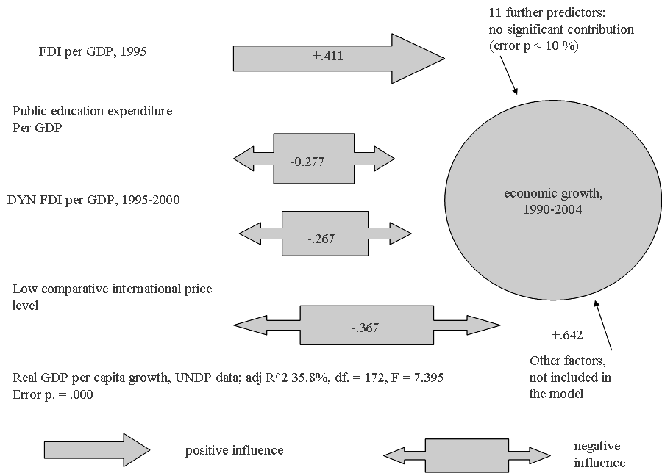

Diagram 1: a causal path/regression model of economic growth
in the world system, 1990–2004
Explanation: the numbers are beta-weights in multiple regressions. PIN =.05; POUT = .10, mean substitution of missing values. Source: our own calculations based on UNDP data 2000–2006, and UNCTAD data (World Investment Survey). SPSS version 14, August 2007, provided by Innsbruck University. Error p < 10 %: the 11 insignificant predictors were not significant at the 10 % error probability level

Contrary to dozens of analyses, written by neo-classical economists, the long-run negative effects of very radical pro-globalization policies on economic growth in the period of the outgone K-cycle, which ended in 2008, are clear. As we stated already above, transnational corporations were interested above all in stable and growing home-markets, fuelled by mass-demand and high-quality services, and they were not at all interested in the long run in ‘republics for export’ with no stable and large home markets. Bad for the neo-liberals, but also bad for populists and conventional left-wing radicals, transnational corporations were not interested in ‘superexploitation’, but in quantity and quality markets.

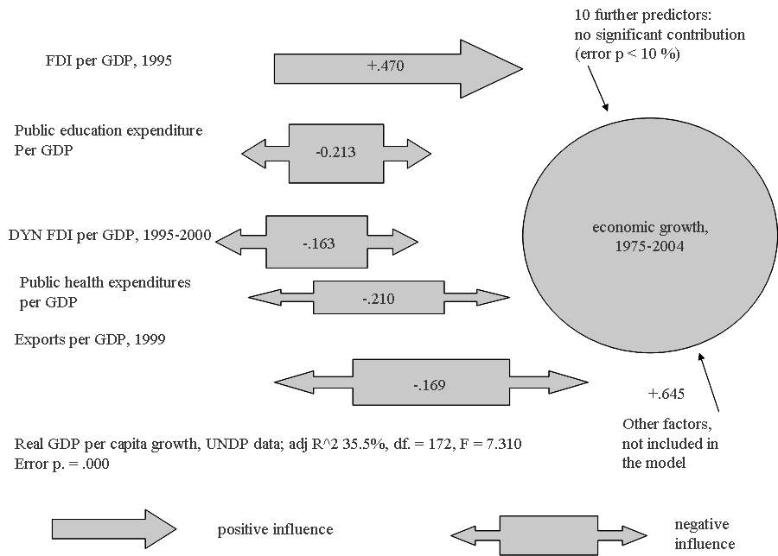

Diagram 2: a causal path/regression model of economic growth
in the world system, 1975–2004
Explanation: the numbers are beta-weights in multiple regressions. PIN =.05; POUT = .10, mean substitution of missing values. Source: our own calculations based on UNDP data 2000–2006 and UNCTAD data (World Investment Survey). SPSS version 14, August 2007, provided by Innsbruck University. Error p < 10 %: the 10 insignificant predictors were not significant at the 10 % error probability level
In this context, it should be emphasized that the recent Russian re-reading of N. D. Kondratiev also touches on the nature of waves in the centre and in the periphery. Especially the contemporary Russian economist Aleksandr Bobrovnikov put forward an interesting frame of reference, in fact linking the Kondratiev cycle debate with dependencia theory. Bobrovnikov makes the important point that transnational capital flows during the beginning of the downswing in the centre to the periphery, where the belated cycle still allows huge profits; and during the belated periphery depression, transnational capital again flows to the centre, thus exacerbating
the debt crisis in the periphery.
Our next analysis is about the causes of inequality in the countries of the world system. Our analysis of the process of inequality only partially confirms the earlier research results, discussed at length by quantitative sociology on the pages of the major transnational social science journals since the late 1970s. Especially taxes reduce income inequality to a considerable extent, while state sector expenditures in education in reality still increase existing inequalities, basically, because only the upper and the middle income classes are the real beneficiaries of capital intensive education outlays, especially on the tertiary level. There is a typical ‘Kuznets’ process of first rising and then shrinking inequality, but this process is not so much driven by the natural logarithm of income levels and their square – as traditionally assumed in the literature, but by fertility rates and their square. That is, rising fertility rates are associated with higher income inequality, but very high levels of fertility rates work in the opposite direction. As expected by dependency theory, heavy inflows of foreign capital do create additional inequalities, highly rewarding scarce skills, which are not available on the labour market, and making redundant unskilled labour, basically via the high capital intensity of foreign direct investments.
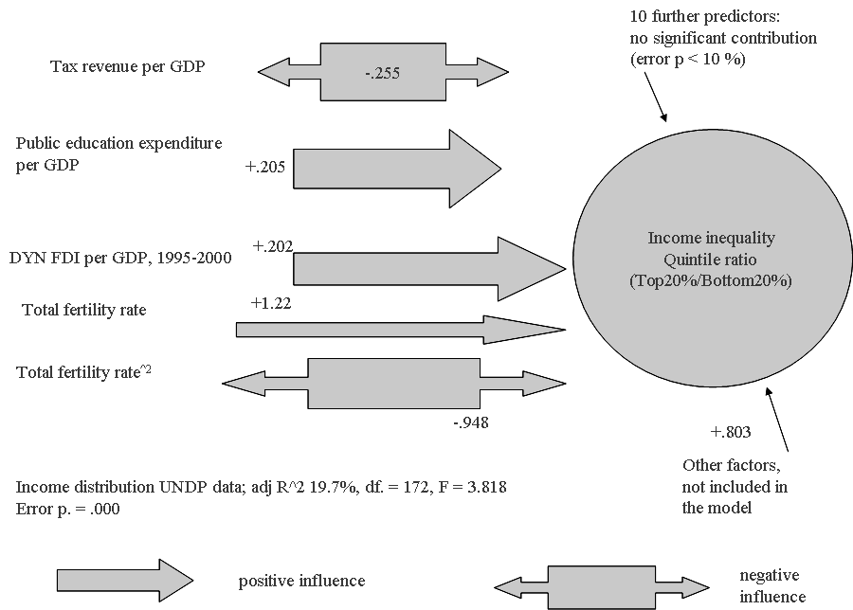

Diagram 3: a causal path/regression model of economic inequality
in the world system
Explanation: the numbers are beta-weights in multiple regressions. PIN =.05; POUT = .10, mean substitution of missing values. Source: our own calculations based on UNDP data 2000–2006 and UNCTAD data (World Investment Survey). SPSS version 14, August 2007, provided by Innsbruck University. The Beta-weight > 1.0 indicates that there is a high collinearity between the models of the variable. Error p < 10 %: the 10 insignificant predictors were not significant at the 10 % error probability level

Gender empowerment is determined by high female economic activity rates; and in addition, low comparative price levels – as implicitly foreseen by neo-classical economics – level-off the ‘playing field’ in the gender contest for incomes, prestige and power, and indeed work in favour of gender empowerment and work against male privileges in society. Gender empowerment rises – as inequality rates do – with rising fertility rates, and only at very high levels of fertility rates gender empowerment is reduced. This is an important finding in the context of the demographic debates in Europe – very low fertility rates actually are closely connected to lesser gender empowerment and are caused by higher male privileges, and gender empowerment is not only compatible, but also a precondition of ‘balancing work and family life’.
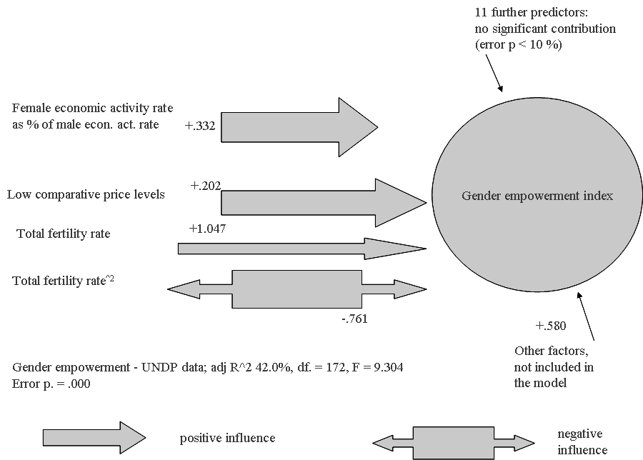

Diagram 4: a causal path/regression model of gender empowerment
in the world system
Explanation: the numbers are beta-weights in multiple regressions. PIN =.05; POUT = .10, mean substitution of missing values. Source: our own calculations based on UNDP data 2000–2006 and UNCTAD data (World Investment Survey). SPSS version 14, August 2007, provided by Innsbruck University. Error p < 10 %: the 11 insignificant predictors were not significant at the 10% error probability level

Our next and most probably most encompassing test result is our analysis of the determinants of the UNDP Human development index. The UNDP HDI is a real master indicator for the social situation of countries, and is very closely correlated with all other social indicators, including the available composite measures of the ‘Lisbon performance’ of a country in the EU-27. Balancing work and family life significantly increases the Human development index. Time lagged foreign direct investment per GDP
is closely connected to the human development performance, while fresh inflows of foreign direct investment, by the very nature of the ‘destructive creation process’ first of all increase existing inequalities and also existing human development deficits. As correctly foreseen by Schumpeter, capitalism is not that smooth transition phase and above all has nothing to do with the neat equilibrium worlds of neo-classical equilibrium economics. It is a process of oligopolistic competition, where the power of transnational corporations interacts with the power of national elites and national governments. Latin American sociology of the 1960s and 1970s was very explicit about these structures of inequality, power, and unequal interaction. Fernando Henrique Cardoso, Celso Furtado, Osvaldo Sunkel and many others predicted the hardening of these structures and the next to impossibility for the countries of the semi-periphery and periphery to overcome these structures.
In addition, a strong government social policy orientation in favour of human development is logically very significantly related to the human development outcome.
There is of course a curvilinear Kuznets-type of interaction between development levels and the human development index. There IS a definite possibility of social decay, foreseen in our quantitative results, which is or might be a real threat to the European ‘centre’. In addition, the centre HAS to come to terms with the demographic challenge and with high female economic activity rates. The capitalist work process, which makes dual work in the classically gendered household necessary, MUST offer the appropriate institutions, which make the balancing of work and household life necessary.
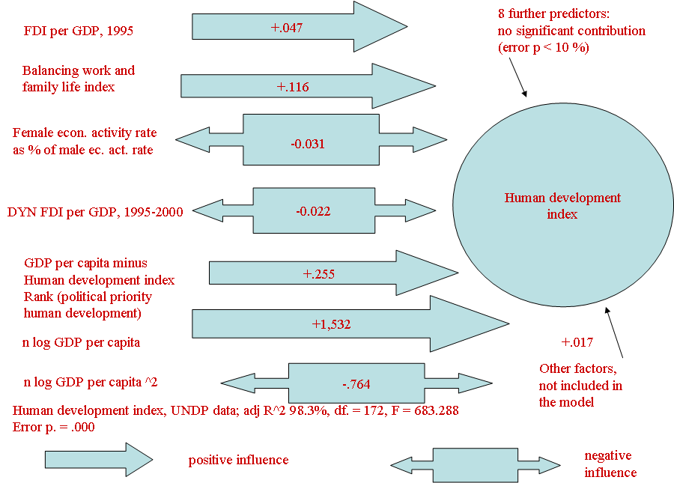

Diagram 5: a causal path/regression model of human development
in the world system
Explanation: the numbers are beta-weights in multiple regressions. PIN =.05; POUT = .10, mean substitution of missing values. Source: our own calculations based on UNDP data 2000–2006 and UNCTAD data (World Investment Survey). SPSS version 14, August 2007, provided by Innsbruck University. Error p < 10 %: the 8 insignificant predictors were not significant at the 10 % error probability level

Our last test result is our analysis of the determinants of the UNDP data on life expectancy. Again, balancing work and family life significantly increases life expectancy.
Again, a strong government social policy orientation in favour of human development is logically very significantly related to the life expectancy outcome. Low comparative price levels, ceteris paribus, are positively related to life expectancy, most probably because in aging societies, cheap social sector services and cheap state sector services are well compatible with the 24-hour care needs of the very elderly persons.
There is of course again a curve-linear Kuznets-type of interaction between development levels and life expectancy. Goldstein foresaw this interaction already in 1985. Again, there IS a definite possibility of social decay, foreseen in our quantitative results. The first part of the social Kuznets curve this time is taken up by the indicator ‘fertility rates’, indicating that with falling fertility rates in poor countries, life expectancy is rising, and vice versa. The second, decay-oriented part of the life expectancy ‘Kuznets curve’, based on incomes per capita in real purchasing power, wields significant results as well.
Again, it is shown that the capitalist work process, which makes dual work in the classically gendered household necessary, MUST offer the appropriate institutions, which make the balancing of work and household life necessary. Female economic activity rates are negatively related, under the present conditions of the often to be encountered incompatibility between work and family life, to life expectancy.
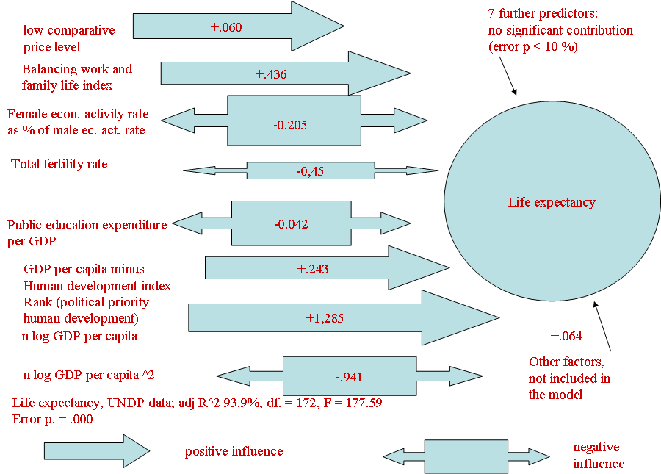

Diagram 6: a causal path/regression model of life expectancy in the world system
Explanation: the numbers are beta-weights in multiple regressions. PIN =.05; POUT = .10, mean substitution of missing values. Source: our own calculations based on UNDP data 2000–2006 and UNCTAD data (World Investment Survey). SPSS version 14, August 2007, provided by Innsbruck University. Error p < 10 %: the 7 insignificant predictors were not significant at the 10 % error probability level
5. Political perspectives and conclusions
We cannot but re-iterate that current globalization debates increasingly would have to take into account the ‘Asia/Pacific’-dimension (see Frank 1998, for his prophetic world historical projections of currently observable growth differences during the present world economic crisis). The landscape of the economic growth marathon, 1975–2003 was already clear enough, and it is even dramatic: East and South-east Asia are the real growth engines of the world economy.
Map 1. The development marathon, 1975–2003 on a global scale
Source: our own calculations from the United Nations Human Development Report Statistics data base, freely available under: http://hdr.undp.org/hdr2006/statistics/. The map shows real economic growth rates for the ‘marathon’ period 1975–2003. ‘Bis’ is shorthand for: ranging from … to … Countries and territories with missing values (from North to South): Greenland, Latvia, Lithuania, Poland, Czech Republic, Belarus, Kazakhstan, countries in ex-Yugoslavia and in the Caucasus region, Afghanistan, Libya, North Korea, Iraq, West-Sahara, Mali, Cuba, French Guyana, Senegal, Eritrea, Liberia, Yemen, Cambodia, Somalia, Zimbabwe

Map 2. The development marathon, 1975–2003 in the Atlantic arena

Source: our own calculations from the United Nations Human Development Report Statistics data base, freely available under: http://hdr.undp.org/hdr2006/statistics/. The map shows real economic growth rates for the ‘marathon’ period 1975–2003. ‘Bis’ is shorthand for: ranging from … to … Countries and territories with missing values (from North to South): Greenland, Latvia, Lithuania, Poland, Czech Republic, Belarus, Kazakhstan, countries in ex-Yugoslavia and in the Caucasus region, Libya, Iraq, West-Sahara, Mali, Cuba, French Guyana, Senegal, Eritrea, Liberia, Yemen, Somalia

The period after 1990 meant a continuation of this general trend, with a welcome shift of the growth potential in Europe from the centres away to the peripheries:

Map 3. Development after 1989 on a global scale
Source: our own calculations from the United Nations Human Development Report Statistics data base, freely available under: http://hdr.undp.org/hdr2006/statistics/. The map shows real economic growth rates for the period after the downfall of the Berlin Wall and the end of Communism in East Central Europe. Contrary to the assumptions of the European policy makers, who at the European Council meeting in Lisbon in 2000 planned to overtake the US by 2010, the United States is not ‘Miss world’ in terms of real economic growth rates. ‘Bis’ is shorthand for: ranging from … to … Countries and territories with missing values (from North to South): Greenland, Serbia, Montenegro, Afghanistan, Libya, Chad, Nigeria, North Korea, Iraq, West-Sahara, French Guyana, Liberia, Somalia

Map 4. Development after 1989 in the Atlantic arena
Source: our own calculations from the United Nations Human Development Report Statistics data base, freely available under: http://hdr.undp.org/hdr2006/statistics/. The map shows real economic growth rates for the period after the downfall of the Berlin Wall and the end of Communism in East Central Europe. The map clearly shows the deficiency of growth in several European countries, including Germany. ‘Bis’ is shorthand for: ranging from … to … Countries and territories with missing values (from North to South): Greenland, Serbia, Montenegro, Afghanistan, Libya, Chad, Nigeria, Iraq, West-Sahara, French Guyana, Liberia, Somalia

At the same time, and largely unnoticed by the international scientific and media community, was a dramatic convergence of the real life conditions around the globe in favour not only of Asia, but also in favour of the larger European periphery – i.e. the countries of the European Mediterranean partnership, which has become one of the most important and fundamental policy areas of European foreign policy for years to come. Instead of ‘fixing’ European economic and social policy targets at the ‘best practice’ country United States, European decision makers would be well advised to consider the often very heterodoxical development lessons of the ascending Asian giants – which were much more selective in their policy orientation vis-à-vis globalization than many, less successful countries and regions:

Map 5. The process of human development convergence/divergence
in the world system
C
Source: our own calculations from the United Nations Human Development Report Statistics data base, freely available under: http://hdr.undp.org/hdr2006/statistics/. The map compares the convergence of human development indices for the period 1995 – 2003. The world average, unweighted by the population factor, is taken as 100 for each period, i.e. 1995 and 2003, and the percentage increases are calculated. The best country increased its level of the UNDP Human Development Index by 15.5 %, and the worst country decreased its Human Development level by 18.6 %, compared to the world average. The human development index ranges from 0 (worst performance) to 1 (best performance) and combines life expectancy, education and real income. For a more detailed description of the UNDP methodology, see http://hdr.undp.org/hdr2006/statistics/indices/. Our map clearly shows the stagnation of human development in Sub-Saharan Africa, the surge of Asia and the dynamics in many Muslim countries, which cannot be explained by Huntington's pessimistic theories. In many highly developed western democracies, human development is stagnating, largely reflecting the tendencies also described in the recent UNICEF Report on child poverty in the advanced countries, Child Poverty in Perspective: An Overview of Child Well-Being in Rich Countries. (Series: Innocenti Report Cards, 7 Date of Publication: 2007 Pages: 52, ISBN: 88-89129-43-3 freely available under: http://www.unicef-icdc.org/publications.) For East Central Europe, see also the Trasmonee data series, freely available: http://www.unicef-icdc.org/research/. ‘Bis’ is shorthand for: ranging from … to … Missing values for the following countries and territories (from North to South): Greenland, Slovak Republic, Bosnia, Serbia, Georgia, Azerbaijan, Turkmenistan, Afghanistan, Guinea, Sierra Leone, Liberia, Cuba, Suriname, French Guyana, Somalia, Qatar, Kyrgyzstan, Bhutan, Burma, North Korea, Taiwan, Angola, Gabon

C
Map 6. The process of human development convergence/divergence
in the Atlantic arena
Source: our own calculations from the United Nations Human Development Report Statistics data base, freely available under: http://hdr.undp.org/hdr2006/statistics. The map compares the convergence of human development indices for the period 1995–2003. The world average, unweighted by the population factor, is taken as 100 for each period, i.e. 1995 and 2003, and the percentage increases are calculated. The best country increased its level of the UNDP Human Development Index by 15.5 %, and the worst country decreased its Human Development level by 18.6 %, compared to the world average. The human development index ranges from 0 (worst performance) to 1 (best performance) and combines life expectancy, education and real income. For a more detailed description of the UNDP methodology, see http://hdr.undp.org/hdr2006/statistics/indices/. ‘Bis’ is shorthand for: ranging from … to … Missing values for the following countries and territories (from North to South): Greenland, Slovak Republic, Bosnia, Serbia, Georgia, Azerbaijan, Turkmenistan, Afghanistan, Guinea, Sierra Leone, Liberia, Cuba, Suriname, French Guyana, Somalia

C

Map 7. The convergence of human development performance on a global scale –
the case of Asia

Source: our own calculations from the United Nations Human Development Report Statistics data base, freely available under: http://hdr.undp.org/hdr2006/statistics. The map compares the convergence of human development indices for the period 1995–2003. The world average, unweighted by the population factor, is taken as 100 for each period, i.e. 1995 and 2003, and the percentage increases are calculated. The best country increased its level of the UNDP Human Development Index by 15.5 %, and the worst country decreased its Human Development level by 18.6 %, compared to the world average. The human development index ranges from 0 (worst performance) to 1 (best performance) and combines life expectancy, education and real income. For a more detailed description of the UNDP methodology, see http://hdr.undp.org/hdr2006/statistics/indices/. ‘Bis’ is shorthand for: ranging from … to … Missing values for the following countries and territories (from North to South): Greenland, Slovak Republic, Bosnia, Serbia, Georgia, Azerbaijan, Turkmenistan, Afghanistan, Guinea, Sierra Leone, Liberia, Cuba, Suriname, French Guyana, Somalia, Qatar, Kyrgyzstan, Bhutan, Burma, North Korea, Taiwan, Angola, Gabon

References
Aghion, Ph., and Howitt, P.
1992. A Model of Growth Through Creative Destruction. Econometrica 60(2): 323–351.
Amin, S.
1976. Unequal Development: An Essay on the Social Formations of Peripheral Capitalism. New York: Monthly Review Press.
1994. Re-reading the Postwar Period: An Intellectual Itinerary. New York: Monthly Review Press.
1997. Die Zukunft des Weltsystems. Herausforderungen der Globalisierung. Herausgegeben und aus dem Franzoesischen uebersetzt von Joachim Wilke. Hamburg: VSA.
Arrighi, G.
1995. The Long 20th Century. Money, Power, and the Origins of Our Times. London; New York: Verso.
Balassa, B.
1964. The Purchasing Power Parity Doctrine: A Reappraisal. Journal of Political Economy 72(4): 584–596.
Barro, R. J.
2003. Economic Growth in a Cross Section of Countries. International Library of Critical Writings in Economics 159(1): 350–386.
Beer, L.
1999. Income Inequality and Transnational Corporate Penetration. Journal of World Systems Research 5(1): 1–25.
Bobrovnikov, A. V.
2004. Macrocycles in the economies of Latin American Countries. Moscow: Institute of Latin America. In Russian (Бобровников, А. В. Макроциклы в экономике стран Латинской Америки. Москва: ин-т Латинской Америки).
Bornschier, V.
1976. Wachstum, Konzentration und Multinationalisierung von Industrieunternehmen. Frauenfeld – Stuttgart: Huber.
1980. Multinational Corporations, Economic Policy and National Development in the World System. International Social Science Journal 32(1): 158–172.
1981. Dependent Industrialization in the World Economy: Some Comments and Results concerning a Recent Debate. The Journal of Conflict Resolution 25(3): 371–400.
1982. The World Economy in the World System. Structure Dependence and Change.
International Social Science Journal 34(1): 38–59.
1983. World Economy, Level Development and Income Distribution: An Integration of Different Approaches to the Explanation of Income Inequality. World Development 11(1): 11–20.
1996. Western Society in Transition. New Brunswick, N. J.: Transaction Publishers.
2002. Changing Income Inequality in the Second Half of the 20th Century: Preliminary Findings and Propositions for Explanations. Journal of World Systems Research VIII(1): 100–127. URL: http://jwsr.ucr.edu/index.php
Bornschier, V., and Ballmer-Cao, T. H.
1979. Income Inequality: A Cross-National Study of the Relationships Between MNC-Penetration, Dimensions of the Power Structure and Income Distribution. American Sociological Review 44(3): 438–506.
Bornschier, V., and Chase-Dunn, Ch. K.
1985. Transnational Corporations and Underdevelopment. New York, NY: Praeger.
Bornschier, V., Chase-Dunn, Ch. K., and Rubinson, R.
1978. Cross-National Evidence of the Effects of Foreign Investment and Aid on Economic Growth and Inequality: A Survey of Findings and a Reanalysis. American Journal of Sociology 84(3): 651–683.
Cardoso, F. H.
1977. El Consumo de la Teoría de la Dependencia en los Estados Unidos. El Trimestre Economico 173/44(1): 33–52.
1979. Development under Fire. Mexico D.F.: Instituto Latinoamericano de Estudios Transnacionales, DEE/D/24 i, Mayo (Mexico 20 D.F., Apartado 85–025).
Cardoso, F. H., and Faletto, E.
1971. Dependencia y desarrollo en América Latina. Mexico D.F.: Editorial Siglo XXI.
Chase-Dunn, Ch. K.
1975. The Effects of International Economic Dependence on Development and Inequality: a Cross-national Study. American Sociological Review 4(4): 720–738.
Coleman, J. S.
1965. Education and Political Development. Princeton, NY: Princeton University Press.
Devezas, T. C. (ed.)
2006. Kondratieff Waves, Warfare and World Security. Proceedings of the NATO Advanced Research Workshop on the Influence of Chance Events and Socioeconomic Long Waves in the New Arena of Asymmetric Warfare, Covilhã, Portugal, 14–18 February 2005. Amsterdam: IOS Press.
Devezas, T. C., and Corredine, J. T.
2001. The Biological Determinants of Long-wave Behavior in Socioeconomic Growth and Development. Technological Forecasting and Social Change 68(1): 1–57.
Durlauf, St. N., Kourtellos, A., and Tan, Ch. M.
2008. Are any Growth Theories Robust? The Economic Journal 118(1): 329–346.
Dutt, A. K.
1997. The Pattern of Direct Foreign Investment and Economic Growth. World Development 25(11): 1925–1936.
Frank, A. G.
1967. Capitalism and Underdevelopment in Latin America: Historical Studies of Chile and Brazil. New York: Monthly Review Press.
1998. ReOrient: Global Economy in the Asian Age. Ewing, CA: University of California Press.
Froebel, F.
1980. The New International Division of Labour: Structural Unemployment in Industrialised Countries and Industrialisation in Developing Countries. Cambridge, NY: Cambridge University Press; Paris: Editions de la Maison des Sciences de l'Homme.
Furtado, C.
1963. The Economic Growth of Brazil: a Survey from Colonial to Modern Times. Berkeley: University of California Press.
1964. Development and Underdevelopment. Berkeley: California University Press.
1976. Economic Development of Latin America: Historical background and Contemporary Problems. Cambridge; New York: Cambridge University Press.
1983. Accumulation and Development: the Logic of Industrial Civilization. Oxford:
M. Robertson.
Galtung, J.
1971. A Structural Theory of Imperialism. Journal of Peace Research 8(2): 81–117.
Goldstein, J. S.
1985. Basic Human Needs: The Plateau Curve. World Development 13(5): 595–609.
1988. Long Cycles: Prosperity and War in the Modern Age. New Haven, CT: Yale University Press.
Heshmati, A.
2006a. Measurement of a Multidimensional Index of Globalization. Global Economy Journal 6(2): Paper 1.
2006b. The World Distribution of Income and Income Inequality: A Review of the Economic Literature. Journal of World Systems Research 12(1): 61–107.
2007. Global Trends in Income Inequality. Hauppauge, NY: Nova Science Publishers.
Huntington, S. P.
1968. Political Order in Changing Societies. New Haven: Yale University Press.
1996. The Clash of Civilizations and the Remaking of World Order. New York: Simon & Schuster.
Ibn Khaldun (1332–1406)
2005. The Muqaddimah: an Introduction to History. In Dawood, N. J. (ed.), Ibn Khaldun. Princeton, N.J.: Princeton University Press.
Inglehart, R., and Norris, P.
2003. Rising Tide: Gender Equality and Cultural Change around the World. New York; Cambridge: Cambridge University Press.
Kalecki, M.
1972. The Last Phase in the Transformation of Capitalism. New York: Monthly Review Press.
1979. Essays on Developing Economies. Hassocks: The Harvester Press.
A. T. Kearney, Inc., and the Carnegie Endowment for International Peace
2002. Globalizations Last Hurrah? Foreign Policy January/February 38–51.
2003. Measuring Globalization: Who's Up, Who's Down? Foreign Policy January/Feb-ruary: 60–72.
Kentor, J.
1998. The Long-Term Effects of Foreign Investment Dependence on Economic Growth, 1940–1990. The American Journal of Sociology 103(4): 1024–1046.
Kondratiev, N. D.
2004. The World Economy and its Conjunctures during and after the War. Moscow: International Kondratieff Foundation.
Klitgaard, R., and Fedderke, J.
1995. Social Integration and Disintegration: An Exploratory Analysis of Cross-country Data. World Development 23(3): 357–369.
Krasilshchikov, V.
2008. The Rise and Decline of Catching Up Development. An Experience of Russia and Latin America with Implications for Asian Tigers. Málaga: Entelequia, Revista Interdisciplinar. URL: http://www.eumed.net/entelequia/en.lib. php?a=b008
Kuznets, S.
1940. Schumpeters Business Cycles. The American Economic Review 30(2): 157–169.
1955. Economic Growth and Income Inequality. The American Economic Review 45(1): 1–28.
1976. Modern Economic Growth: Rate, Structure and Spread. New Haven, CT: Yale University Press.
Mandelbaum, K.
1945. The Industrialisation of Backward Areas / Assisted by J. R. L. Schneider. Oxford: B. Blackwell.
Mann, Th.
1924. Buddenbrooks. New York: A. A. Knopf.
Norris, P., and Inglehart, R.
2004. Sacred and Secular: Religion and Politics Worldwide. Cambridge; Melbourne: Cambridge University Press.
Polanyi, K.
1957. The Great Transformation. Boston: Beacon.
Prebisch, R.
1950. The Economic Development of Latin America and its Principal Problems. Economic Commission for Latin America. New York: United Nations Department of Economic Affairs.
1983. The Crisis of Capitalism and International Trade. ECLAC Review/Revista de la CEPAL (Santiago) 20, August: 51–74.
1988. Dependence, Development, and Interdependence. In Ranis, G., and Schultz, T. P. (eds.), The State of Development Economics (pp. 31–41). Oxford, UK: Basil Blackwell.
Rennstich, J.
2007. Is Globalization Self-organizing? In Modelski, G., Devezas, T. C., and Thompson, W. R. (eds.), Globalization as Evolutionary Process. Modeling Global Change (pp. 74–107). London; New York: Routledge.
Rosenstein-Rodan, P. N.
1964. Capital Formation and Economic Development. London: Allen & Unwin.
Ross, R. J. S.
2004. Slaves to Fashion. Poverty and Abuse in the New Sweatshops. Ann Arbor, MI: University of Michigan Press.
Rothschild, K. W.
1944. The Small Nation and World Trade. The Economic Journal, April: 26–40.
1954. The Theory of Wages. Oxford: Blackwell.
1957. Der Lohnanteil am Gesamteinkommen: Einige Bemerkungen zu einem umstrittenen Problem. Weltwirtschaftliches Archiv 78(2): 157–202.
1958. Einkommensbildung und Einkommensverteilung. Weltwirtschaftliches Archiv 80(2): 53–58.
1959. The Limitations of Economic Growth Models. Kyklos 12(4): 567–588.
1964. Surveys of Foreign Post-war Developments in Economic Thought. The American Economic Review 54, 2(2): 1–55.
1965. Theme and Variations, Remarks on the Kaldorian Distribution Formula. Kyklos
18(4): 652–669.
Rubinson, R.
1976. The World Economy and the Distribution of Income within States – a Cross-national Study. American Sociological Review 41(4): 638–659.
Samuelson, P.
1964. Theoretical Notes on Trade Problems. The Review of Economics and Statistics 46(2): 145–154.
Schumpeter, J. A.
1908. Wesen und Hauptinhalt der theoretischen Nationalökonomie. Leipzig: Duncker & Humblot. (2009. The Nature and Essence of Economic Theory. Rutgers, NJ: Transaction Publishers.)
1912. Theorie der wirtschaftlichen Entwicklung. Leipzig: Duncker & Humblot (1934. The Theory of Economic Development: an Inquiry into Profits, Capital, Credit, Interest and the Business Cycle. Cambridge, MA: Harvard University Press).
1939. Business Cycles. A Theoretical, Historical, and Statistical Analysis of the Capitalist Process. New York; London: McGraw-Hill Book Company.
1942. The Process of Creative Destruction. London: Unwin.
1950. Capitalism, Socialism and Democracy. New York; London: Harper & Row.
1954. History of Economic Analysis. New York: Oxford University Press.
Seers, D., and Öström, K. (eds.)
1983. The Crises of the European Regions. London: Macmillan (in association with the European Association of Development Institutes).
Seers, D. (ed.)
1981. Dependency Theory: a Critical Reassessment. London: Pinter.
Seers, D., Schaffer, B., and Kiljunen, M.-L.
1979. Underdeveloped Europe: Studies in Core – Periphery Relations. Atlantic Highlands, NJ: Humanities Press.
Seers, D., Vaitsos, C., and Kiljunen, M.-L. (eds.)
1980. Integration and Unequal Development: the Experience of the EEC. London: Macmillan.
Singa Boyenge, J.-P.
2007. ILO Database on Export Processing Zones. (Revised.) sectoral activities programme; Working Paper 251. Geneva: International Labour Office.
Singer, H. W.
1975. The Strategy of International Development: Essays in the Economics of Backwardness. In Cairncross, A., and Puri, M. (eds.), H. W. Singer. London: Macmillan.
Singer, H. W., and Ansari, J. A.
1988. Rich and Poor Countries: Consequences of International Economic Disorder. London; Boston: Unwin Hyman.
Singer, H. W., and Roy, S.
1993. Economic Progress and Prospects in the Third World: Lessons of Development Experience since 1945. Aldershot; Brookfield, VT: E. Elgar.
SPSS
2007. Statistical Package for the Social Sciences, User Guide. Version 14, August 2007.
Sunkel, O.
1966. The Structural Background of Development Problems in Latin America. Weltwirtschaftliches Archiv 97(1): 22–63.
1973. Transnational Capitalism and National Disintegration in Latin America. Social and Economic Studies 22(1): 132–176.
1978. The Development of Development Thinking. In Villamil, J. J. (ed.), Transnational Capitalism and National Development. New Perspectives on Dependence (pp. 19–30). Hassocks: Harvester Press.
2003 (ed.). Development from within: Toward a Neostructuralist Approach for Latin America. Boulder, CO: L. Rienner.
Tausch, A.
2003. Social Cohesion, Sustainable Development and Turkeys Accession to the European Union. Alternatives: Turkish Journal of International Relations 2(1): 1–41.
2007. War Cycles. Social Evolution and History 6(2): 39–74.
2008. Destructive Creation? (Schumpeter-Style Reasonings on Some Trends and Lisbon Process in Europe). Mirovaya ekonomika i mezhdunarodnye otnosheniya 10: 34–41. In Russian (Тауш, А. Разрушительное созидание? [Рассуждения в духе Шумпетера о некоторых трендах и Лиссабонском процессе в Европе]. Мировая экономика и международные отношения 10: 34–41).
Tausch, A., and Prager, F.
1993. Towards a Socio-Liberal Theory of World Development. Basingstoke; New York: Macmillan/St. Martins Press.
Tsai, P.-L.
1995. Foreign Direct Investment and Income Inequality: Further evidence. World Development 23(3): 469–483.
United Nations (current issues) United Nations Human Development Report. New York; Oxford: Oxford University Press.
United Nations Conference on Trade and Development
2009. World Investment Report. New York; Geneva: United Nations.
United Nations Economic Commission for Latin America, ECLAC/CEPAL
2002. Globalización y desarrollo. URL: http://www.eclac.cl/cgibin/getProd.asp?xml= /publicciones/ xml/6/10026/P10026.xml&xsl=/tpl/p9f.xsl&base=/MDG/tpl/top-bottom.xsl
Wallerstein, I.
2000. The Essential Wallerstein. New York: The New Press.
Weede, E.
2002. Impact of Intelligence and Institutional Improvements on Economic Growth. Kyklos 55(3): 361–380.
2004. Does Human Capital Strongly Affect Economic Growth Rates? Yes, But Only If Assessed Properly. Comparative Sociology 3(2): 115–134.
Yotopoulos, P. A.
1996. Exchange Rate Parity for Trade and Development: Theory, Tests, and Case Studies. Cambridge (England); New York: Cambridge University Press.
Yotopoulos, P., and Sawada, Y.
2005. Exchange Rate Misalignment: A New Test of Long-Run PPP Based on Cross-Country Data. CIRJE Discussion Paper CIRJE-F-318, February, Faculty of Economics, University of Tokyo. URL: http://www.e.u-tokyo.ac.jp/cirje/research/dp/2005/2005cf318.pdf

